GEOGRAPHY FORM ONE WORK

PREPARED BY MR. OGOTI R.M

TOPIC ONE: INTRODUCTION TO GEOGRAPHY


The origin of Geography
- The term Geography is derived from two Greek words: Geo and Graphien. Geo means
Earth and Graphien means to write, draw or describe.
- The two words combined to become Geographien – which means to write, draw or describe the earth.
- Geographien was later adapted by English language to become Geography. Its definition was improved upon and today Geography is defined as “the study of the earth as a home of mankind” –kcse 2019

Definition of Environment
- Environment is the external conditions that surround an organisms/ external conditions that influence the development and behavior of an organism –kcse 2020
- The set of these external surroundings that influence the development and behaviour of a specific living organism is referred to as ecology.
- The home that provides the physical conditions under which specific living organisms live is referred to as habitat.
- The complex of a community of organism and its environment functioning as an ecological unit is referred to as ecosystem.

This environment is divided into two:
  - Physical environment comprising natural/ physical features that are products of land forming processes.
  - Human environment comprising human activities on the earth’s surface and their effects.

Branches of Geography –kcse 2019
    - Physical geography
    - Human and Economic geography
    - Practical geography

Physical Geography
- This deals with land forming processes that shape the earth’s surface and their resultant features and effects.

Areas/ Topics covered under physical geography.
- Study of Earth & the Solar System
- Weather & Climate
- Internal land forming processes such as folding, faulting and vulcanicity.
- External land forming processes such as weathering and mass wasting, action of rivers, lakes, glaciation, action of wind & water in arid areas, oceans, seas & their coasts e.t.c.
- Soil
- Vegetation
- Minerals and Rocks

Divisions of physical geography –kcse 2020
- Geology
- Geomorphology
- Climatology/Meteorology
- Pedology
- Biogeography/Ecology
- Hydrology
- Spatial geography

Human and Economic Geography
- This involves the study of people/human and their activities on the earth’s surface. These activities are because of exploitation and processing of available physical resources.

Areas/ Topics covered under Human and Economic geography.
- Mining
- Forestry
- Fishing
- Agriculture
- Wildlife and tourism
- Industry
- Transport and communication
- Trade

Division of Human and Economic geography.
- Historical geography
- Cultural geography
- Demography geography
- Political geography
- Social geography
- Settlement geography
- Economic geography

Practical geography
-These are skills used in the study and understanding of physical and human & economic geography.

Areas/Topics covered under Practical Geography.
- Map work
- Fieldwork
- Photograph work
- Statistical methods

Importance of practical geography.
- It gives learners an opportunity to develop skills.
- It enables learners to develop a practical understanding and interpretation of geographical information.
- It enables learners to clearly bring out the interrelationship between different geographical events.

Relationship between geography and other disciplines.
- Geography as a subject widely relates with other disciplines/subjects as follows:
- Geography and Mathematics –kcse 2012
- Mathematics principles/formulae are used in geography to calculate distance/area/population density.
- Geography information can be analyzed/presented accurately through the application of mathematical techniques.
- Geographical concepts are applied in calculating direction/bearing in mathematics.

Geography and Biology
  - Biology is the study of plants and animals while geography attempts to explain the distribution of these plants and animals on the earth’s surface as well as their importance.

- Geography and Agriculture –kcse 2017
  - Geography deals with the study of climate and weather which is important in planning agricultural activities such as planting and harvesting.
  - Geography studies the relief of an area which helps identify suitable areas for various agricultural activities.
  - Geography describes and explains agricultural systems, their distribution and differences in terms of development.
  - Geography deals with type of soils which influences types of crops.

Geography and Demography
  - Demography is the scientific study of the number of people, their gender in terms of male or female, their ages and rate at which people are born and die. On its part, Geography deals with the distribution of people on the earth’s surface and how the population changes with time.

Geography and Economics
  - Deals with the study of production, distribution and consumption of goods and services. Economic development is based on natural resources e.g. land, minerals, vegetation, etc.
  - Geography deals with the distribution of natural resources while economics add value to these natural resources.

Geography and Geology
  - Geology is the scientific study of the structure and composition of the earth. Geography use geological information to understand how physical features influence human activities.

Geography and Meteorology
  - Meteorology is the scientific study of the weather (atmospheric conditions) while Geography deals with how the weather influences human activities.

Geography and History
- History describes past events while geography explains where and how these events took place.
- In addition, history uses geographical tools such as charts and maps to explain some historical events.

Geography and Chemistry
- Geography applies chemistry in studying chemical composition/properties of rocks and soils that results to the formation of geographic features.
- Chemistry knowledge helps in understanding chemical processes in physical geography such as carbonation/hydrolysis/solution/hydration/oxidation.
- Chemistry knowledge helps in understanding chemical changes in rocks and soils.

Geography and Physics
- This is the study of matter and natural forces e.g. energy, light, heat, sound, gravity, magnetism, etc.
- Geography focuses on the heat from the sun as it is responsible for the movement of air, evaporation of water and distribution of moisture in the atmosphere.

Geography and Civil engineering
- Deals with building and maintenance of structures e.g. drainage systems, dams, airports, roads, railway lines, etc.
- Geographical knowledge on rocks and soils is a must before these structures/projects are designed and developed.
- Geography is also interested in the distribution and how these projects affect human activities

Geography and Medicine
- Deals with diseases, their causes and possible cures.
- Geography focuses on the factors that influence the spread of a given pest and disease.

Reasons for the uniqueness of geography.

- Geography emphasizes on the spatial distribution of both physical and human phenomena/features on the Earth’s surface and maps them to show their relationships and pattern.
- Geography relates well with other disciplines of earth science, social science and geometric science hence it has a wide scope i.e. centrality of geography as a science.
Importance of studying geography- kcse 2017
  - It helps to develop mental skills.
  - It enables learners understand/appreciate different environmental awareness/cooperation.
  - It encourages international awareness/cooperation.
  - It helps learners appreciate important social values such as time management/responsibility.
  - It promotes positive attitude towards protection/conservation of resources.
  - It leads to development of career opportunities.
  - It enables learners to explain the origin/formation of the earth/landforms.

“END OF TOPIC ONE”

TOPIC TWO: THE EARTH AND THE SOLAR SYSTEM

Definition of Solar System –kcse 2014
- Solar system is made up of the sun, the planets and other heavenly bodies like comets/meteors that revolve around the sun.
- The study of heavenly bodies is known as astronomy.

Origin of the Solar System
- Theories that explain the origin of the earth/solar system are: -kcse 2005
    - The Passing star theory
    - The Nebula cloud theory
    - Collision theory
    - Supernova/explosion theory

The passing star theory
  - This theory suggests that a star with a greater gravitational pull than the sun passed near the sun.
  - As a result, it drew off a stream of gaseous materials from the sun.
  - These material split, cooled and condensed to form planets.
  - The planets were then set in orbit around the sun by the passing star.
  - Some smaller materials also cooled and condensed to form other heavenly bodies like the moon and asteroids that were also set in their orbits.

Weaknesses of the passing star theory –kcse 2021
- The theory does not explain the origin of the sun and the star.
- Chances of another star approaching the sun are minimal.
- High temperature materials drawn from the sun or star would disperse in space rather than condense.
- The sun could be broken up by gravitational force generated by the star hence materials could not condense to form planets.
- The effects of the star setting planets on their orbit could have reduced as the star was moving away.

- The nebula cloud theory –kcse 2013
  - This theory suggests that there was a huge cloud of gases (hydrogen and helium), dust and ice particles called nebula.
  - This cloud whirled, cooled and condensed to form a disc shape.
  - There was gravitational attraction within the materials causing the particles to compact.
  - Some particles broke from the edge of the disc and whirled.
  - As they whirled, they cooled and solidified to form the planets.
  - The earth is one of the planets.
  - The centre of the disc formed the sun.

Weaknesses of the nebula cloud theory
- The theory does not explain the causes of rotation of the nebula.
- The theory does not explain the origin of the nebula.
- All the planets should rotate in the direction of the centre of the nebula i.e. from west to east but Venus and Uranus rotate from east to west.

Composition of the solar system- kcse 2021
- Sun, planets, asteroids, meteors, meteorites, comets, satellites/moons, meteoroids and dwarf planets.

The Sun
  - This is a star and is the center of the solar system.
  - It has the planets and some heavenly bodies orbiting/revolving around it.
  - It radiates/produces solar energy.
  - It rotates on its own axis in an anticlockwise direction.
  - It produces its own light.
  - It has gravitational pull.
  - It is made up of very hot gases mainly hydrogen and helium.
  - It is surrounded by a layer of gas which boils at its surface called corona.

NOTE: A star is a heavenly body possessing its own light which it transmits.
: Nebula/Galaxy is a cluster of stars. The earth is in a galaxy called Milky Way.

Planets
- Planets are large spherical celestial/heavenly bodies that revolve around the sun.
- There are 8 planets in the solar system. Characteristics of planets.
  - They revolve around the sun in anticlockwise direction.
  - They are maintained in their own orbits by a strong gravitational pull from the sun.
  - They reflect light from the sun.
  - They are spherical in shape.
  - They have their own force of gravity.
  - Only one planet (earth) supports life.
  - Each planet has orbit. An orbit is a path which a planet follows around the sun.

The solar system
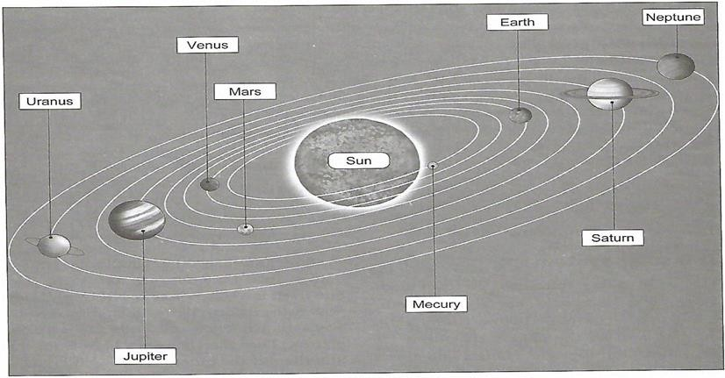

- Mercury: - this is the smallest of all the planets and nearest to the sun. It takes 88 days to make one complete revolution around the sun. It lacks satellites. It is an evening star.

- Venus: - this is the second planet from the sun. It takes 225 days to make one complete revolution around the sun. It also lacks satellites. It is the brightest. It is the hottest planet. It is the morning star. It can be seen clearly with naked eyes.

- Earth: - third planet from the sun. This is the only planet in the solar system that supports life. It takes about 365days to make one complete revolution around the sun. It has only one satellite/the moon. It takes 24 hours to rotate.
NOTE: Venus and Earth are called twin planets.

- Mars: - fourth planet from the sun. Takes 687days to make one complete revolution around the sun. It has two satellites and many asteroids between it and Jupiter.

- Jupiter: - fifth planet from the sun. This is the largest planet in the solar system. It takes 12 years to make one compete revolution around the sun. It has a thick layer of ice on its surface. It has 13 satellites revolving around it.

- Saturn: - sixth planet from the sun. The second largest planet. It has a halo ring around it. It has 8 satellites. It takes 29 ½ years to make one complete revolution around the sun.

- Uranus: - seventh planet from the sun. It experiences very low temperatures. It is surrounded by methane gas. It has 5 satellites. It takes 84 years to make one complete revolution around the sun.

- Neptune: - It is the farthest planet from the sun and can only be viewed by very powerful telescopes. It takes 165 years to make one complete revolution around the sun.

NOTE: The planets of the solar system can be classified into:

- Inner planets/terrestrial planets.
  - Made up of rocky materials.
  - They are smaller in size.
  - Have a thin atmosphere.
  - Have few or no satellites.
  - Take short time to complete one revolution.
  - They include: Mercury, Venus, Earth and Mars.

Outer planets/Gas giants.
  - They are larger in size.
  - They have a rocky core but a large proportion of helium and hydrogen.
  - Have many satellites.
  - Rotate very fast on their axes.
  - Have a thick atmosphere.
  - They include: Jupiter, Saturn, Uranus and Neptune.

Other Heavenly bodies
- Asteroids/planetoids
  - These are small planet-like heavenly bodies orbiting around the sun between Mars and Jupiter.

Comets
- These are heavenly bodies which appear to have a head and a long tail orbiting around the sun.
Characteristics of comets –kcse 2020
  - They are made up of frozen gases/dust/small rocky particles.
  - They move along oval-shaped orbit.
  - They have a head and tail.
  - They cross orbits followed by the planets.

Meteoroids
  - These are small heavenly bodies which splits from their orbits and enters the earth’s atmosphere at very high speed. Friction between them and the atmosphere causes them to burn brightly.

Meteors
  - Meteors are small heavenly bodies that enter the earth’s atmosphere from the universe at very high speeds, burns up and completely disappears.
  - They appear as glowing objects that move quickly across the sky before they completely disappear.

Meteorites
  - Meteorites are meteors that pass through the atmosphere, fails to burn and land on the earth’s surface as large rocks.
  - When they fall, they sink into the ground forming craters.

The moon
  - This is a natural satellite.
  - It receives its light from the sun and reflects it onto the earth.
  - It revolves around the earth.
  - It takes 29 ½ days to make one complete revolution around the earth.
  - Its orbit is almost circular.
  - It has gravitational pull which causes the rise and fall of tides.
  - It has no light of its own.
  - As it revolves around the earth, it appears in various shapes like crescent, new moon, half moon, gibbous moon and full moon.

Dwarf planets.
- Dwarf planets are heavenly bodies which orbits the sun and are large enough to be pulled by their own gravity into round or nearly round shape.
  - Have their own gravity.
  - They are dominant in their orbits.
  - They are surrounded by other objects(don’t have the ability to clear their paths)
  - They are planets with objects of their same size near them.

Examples of Dwarf Planets
    - Pluto
    - Ceres
    - Haumae
    - Makemake
    - Eris (Xena)

The Origin of the Earth.
- A star with a greater gravitational pull than the sun passed near the sun.
- As a result, it drew off a stream of gaseous materials from the sun.
- These material split, cooled and condensed to form planets.
- The planets were then set in orbit around the sun by the passing star.
- Earth is one of the planets.
- Heavier materials collected at the centre to form the Earth’s core.
- Less dense materials collected around the core to form the Earth’s mantle.
- The lightest materials formed the Earth’s crust.

The Shape of the Earth. –kcse 2021
- The shape of the earth is geoid or an oblate spheroid due to it being an imperfect sphere since it is wider around the equator and nearly flat at the poles.
- Earth is shaped by three forces namely; -kcse 2022
- Gravitational force
- Centripetal force
- Centrifugal force.
- Gravitational force pulls all parts of the earth towards the centre which creates the shape/ create a rounding effect at the centre.
- Centripetal force constantly pulls the north and south poles towards each other leading to flattening at the poles.
- The equator of the earth experiences centrifugal force that causes bulging at the equator.

Proofs/Evidence that the shape of the Earth is spherical –kcse 2020
- Photographs taken from satellite clearly show the earth is spherical.
- The gradual emergence of a ship approaching the shore. When a ship is approaching the shore, the smoke is seen first, then the mast and finally the entire ship is seen.
- During lunar eclipse, the spherical shaped shadow of the earth is cast on the moon.
- Circumnavigation along a straight path leads one to the starting point from the opposite direction.
- The different times during which the sun rises and sets in different parts of the world.
- The earth’s horizon appears circular/curved when viewed from a very high point like a tower.
- The earth is a planet and all planets are spheres.

The movement of the Earth.
  - There are two movements of the earth namely;
    - Rotation of the earth
    - Revolution of the earth

1. Rotation of the Earth
- This is the movement of the earth on its own axis in an anticlockwise direction i.e. from west to east through 360⁰ in 24 hours.
- Axis is an imaginary line through the centre of the earth from North Pole to the South Pole.
- The axis of the earth is inclined at an angle of 23 ½°.
- Earth takes 24 hours/ one day to complete one rotation.
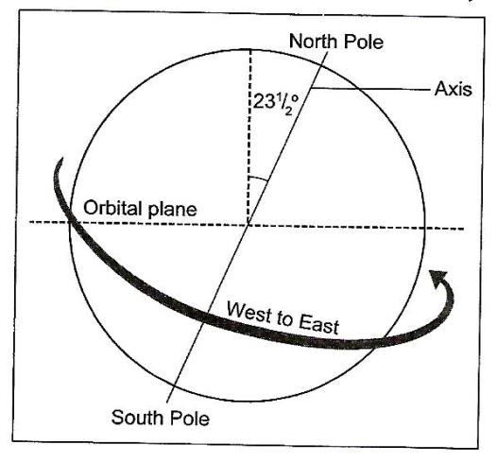

Effects of rotation of the Earth –kcse 2015
- It causes occurrence of day and night.
- It causes deflection of winds/ocean currents.
- It causes a difference of one hour between two longitudes 15° apart.
- It causes variation in atmospheric pressure on the earth’s surface.
- It causes the daily rise and fall of tides.
- It causes variation in the speed of air masses.

QUIZ: Explain how Rotation of the Earth causes the following:
- Variations in the speed of air masses.
  - The speed of earth’s rotation is faster at the equator due to longer diameter and slowest at the poles due to shorter distances.
  - Thus, the mass of air moving towards the equator crosses over latitudes whose speeds are increasing.

Occurrence of Day and Night
  - During rotation of the earth, one side/half of the earth faces the sun and experiences day time while the other side obscured/blinded from the sun experiences night.
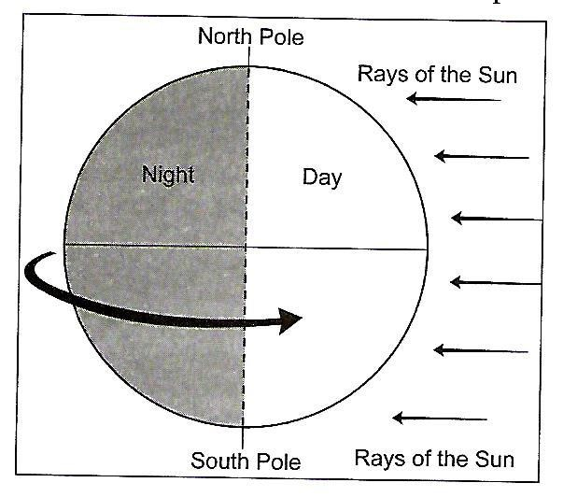

Time difference of one hour between meridians that are 15⁰ apart.
  - Earth rotation causes a difference in time between longitudes such that in every one degree covered eastwards or westwards during the earth’s rotation, a gain or loss of 4 minutes is experienced respectively.
  - Every 24 hours, the earth rotates through 360°. It therefore means that 1⁰ of rotation takes 4 minutes.
24hrs → 360⁰
1hr → 3600 = 15⁰
24
But 1hr = 60min → 1⁰ = 60 = 4min
15

Deflection of winds and ocean currents
  - Winds usually blow from high pressure areas to low pressure areas.
  - The force of rotation known as the Coriolis force deflects bodies moving along the surface of the earth to the right of their paths in the northern hemisphere and the left of their paths in the southern hemisphere.
  - Since ocean currents are driven by winds, they also deflect them accordingly to the right of their paths in the Northern Hemisphere and to left in the Southern Hemisphere.
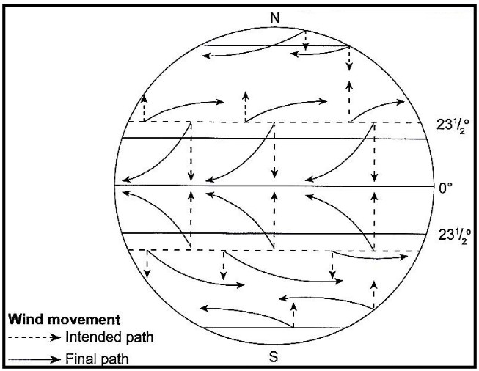

Rising and falling of ocean tides
  - Tides are the periodic rise and fall in the level of ocean water.
  - They are caused by the gravitational pull that is exerted on the earth’s surface by the moon and the sun.
  - Every time the earth rotates on its axis, it exposes some ocean basins to the moon and the sun. This causes high tides in those exposed areas.
  - Those ocean basins that face away from the moon and the sun therefore experience low tides.
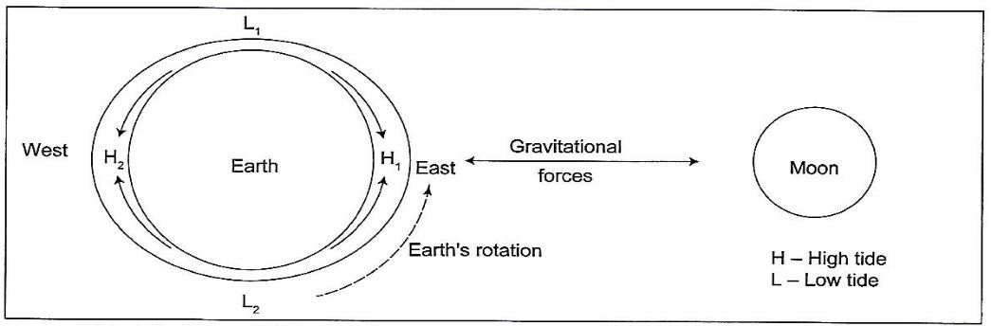

2. Revolution of the Earth.
- This is the movement of the earth around the sun on its own orbit.
- It takes 365 ¹ days (1 year) or 366days during a leap year - calendar year in which an
4
extra day is added at the end of February, giving a total of 366 days instead of the usual 365 days.
- It is in anticlockwise direction.
- The earth’s axis is tilted at an angle of 66 ½ ° to its orbital plane.

Effects of the Revolution of the Earth –kcse 2021
- It causes the four seasons.
- It causes varying length of day and night.
- It causes the change in the position of midday sun at different times of the year.
- It causes lunar eclipse.

QUIZ: Explain how revolution of the Earth causes the following:
- Changes in the position of midday sun at different times of the year.
  - The sun is vertically overhead at the equator at noon twice a year (this is called the equinox), that is, on 21st March and 23rd September. At these two periods, the sun reaches its highest altitude in the sky.
  - The sun is also overhead at the tropics at noon (solstice). On 21st June, the sun is vertically overhead at the Tropic of Cancer (23½° N). This is called the summer solstice. On 22nd December the sun is vertically overhead at the Tropic of Capricorn (23½°S) in the southern hemisphere. This is called the winter solstice.
  - Both the Tropic of Cancer in the north and the Tropic of Capricorn in the south are the farthest points reached by the overhead sun.
  - Equinox is the period of the year when the day and night hours are equal.
  - Solstice is the period of the year when the position of midday sun is far away from the earth.

Varying lengths of day and night at different times of the year.
- The axis of the Earth is inclined to the elliptical plane at an angle of 66.5°. It is this inclination that causes differences in the length of days and nights in the northern and southern hemisphere.
- When it is summer in the northern hemisphere, longer daylight is experienced than night-time. On 21st June, all areas in the northern hemisphere experience the longest day and shortest night.
- Similarly, during the southern summer, days become longer than nights, reaching a climax where areas south of the Antarctic Circle experience 24 hours of daylight.
- Areas along the equator experience 12 hours of daytime and 12 hours of night time. During equinoxes all regions of the earth experience a 12-hour day and a 12-hour night.

The four seasons.
- As the earth revolves around the sun, different parts of the earth experience changing weather patterns. These changes are more diverse/serious in places farther away from the equator. The equatorial areas experience minor changes since they are closer to the sun.
- High latitude areas experience four main seasons of summer, winter, spring and autumn.

- Summer and winter are the major seasons while spring and autumn are transitional seasons.
- Summer season is experienced when the sun is overhead at the tropic of cancer in the northern hemisphere, at the same time it is winter in the southern hemisphere.
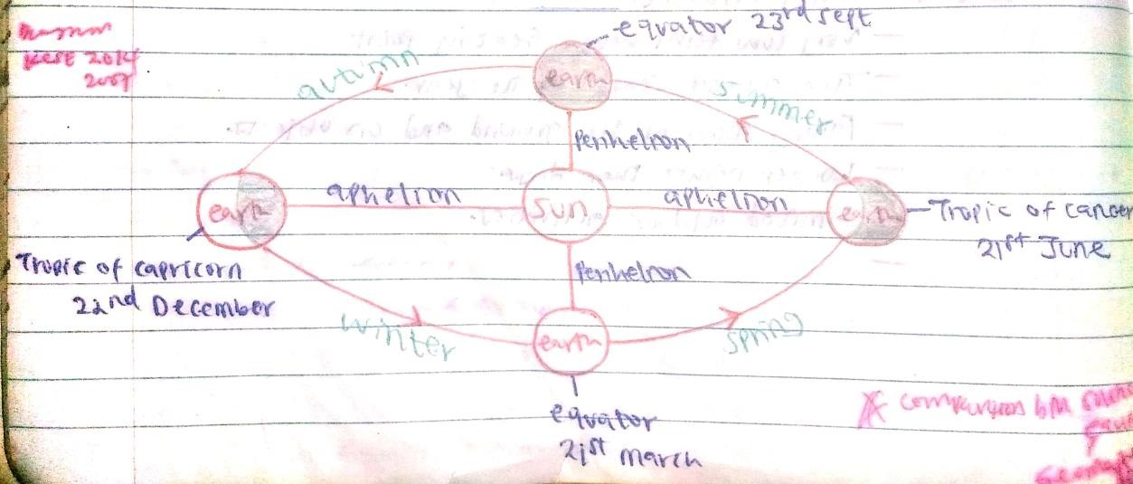
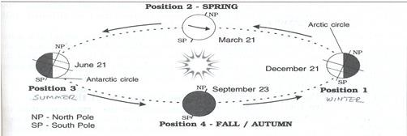

NOTE: The period of the year when the earth is far away (in June) from the sun is called aphelion while the period of the year when the earth is near (in September) the sun is called perihelion. The four main seasons are;

Spring
  - On 21st March the sun is vertically overhead at noon at the equator.
  - It is also called vernal/spring solstice.
  - Snow melts
  - Vegetation begins to blossom
  - Animal spring to life by coming out of hibernations
  - Farmers begin to till land.

Summer
  - On 21st June, the sun is vertically overhead at noon at the tropic of cancer. This time is called summer solstice.
  - A lot of sunshine.
  - Generally high temperatures
  - Plants growing luxuriantly
  - Human activities in high gear.

Autumn
  - On 23rd September, it is called autumnal equinox because the length of day and night is equal. The sun is vertically overhead at noon at the equator.
  - Temperatures begin to drop.
  - Air becomes cool and eventually chilly.
  - Hours of sunlight begin to reduce and nights become longer.
  - Some trees begin to shed their leaves.
  - The sky becomes hazy/not clear.
  - Snow begins to fall at the end of the season instead of rain.

Winter
  - On 22nd December, it is called winter solstice because it is winter in the northern hemisphere. The sun is vertically overhead at noon at the tropic of Capricorn.
  - Faint sunshine.
  - Very low temperatures below freezing point.
  - The coldest season of the year.
  - Falling snow on the ground and on objects.
  - Longer nights than days.
  - Limited outdoor activities.

Eclipse
- An eclipse is a shadow resulting when the rays of the sun are blocked from reaching the surface of the earth or moon.
- There are two types of eclipse:
- Lunar eclipse
- Solar eclipse

Lunar Eclipse/Eclipse of the moon.
- Lunar eclipse is the shadow formed when the rays of the sun are blocked by the earth from reaching the moon’s surface.
- Formed during the revolution of the earth around the sun.
- The earth lies in between the sun and the moon.
- Earth blocks sun’s rays from reaching the moon’s surface.
- The shadow of the earth is cast onto the moon forming lunar eclipse.
- The shadow has two parts namely umbra and penumbra.
- The umbra shadow causes total lunar eclipse.
- The penumbra causes partial lunar eclipse.
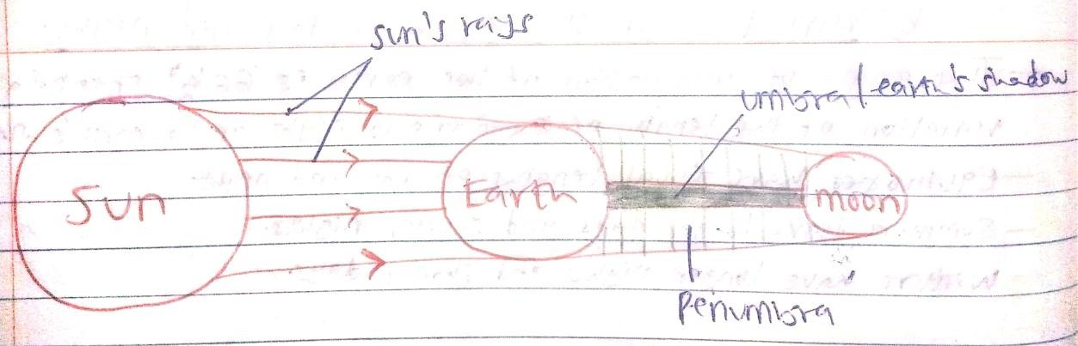

- Solar Eclipse –kcse 2014
- Solar eclipse is the shadow formed when the rays of the sun are blocked by the moon from reaching the earth’s surface.
- Formed during the revolution of the moon around the earth.
- The moon lies in between the sun and the earth.
- Moon blocks sun’s rays from reaching the earth’s surface.
- The shadow of the moon is cast onto the earth forming solar eclipse.
- The shadow has two parts namely umbra and penumbra.
- The umbra shadow causes total solar eclipse.
- The penumbra causes partial solar eclipse.
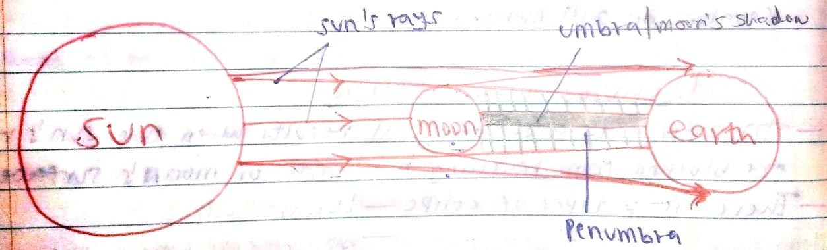

LATITUDES
  - Latitudes are imaginary lines drawn on the map running from west to east showing how far a place is north or south of the equator –kcse 2004
  - They run from west to east.
  - They increase from south to north in degrees.
  - They run across the earth and are parallel to each other.
  - The main latitude is called Equator (0⁰)
  - Equator divides the earth into two equal parts called hemispheres i.e. northern and southern hemispheres.
  - Latitude increase in degrees (0⁰ to 90⁰) either in north or south of the equator.
  - The most northern point is called North Pole while the southern point is called South Pole.
  - Latitudes are used to locate places on the earth’s surface.
  - Latitudes are used to find distances between places.
  - The linear distance of a latitude is 11km.

Other lines of latitudes are shown below;
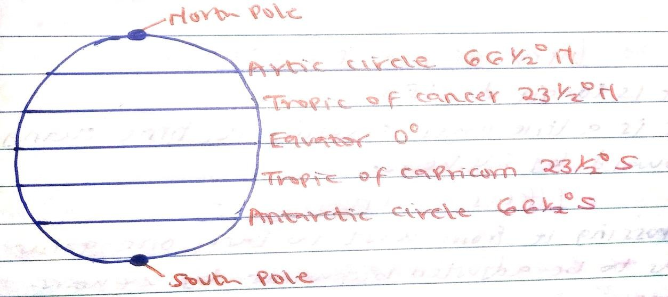

LONGITUDES
  - Also called lines of meridians.
  - Longitudes are imaginary lines on the earth surface running from north to south showing how far a place is east or west of the prime meridian –kcse 2009
  - They run from north to south.
  - They increase from west to east in degrees.
  - They are not parallel to each other but runs in an angular manner.
  - The main latitude is called Prime meridian/ Green which meridian (0⁰)
  - They increase up to 180⁰ east or west.
  - They help to locate places on map.
  - The linear distance of a longitude is 111.3km.
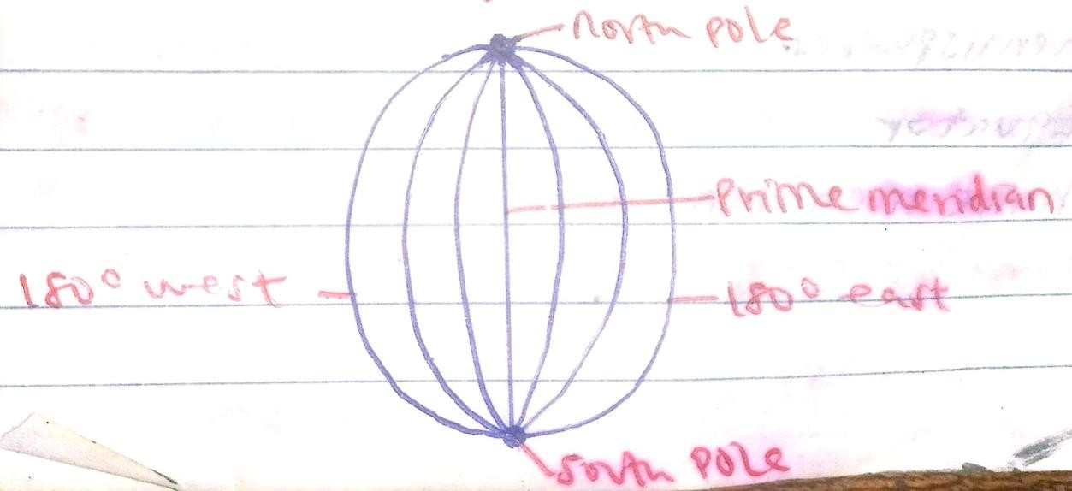

  - Prime meridian passes through towns like;
    - Green which (UK)
    - Accra (Ghana)

  - World time due to Green which meridian is called Green which mean time (GMT).

International Date Line
  - This line follows longitude 180⁰ except where it must cross a country or a group of islands (to avoid splitting a country into different time zones).
  - It is a line when crossing it, time changes backward or forward by 24 hours.

Effects of the International Date Lines
  - On crossing this line from the eastern side to the west, a day (24 hours) is lost. The clock has to be adjusted forward by 24 hours.
  - On crossing the line from the western side to the east a day (24 hours) is gained. The clock has to be adjusted backward by 24 hours.

Great circle
  - It is a line around the earth which forms a circle whose plane passes through the centre of the earth and divides the earth into two equal hemispheres.
  - Examples are equator and prime meridian.

Standard time and zones.
  - All countries in the same time zone record same time called standard time.
  - It is the common time shared by a region within 15⁰ of longitude.
  - The world has 24 time zones.

Local time
  - It is the specific time based on the longitude of a place.

Calculation of time.
- What is the local time at Kinshasa 15⁰E when local time at Malindi 40⁰E is 12:00 noon? –kcse 2021

Solution
Change in Longitude = 40⁰ − 15⁰ = 25⁰
Time difference; 1⁰ = 4min
25⁰ = 25 × 4 = 100 min = 1ℎ𝑟 40𝑚𝑖𝑛
Time at Kinshasa =12.00 noon – 1hr 40min = 10:20a.m.

The local time at Manau (60⁰ W) is 11:30am. What is the time in Nairobi (37⁰ E)?
–kcse 2014

Solution
Change in Longitude = 60⁰ + 37⁰ = 97⁰
Time difference; 1⁰ = 4min
97⁰ = 97 × 4 = 388min
= 6hrs 28min Time in Nairobi =11:30a.m + 6hrs 28min = 1758hrs
=5:58 p.m.

The local time at Green which meridian is 12:00 noon. What is the local time at point E which is 30⁰ W?

Solution
Change in Longitude = 30⁰ + 0⁰ = 30⁰
Time difference; 1⁰ = 4min
30⁰ = 30 × 4 = 120min
= 2hrs Time at point E = 12:00p.m - 2hrs= 10:00 a.m.

The local time of Jinja, Uganda is 2:00p.m at longitude 45⁰ E. What is the longitude of point K whose local time is 10:30a.m?

Solution
Change in Time = 2:00p.m – 10:30a.m
= 1400 – 1030 = 3 ½ hrs
= 210min
1⁰ = 4min
? = 210min
210 ÷ 4 = 52 ½ ⁰
Longitude of point K = 52 ½ ⁰ - 45⁰
= 7 ½ ⁰ W

NOTE:
- To the East, time is gained (add the difference time) while to the West the time is lost (subtract the difference in time)
- When both places are on the same side of the Prime Meridian, change in longitude is obtained by getting the difference between the longitudes, when on either side of the Greenwich meridian, the change in longitude is obtained by summing or adding up the individual longitudes.

Assignment.
- It is noon in Nairobi (37⁰ E). What would be the time at Australia (90⁰ E)? Ans= 3:32p.m

- What is the longitude of station P when it is 8:00a.m when in Nakuru at longitude 37⁰ E is noon?
Ans= 23⁰W

- Kakamega is on longitude 20⁰ E whose local time is 6:00a.m. What is the local time of Bangladesh at longitude 30⁰ W?
Ans= 2:40p.m

- If the local time at Port Victoria 120⁰ W is 3:00p.m. What is the local time in Norway 165⁰ W?
Ans= 12 noon

- What is the longitude of Place T whose local time is 8:00a.m when the local time at GWM is noon?
Ans= 60⁰W

- At Dar-es-salaam 40⁰ E time is noon, what is the time in Equador 70⁰ E?
Ans= 2:00p.m

THE STRUCTURE OF THE EARTH
- The Earth is divided into a series of layers namely: –kcse 2021
  - Atmosphere
External structure of the earth
  - Hydrosphere

  - Lithosphere/ crust
  - Asthenosphere/ mantle
  - Barysphere/ core

Internal structure of the earth

External Structure of the Earth.
  - This comprises of the atmosphere and the hydrosphere.
  - Atmosphere is a layer of gases and vapour which surrounds the earth and held by the gravitational force -kcse 2018
  - Hydrosphere is part of the earth’s surface covered by water masses e.g. rivers, lakes, seas, oceans and swamps –kcse 2017

Layers of the atmosphere.
    - Troposphere
    - Stratosphere
    - Mesosphere To be learnt under the topic “WEATHER”
    - Thermosphere

Internal Structure of the Earth.
  - This comprises of the crust, mantle and core.
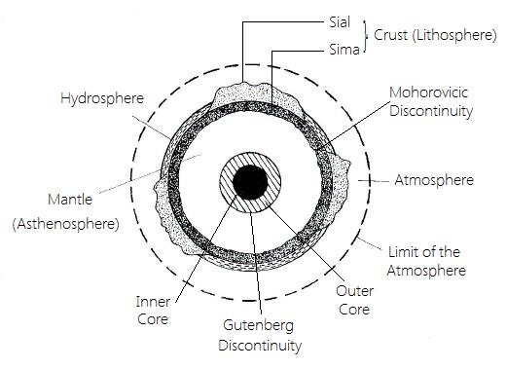

- The Crust/Lithosphere –kcse 2013
  - This is the outer most layer of the earth.
  - It is about 16-24km in thick.
  - It is made up of rocks and soils.
  - The dominant rocks are granites.
  - It is composed of a series of plates which are constantly in motion.
  - It is divided into sial and sima.

Sial/Continental crust.
      - It is the outer crust.
      - Dominant minerals are silica and Aluminium.
      - It has granitic rocks.
      - It is made up of light coloured rocks.
      - It is made up of lighter rocks/rocks has a density of 2.7g/cc
      - It has 90% of water vapour.
      - It is made up of rigid/brittle rocks.

    - Sima/Oceanic crust –kcse 2021
      - It is the inner crust.
      - The most common minerals are silica, iron and magnesium.
      - It has rocks which are mainly basaltic.
      - The average density is between 2.8-3.0 g/cc
      - It is 6-10 km thick.
      - It forms the bulk of the oceanic floor.
      - It underlies the continental crust.
      - Rocks are plastic like/flexible.
      - Temperature is about 400°c

NOTE: There is a zone of discontinuity between the crust and the mantle called the
Mohorovicic (Moho) discontinuity –kcse 2021

- The Mantle/Asthenosphere –kcse 2014
  - This lies between the core and the crust.
  - It is about 2900km thick.
  - It is made up of silicate rocks.
  - It has minerals like silica, iron and magnesium.
  - It has an average density of 3.0 – 3.3g/cm³
  - Temperature ranges between 1000⁰C and 3000⁰C
  - Its average density is between 3.0-3.3 g/cc
  - The dominant mineral is olivine/ferromagnesian silicate.
  - It is divided into two parts namely upper mantle and lower mantle.

Upper mantle
    - It is made up of hard rigid rocks.
    - It is semi-solid state.
    - It has lower temperature of about 1000°c
✓

Lower mantle
    - It is made up of semi-molten rocks.
    - It is liquid/viscous fluid.
    - It has higher temperature of about 3000°c
✓

NOTE: There is a zone of discontinuity between the mantle and the core called the
Gutenberg discontinuity –kcse 2021

- The Core/Barysphere/Centrosphere –kcse 2002
  - It is the innermost/central layer of the earth.
  - It has a radius of about 3475km.
  - It consists of rocks rich in iron and nickel –kcse 2022
  - It has high pressure.
  - It has very high temperatures of about 5500°c
  - It is divided into two layers namely outer core and inner core.

- Outer core –kcse 2012
    - It is about 2100-2890km thick.
    - Composed of molten rock material.
    - Made up of iron and nickel.
    - Has temperature ranging from 3700-5000°c
    - Has average density of 10.0g/cc-12.3g/cc
✓

- Inner core –kcse 2021
      - It has radius of about 1278km.
      - It is solid in nature.
      - It is made up of iron and nickel.
      - It has very high density/density of 17.0g/cc
      - It has very high temperature/temperature range is 5000-6000°c
✓

Reasons why the interior of the earth is very hot –kcse 2021
- After materials broke away from the sun, the planet earth started cooling. The interior of the earth cooled at a lower rate.
- The weight of the overlying materials exert great pressure that generates a lot of heat making the interior hot.
- Radioactivity/Nuclear fission in the interior of the earth releases a lot of heat which is retained.

Evidences showing that interior of earth is hot.
  - Ejection of hot water/spring.
  - Ejection of hot magma.
  - High temperature/heat experienced during deep underground mining.
  - Most of the intrusive volcanic rocks are in molten state.

Sources of information on the internal structure of the earth.
- Observations of topography and bathymetry (measurement of the depth of lakes, seas and oceans).
- Observations of rock outcrop samples brought to the surface from greater depths by volcanic activity.
- Analysis of the seismic waves that pass through the Earth.
- Measurements of the gravity field of the Earth.
- Experiments with crystalline solids at pressures and temperatures characteristic of the Earth's deep interior.

“END OF TOPIC TWO”

TOPIC THREE: WEATHER
Definition (kcse 2023) - Weather is the state/ condition of atmosphere of a given place at a given time/ over a short period of time.
Elements of weather –kcse 2017
  - Temperature
  - Humidity
  - Rainfall
  - Air pressure
  - Wind
  - Sunshine
  - Cloud cover

TEMPERATURE
- This is the degree of sensable heat within the atmosphere.
- It is the degree of hotness or coldness of a place.
- It is measured by an instrument known as Thermometer in degree Celsius (˚c).
- Lines drawn on a map joining places with the same temperatures are called Isotherms.

Factors influencing the amount of solar radiation reaching the earth’s surface.
- The intensity of the sun’s radiation in the space and the earth’s average distance from the sun.
- The transparency of the atmosphere i.e. transmission, absorption, scattering and reflection of the sun’s rays by particles found in the atmosphere.
- The position of the earth on its orbit which produces different seasons. This causes insolation to vary with the time of the day and period of the year.
- The inclination or angle of the earth’s surface on which the sun’s rays fall.
- The area and nature of the surface on which the rays fall.

Processes through which the Earth is heated.
  - Radiation
  - Conduction
  - Convection

Radiation.
  - This refers to the transfer of energy via electromagnetic waves.
  - Radiation travels in waves that are very small and are transmitted from one place to another without the help of a medium (travel in a vacuum).
  - The earth emits heat by long-wave radiation called terrestrial radiation.

Difference between solar radiation and terrestrial radiation
- Solar radiation is short wave while terrestrial radiation is long wave.
- Solar radiation is partially visible as sunlight while terrestrial radiation is invisible.
- Solar radiation takes place only daytime while terrestrial radiation occurs all the time.

Conduction
  - It is the transfer of heat through matter, without moving it (matter). It is the transfer of heat energy through motion, from one molecule to another.
  - Air in the atmosphere is heated by direct contact with the earth’s surface.

Convection
  - This is the transfer of heat through mass movement of a substance. The "substance" could be air or water.
  - It takes place when air is heated by the earth, becomes less dense, and then rises to higher levels transferring heat with it.

Factors influencing temperature on the Earth.
- Latitude
  - Temperature decreases with increasing latitude. Highest temperatures are generally at the equator and the lowest at the poles.
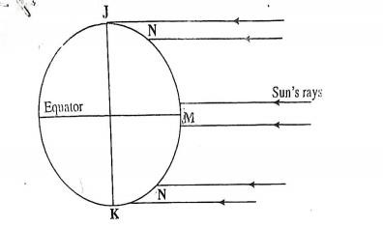

K.C.S.E. 2011- Give reasons why the intensity of the insolation is higher at M (Equator) than at N (poles).
- There is a higher concentration of heating at M than at N because the surface area at M is smaller than at N.

- The angle of the sun’s rays at M is higher than at N hence the variation in intensity.
- At N the sun’s rays travel over a long distance than at M thus losing the heat resulting to low intensity.

Altitude or Height above Sea Level
  - Temperature decreases with an increase in altitude. This is known as normal lapse rate.
  - Low altitude areas have high temperatures because air is heated from below by the earth’s surface (terrestrial radiation).
  - High altitude areas have low temperatures because particles like gases, dust, smoke and water vapour store heat and lose it rapidly to the outer space.

Length of the day
  - The longer the period of solar insolation, the greater the quantity of radiation received at a given place on the earth surface and the higher the temperature.

Winds
  - Various types of wind affect temperature. Winds are a medium of transfer of heat from one place to another.
  - Winds carrying warm air bring a warming effect to a place.

Ocean currents
  - Ocean currents may be warm or cold. When the winds blow over them, they get their warmth or cold and affect the temperatures of coastal areas.
  - For example, the warm North Atlantic Drift raises the winter temperature of North- West Europe.

Aspect
  - It is the direction in which a slope faces in relation to the incoming solar radiation.
  - South facing slopes in northern hemisphere face the sun thus receive more sunshine which raises the temperature than the north facing slopes.

Cloud cover.
  - The presence of clouds in the sky prevents the amount of solar radiation coming to the earth’s surface. It also prevents the ground radiation, leaving the earth’s surface.
  - Because of this, the places where clouds are less, experience a high day temperature and a much lower night temperature.
  - In the equatorial areas, because of the abundance of cloud cover, day temperatures are not so high and night temperatures not so low.

Distance from the sea.
- Areas nearer the sea/ocean experience sea breezes during the day which lowers the temperatures of the surrounding areas.
- At night, the land breeze raises the temperatures of areas surrounding sea/ocean.
- Formation of heavy convectional rainfall in areas nearer the sea/ocean also regulates temperatures of such areas.

Measurement of Temperature
- The temperature of the atmosphere is measured using an instrument called a thermometer.
- Types of thermometers used are;
- Maximum thermometer
- Minimum thermometer
- Six’s thermometer (combined maximum and minimum thermometer)

Maximum thermometer
  - This thermometer uses mercury to record the highest temperature reached in a day.
  - When the temperature rises, the mercury expands and pushes the metal index forward.
  - When the temperature falls, the mercury contracts leaving the index behind.
  - The maximum temperature reached in the previous 24hours is shown by the metal index that was in contact with the mercury last.
  - After taking the readings, the thermometer is reset by bringing the metallic index into contact with mercury using a magnet.
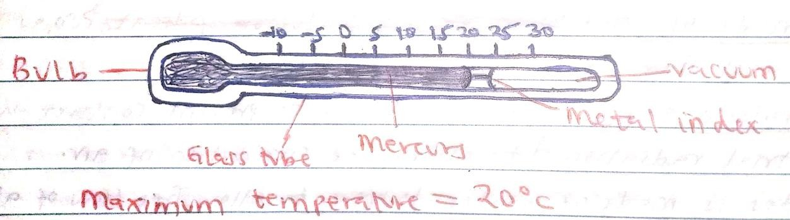

Minimum thermometer
  - It records the lowest reached in a day using alcohol.
  - When the temperature falls, the alcohol contracts and its meniscus pulls the index towards the bulb.
  - When the temperature rises, the alcohol expands leaving behind the index.
  - The minimum temperature in the previous 24 hours is obtained by reading the scale at the end of the index nearest to the meniscus.

  - To reset the thermometer; raise the bulb of the thermometer gently.
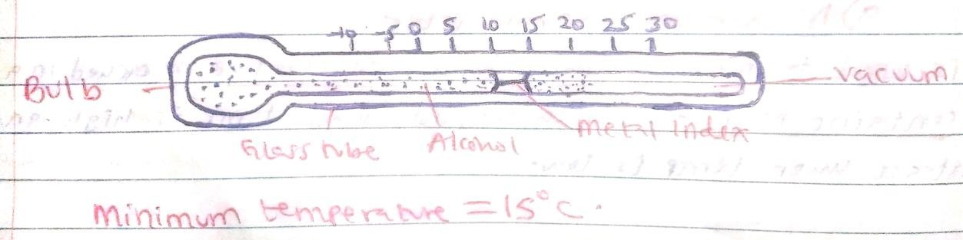

Six’s Thermometer
  - Six's thermometer record the maximum and minimum temperatures reached over a period of time, for example 24 hours.
  - When temperature rises, alcohol in the left hand column expands, pushing the mercury below downwards and up the right hand column.
  - The mercury in turn pushes the metal index in the right hand column.
  - The maximum temperature reached in the last 24 hours is shown by the end of the index that was last in contact with the mercury in the right hand column.
  - When the temperature falls, alcohol in the left hand column contracts and pulls the index along the tube.
  - When the temperature increases, the alcohol expands leaving behind the index.
  - The minimum temperature in the last 24 hours is shown by the end of the index near the alcohol meniscus.
  - The thermometer is reset using a magnet after readings have been recorded.
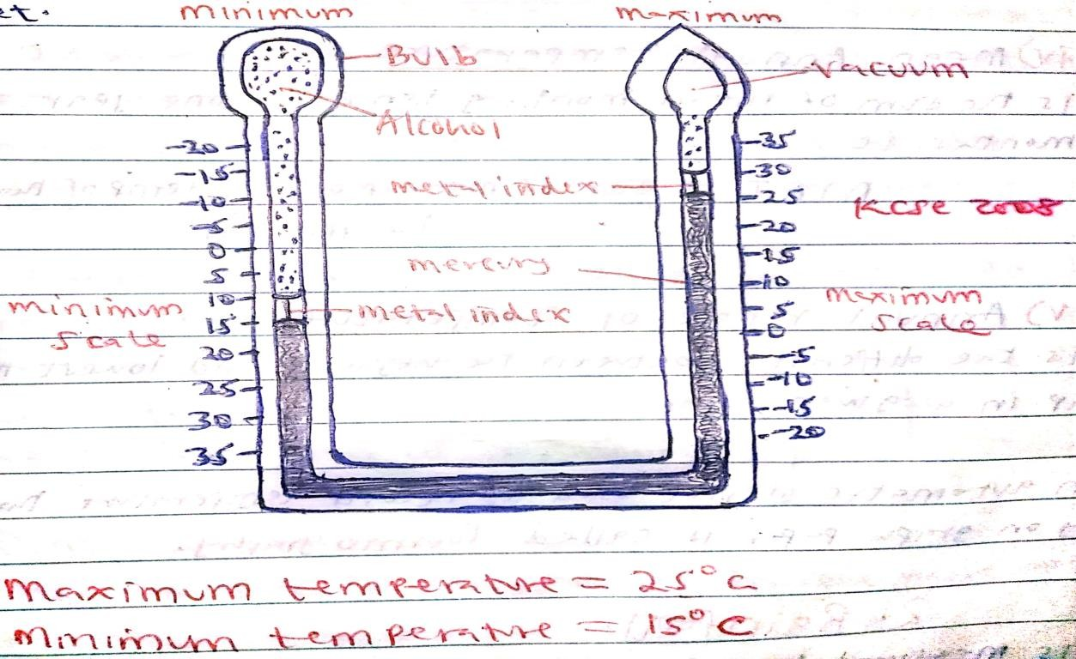

The readings of the maximum and minimum temperatures are used in the following calculations;
- Daily/Diurnal temperature range
  - This is the difference between the maximum and minimum temperatures recorded in a day (24hrs)

Mean diurnal temperatures (Diurnal means daily).
  - This is the average temperature reached in a day.
  - It is obtained by adding the maximum and minimum daily temperatures then dividing the sum by 2.

Mean monthly temperature
  - The average temperature of the month is obtained by adding all the daily means in a month and dividing by the number of days in that month.
- Mean annual temperature –kcse 2011
  - This is the average temperature for the year. It is obtained by adding all the monthly means and dividing by 12 (the number of months in a year).
- Annual range of temperature –kcse 2022
  - This is the difference between the highest and the lowest mean monthly temperatures in a given year.

PRECIPITATION
- Precipitation is a general term referring to the various forms of moisture which fall from the atmosphere to the earth’s surface.
- It is formed when water vapour in the atmosphere condenses below the dew point.

Hygroscopic particles/Condensation nuclei
- They are particles in the atmosphere which absorb water and act as nuclei around which water vapour can condense.
- They include dust particles, salt, smoke particles, pollen grains and negative ions.

Major forms of precipitation –kcse 2021
  - Dew
  - Frost/ hoar frost
  - Snow
  - Mist/ Fog
  - Rain
  - Sleet
  - Hail
  - Rime

Dew
- Dew is the water droplets formed on the ground, or on objects near the ground due to condensation of water vapour.
- The dew point is the temperature at which the water vapour in the air becomes saturated and condenses on any available surface to form tiny droplets of dew.
Conditions for the formation of Dew –kcse 2021
- The air on the ground should be calm so that it can remain in contact with the ground long enough to be cooled below its dew point.
- Daytime temperature should be warm to accelerate evaporation providing a lot of water vapour in the air.
- The sky should be cloudless at night to accelerate the rate at which the earth loses the heat gained during the day.

Hail
- They are spherical lumps of ice droplets that falls on the ground as hailstones.

Frost
- These are tiny ice crystals deposited on objects on the ground.

Snow
- They are numerous tiny ice crystals that falls on the ground.

Sleet
- This is a mixture of rain and snow or partially melted snow that falls on the surface of the earth.

Rime
- They are tiny ice crystals formed when super-cooled tiny water droplets are blown by wind and deposited on objects whose temperature is below freezing point (0˚c).

Fog and mist
- Fog and mist are masses of tiny water droplets suspended in the lower atmosphere.
- They are formed when air is cooled below the dew point but the resultant water droplets remain suspended in the atmosphere.
- The term fog is used when visibility reduces to less than 1km and the relative humidity exceeds 95% whereas mist is used when visibility/obscurity exceeds 1km.

Factors/Conditions for formation of fog and mist –kcse 2001
  - Long nights during the colder months in areas experiencing the winter season.
  - The wind must be light/calm to hold water droplets in suspension.
  - There must be clear sky/absence of clouds to permit free terrestrial radiation.
  - There must be sufficient moisture in the air.
  - A low level temperature inversion.
  - Sufficient supply of condensation nuclei.
NOTE: The mixture of smoke and fog is called smog. It is common in industrial and port areas.

Types of fog
- Radiation or ground fog – forms when air in contact with the ground is cooled by terrestrial radiation at night.
- Advection fog/Sea fog-forms when warm and moist air passes over a cooler land or water surface.
- Hill fog – forms as a low sheet cloud in the hills as result of moist air stream advancing inland from the sea.
- Frontal fog – forms when warm moist air is cooled from below as it rises over the cold air.
- Steam fog – forms when cold air passes over warm water surfaces which then appears to be steaming.
- Ice fog- forms when water vapour is converted directly into ice crystals when temperatures are below freezing point. It is common over the Arctic Ocean.

vii) Rainfall
- They are water droplets that develop from the clouds in the atmosphere that falls on the earth surface.
- Formed as a result of condensation process.
- Lines drawn on a map joining areas receiving the same amount of rainfall are called isohyets.

How condensation takes place/Cloud formation.
- Moist air rises to the condensation level (altitude where temperature is below dew point).
- It is cooled below dew point.
- Tiny water droplets condense around condensation nuclei.
- The droplets merge and eventually become bigger forming clouds which later break down and fall as rain on the earth surface.

Factors influencing rainfall types and amounts.
- Relief– hills/mountains results in the rising and cooling of moist winds to form relief/orographic rainfall.
- Air masses- when warm and cold air masses meet frontal/cyclonic rainfall is formed.
- Forests – areas near thick vegetation such as tropical rainforests experience more convectional rainfall due high evapotranspiration rates.
- Water bodies – regions near large water bodies such as lakes, oceans and seas also experience high evaporation rates hence have high convectional rainfall amounts.
- Aspect-windward slopes which are on the path of rain bearing winds receive heavier relief rainfall than leeward slopes which face away.
- Air pressure- high pressure areas receive low rainfall than low pressure areas due to pushing of air masses from high pressure to low pressure.
- Ocean currents- coasts washed by warm ocean currents experience heavy rainfall when moist onshore winds are warmed by the current and made to hold onto moisture which they release on reaching the land.

Ways in which rainfall is formed.
  - When winds blow over a mountainous region- Relief rainfall
  - When hot air rises by convectional currents- Convectional rainfall
  - When warm air rises over cold air- Frontal rainfall

TYPES OF RAINFALL
    - Relief/Orographic rainfall
    - Convectional rainfall
    - Cyclonic/Frontal rainfall

Relief or Orographic rainfall
- Rain experienced on the windward slopes of mountains/hills formed when moist air is forced to rise over a mountain/a hill.
How it forms –kcse 2000
- A waterbody/sea/lake is heated causing evaporation of water.
- Moist warm air from the sea is forced to rise over a hill/mountain barrier.
- Temperature and air pressure decreases making the rising moist air to expand.
- The rising moist warm air cools, get saturated and condensed to form clouds.
- The clouds drop water droplets in form of rain on the windward side of the hill/mountain forming relief rainfall.
- On crossing the leeward side of the mountain, the wind is dry thus absorbs any moisture available as it descends leaving the area dry.

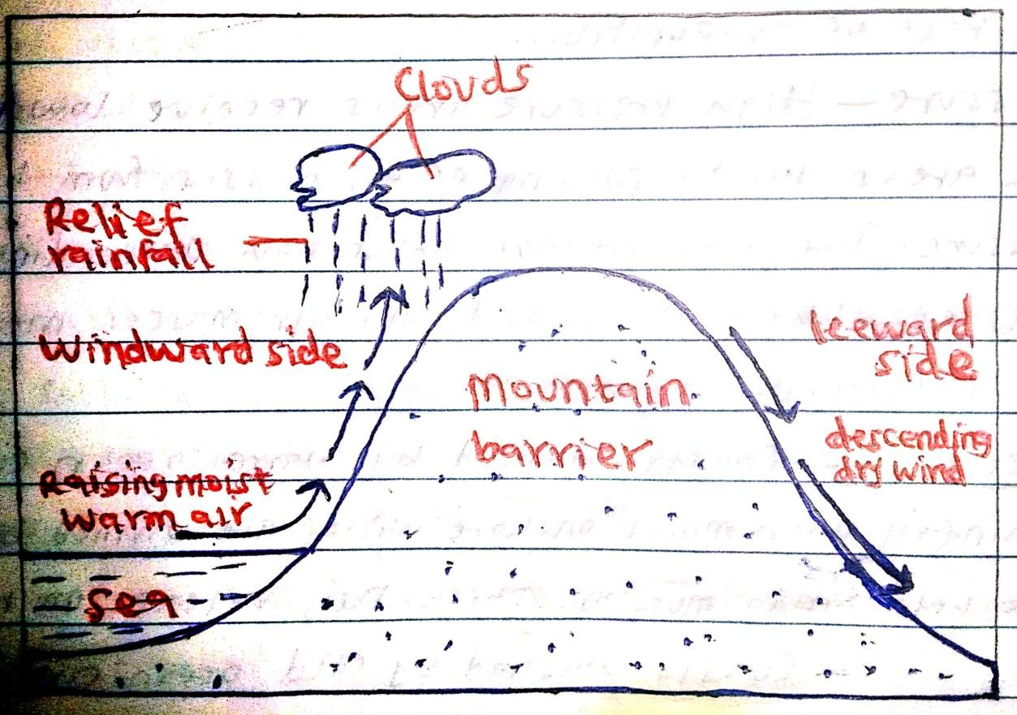

Characteristics of Relief/orographic rainfall
  - Experienced in highlands areas like Mt. Kenya and Elgon.
  - Occurs when moist warm air ascends a highland, cools, condense forming clouds that releases rainfall.
  - Received on windward side of the mountain while leeward side remains dry.
  - Occurs in light showers which last for several hours.
  - May be accompanied by thunder and lightning.

Convectional Rainfall
- Common in lowlands near large waterbodies and forests as a result of convective rising and cooling of moist air.
How it forms –kcse 2003
- Ground/waterbody is intensely heated by solar radiation.
- Moist warm air rises to the atmosphere in form of convectional currents.
- The rising moist warm air expands, cools and condenses to form cumulo-nimbus clouds in the atmosphere.
- The clouds releases water droplets on the earth surface as convectional rainfall.

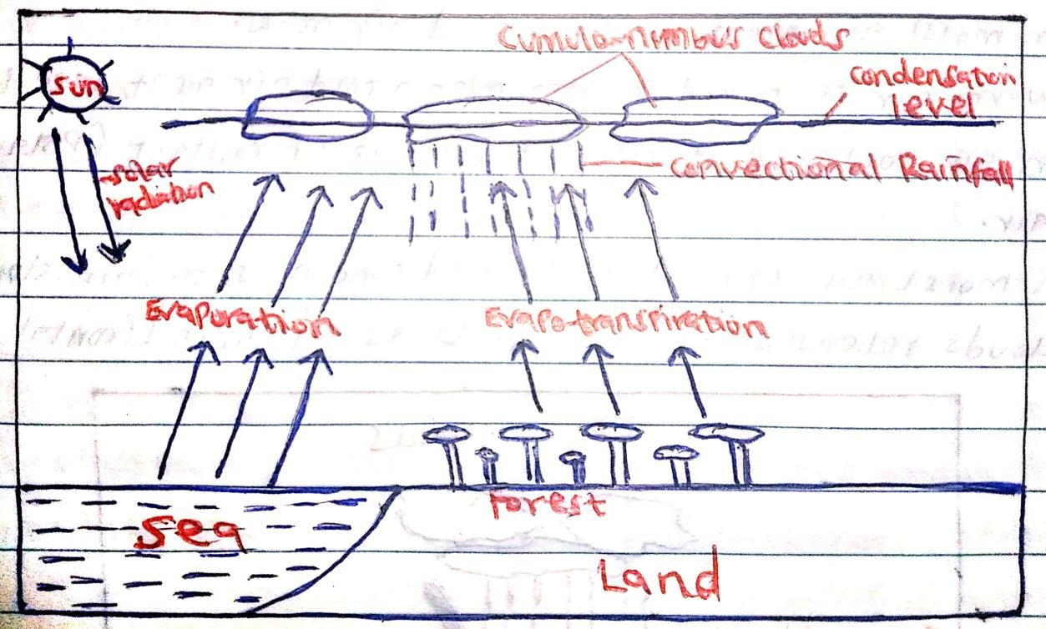

Characteristics of convectional rainfall
- It occurs in the lowland areas near large waterbodies e.g. Lake Victoria and the Indian Ocean.
- It mainly falls in the late afternoons.
- It is associated with cumulo-nimbus clouds i.e. dark dense clouds.
- It is usually accompanied by thunder and lightening
- It falls in large drops i.e. torrential
- It falls for a short time between 15 – 30 minutes
- It may be accompanied by hailstones sometimes
- It may result in floods in lowland areas.

Problems associated with convectional rainfall –kcse 2003
  - The torrential rains cause floods which displace people.
  - The hailstones destroy crops.
  - The strong winds blow off roofs of houses.
  - The strong winds uproot trees.
  - Lightning strikes causes deaths of people and animals and drying of trees.

Cyclonic rain/Frontal rain.
- Common in the mid-latitudes, where moist warm wind from the tropics and cold dry winds from the Polar Regions may converge.

How it forms.
- Moist warm wind from the tropics and cold dry winds from the Polar Regions converge at the frontal zone.
- The cold polar winds being heavier will sink below the warm lighter tropical winds.
- The Moisture in the tropical warm winds will condense to form clouds.
- The clouds releases water droplets as cyclonic or frontal rain.
- The point where the two air masses meet is called a frontal zone.
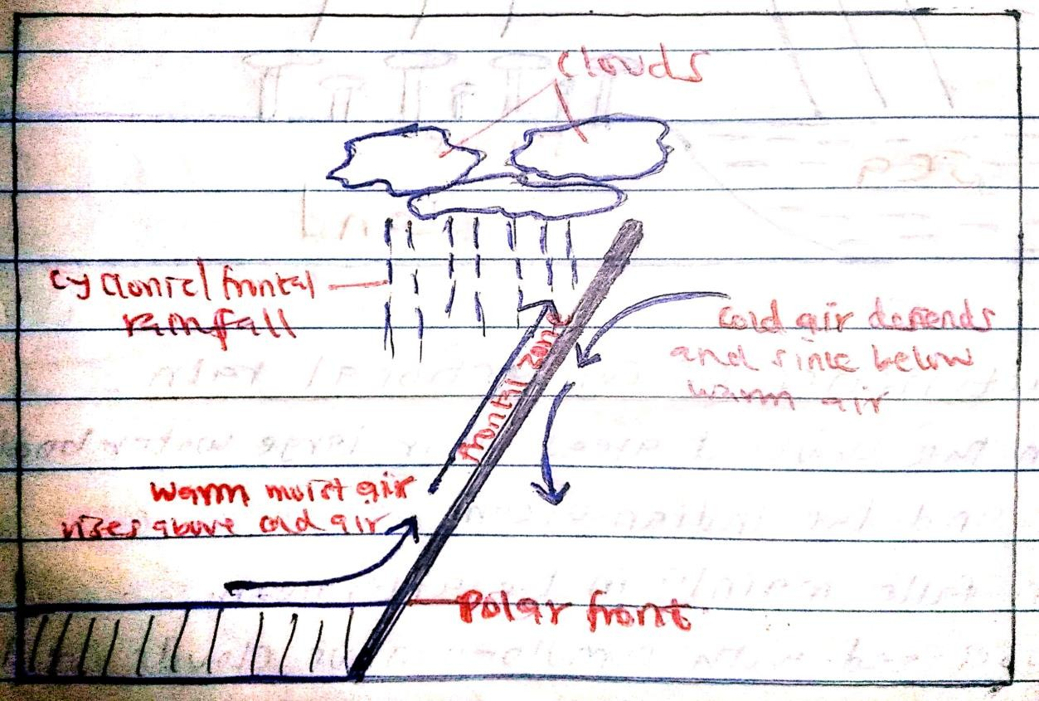

Characteristics of cyclonic/frontal rainfall
- Occurs when two air masses of different characteristics meet at frontal zone.
- It is associated with cumulo-nimbus clouds.
- The rain falls for a short time.
- It is accompanied by cyclones (violent winds).
- It is usually heavy.
- It is usually accompanied by thunder and lightning.

Measurement of rainfall
- Rain gauge is the instrument used to measure the amount of rainfall over a set period of time.
- Rain gauges comprises of a metallic cylindrical container with a collecting jar fitted with a funnel together with a calibrated/graduated measuring cylinder.

Location of a rain gauge
- An open space away from trees, buildings or any other object that can direct water into it.
- The collecting jar should be maintained at a height of 30cm above the ground to avoid water splashing into the funnel.
- The outer case should be sunk into the ground to prevent evaporation of the rainwater collected in the jar.
How Rain gauge works –kcse 2015
- The rain gauge is placed in an open area away from tall trees and buildings.
- It is sunk into the ground and funnel top is left 30cm above the ground.
- When it rains, water from direct rain drops collect into the jar through the funnel.
- After 24 hours, collecting jar with rain water is removed.
- The collected rain water is poured into a measuring cylinder.
- The readings are taken and recorded.
- The water is emptied and the instrument is placed outside to collect more water for measuring the following day.
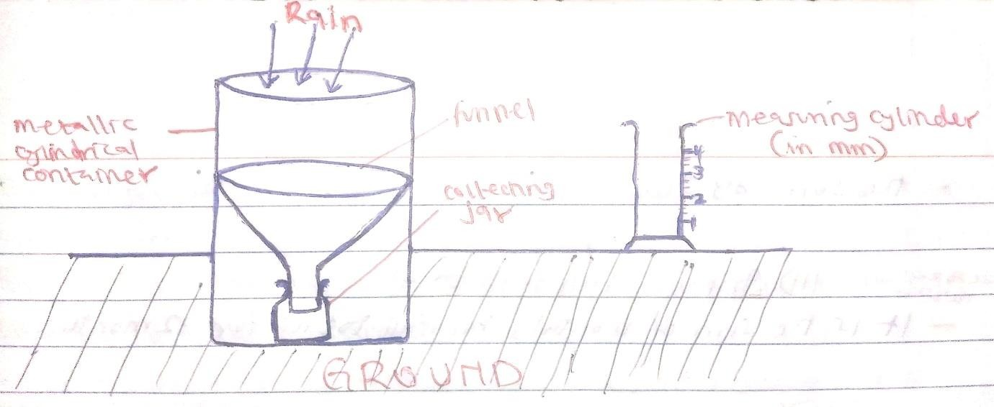
-From the rain data collected, the following calculations are made;
- Monthly rainfall totals – the sum of the rainfall recorded during the month.
- Total annual rainfall – the sum of the rainfall received in the year –kcse 2022

- Mean monthly rainfall – the sum of the monthly rainfall for a particular month observed over several years e.g. 20 or 30 years and divided by the number of observation years.
- Mean annual rainfall - The sum of the mean monthly rainfall for 12 months of the year.
NOTE: Rainfall mean is not calculated in the same way as temperature. It is not the exact arithmetic average. Rainfall is not naturally distributed evenly in all the months of the year.

CLOUD COVER
- A cloud is a mass of tiny visible particles of water or ice, formed by condensation and suspended in the atmosphere.
- Lines drawn on the map showing places having the same amount of cloud cover are called isonephs.

Factors that are considered when classifying clouds –kcse 2008
  - Their height in the atmosphere i.e. high, medium or low clouds.
  - Their colour i.e. white, grey or dark clouds.
  - Their shape/appearance i.e. feathery, heaped or layered clouds.
  - Weather conditions associated with the clouds i.e. those releasing convectional rainfall, those accompanied with lightning and thunderstorms.
  - Their formation.

Types/Classification of clouds
- High level Clouds
- Are 6000-12000m high.
- Contain ice particles and snow.
- White in colour.
Examples of high level clouds –kcse 2010
  - Cirrus
  - Cirro-stratus
  - Cirro-cumulas

Cirrus clouds
- Appear high in the sky.
- Appear in bands/patches in the sky.
- Milky-white clouds.
- Contain tiny ice crystals.
- Are fibrous/wispy resembling feathers.

Cirro – stratus clouds.
- Appear high in the sky.
- Form thin sheets in the sky.
- Covers the whole sky.
- Have a milky appearance.
- Give rise to haloes when the sun or moon shines through them.
- Cause stormy weather.

Cirro – cumulus clouds.
- Appear high in the sky.
- White in colour.
- Made up of ice crystals.
- Have a thin base.
- May be globular in appearance or arranged in ripples.

Medium level clouds
- Appears between 2100-6000m high.
- Grey in colour.
- They are layered.

Examples of medium level clouds
  - Alto-cumulus clouds
  - Alto-stratus clouds

Alto-cumulus clouds
- Appear medium in the sky.
- Form flattened globular masses.
- Arranged in lines/waves.
- Vary considerably in thickness and shape.

Alto-stratus clouds
- Appear medium in the sky.
- Uniform in layers.
- Contain water droplets.
- Are transparent.
- Forms sheet of grey-white colour.

Low level clouds
- Appears below 2100m
- Are thick grey.
- Contain water droplets.
- Are layered.

Examples of low level clouds
  - Stratus
  - Strato-cumulus
  - Nimbo-stratus

Stratus clouds
- Appear low in the sky.
- Grey in colour.
- Resembles fog.
- Has a low base.
- Are in uniform layer.
- Sheet-like causing dull weather and drizzoles.

Strato-cumulus clouds.
- Appear low in the sky.
- Grey or grey-white in colour.
- Are big but vary greatly in size and shape.
- Are loose in structure.
- Are large globular masses arranged in groups/lines.

Nimbo-stratus clouds.
- Appear low in the sky.
- A rain cloud.
- Shapeless
- Dark-grey and dense.
- Spreads all over the sky in low uniform layers.

Great vertical extent level clouds.
- White globular mass.
- Black and white.
- Resembles a cauli flower shape.
- Appears between 1500-9000m

Examples of Great vertical extent level clouds
  - Cumulus
  - Cumulonimbus

Cumulus clouds
- Has a thick vertical development.
- Are large white globular masses.
- Resemble cauli flower.
- Has flat horizontal base and dome shaped tops.
- Do not last for a long time in the atmosphere.
- Convection cloud/rain- bearing cloud.

Cumulonimbus clouds
- Dark at the base and sometimes white at the sides.
- Has great vertical development.
- Towers like mountains.
- Big and dense.
- Form a wedge-shaped pattern in the sky.

Conditions associated with cumulonimbus clouds –kcse 2001
  - Releases convectional rainfall
  - Heavy rainfall
  - Thunder and lightning
  - Hailstones
  - Strong winds(cyclones)

Examples of rain bearing clouds –kcse 2006
    - Nimbo-stratus
    - Stratus
    - Cumulus
    - Cumulonimbus

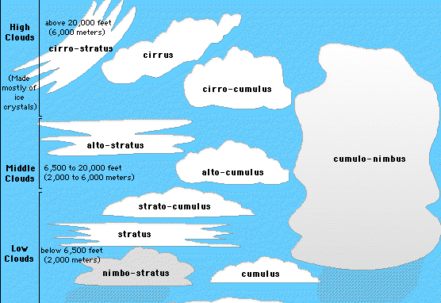

Measurement of cloud cover
- This is estimated by determining what fraction or percentage of the sky is covered by the clouds.
- The remote sensing method is more accurate in this measurement.
- A computerized camera on a spaceship revolving around the earth’s atmosphere is able to measure the amount of cloud cover around the earth.
- The amount of cloud cover is given in oktas i.e. 1 okta= 1/8 of sky covered with clouds.

ATMOSPHERIC PRESSURE
- Atmospheric pressure is the force exerted by a column of air on the earth’s surface.
- It is measured by an instrument called Barometer in mmHg.
- Lines drawn on a map joining places with same/equal atmospheric pressure are called

isobars.
Factors influencing atmospheric pressure

Altitude (or height above sea level).
  - Atmospheric pressure decreases with the increase in altitude. This is because the air column becomes smaller or shorter at higher altitudes thus exerting little weight.

Temperature.
  - When atmospheric air is heated it expands and the air density reduces lowering the amount of pressure exerted by the air i.e. warm air is less dense than cold air and exerts less pressure.

Rotation of Earth.
  - Variations in the speed of rotation once in 24hours of regions on the earth’s surface leads to differential expansion of air between the equator and polar regions.
  - At the equator there is more expansion space for air due to the high speed of rotation.
  - Air blowing from the poles towards the equator crosses latitudes that are getting longer. It therefore spreads out to occupy more space making its pressure to decrease.

World Distribution of Pressure zones.
- The Equatorial Low-Pressure zones.
  - It is a belt of low pressure around the equator common in both hemispheres.
  - It is found between 23 ½ ˚N and 23 ½ ˚S.
  - It is a zone of light and intermediate winds called doldrums or equatorial trough.
  - It is characterized by high temperature and high humidity.
  - Doldrum is a region where air at sea level is calm.
  - Polar front is a convergence zone where air from low pressure belt and high-pressure belt meet.
  - The trade winds converge at the equator hence forming I.T.C.Z
  - I.T.C.Z is a broad belt (trough) with low atmospheric pressure which moves with the movement of sun.

Characteristics of Inter-Tropical Convergence zone (I.T.C.Z) –kcse 2019
- It is found within 23 ½ ˚North and 23 ½ ˚South of the Equator/within the tropics.
- It experiences high temperature.
- It has low pressure/doldrums.
- It is a zone where South East and North East trade winds converge.
- The zone migrates North or South of the equator with the apparent movement of the overhead sun.
- It is associated with convectional rainfall.
- It receives high rainfall.
- It is associated with high humidity.

The sub-tropical high-pressure belt.
  - It is found in regions of latitudes 30⁰ North and South of the equator.
  - It is a region of calm and descending air.
  - It is the source of trade winds and the westerlies.
  - It is a zone of high pressure.
  - Zone of divergence of trade winds and westerlies.

The temperate low-pressure zone.
  - It is also known as the sub-polar low-pressure belt.
  - It is the meeting point of the westerlies and the polar easterlies.
  - It exists in regions 60°N and 60°S of the equator.
  - The low pressure is due to the earth’s rotation.

The polar high-pressure belt.
  - It exists over both the north and south poles.
  - Found over the poles 90°N and 90°S
  - A high pressure zone.
  - It is characterized by currents of descending calm air of low temperatures.
  - It is the source of polar easterlies
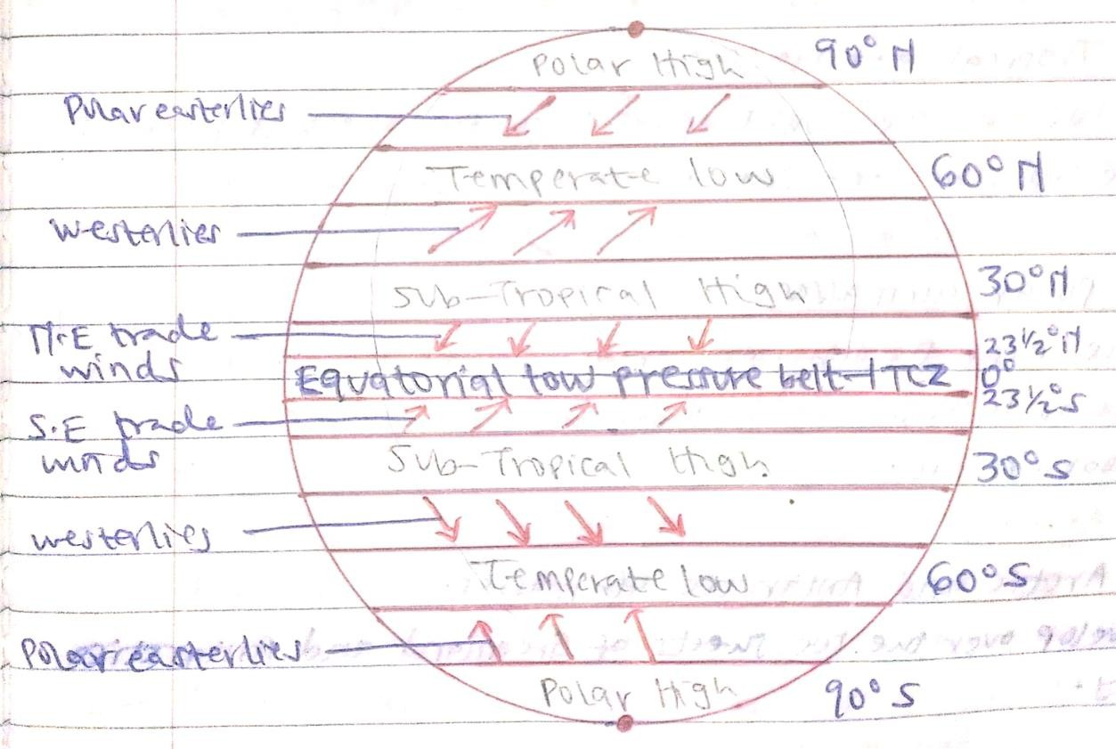

Measuring Atmospheric Pressure.
- Atmospheric pressure can be measured with a mercury barometer and aneroid barometer –kcse 2022

- Mercury Barometer –kcse 2019
- It is made up of a 1m long glass tube open on one end completely filled with mercury then inverted into a mercury container.
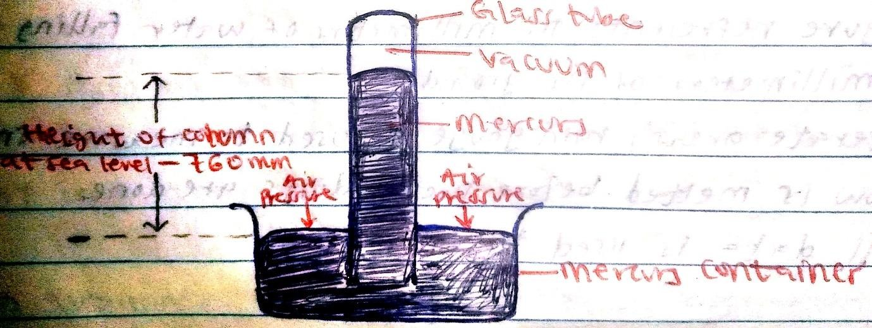
- Air exert pressure on the mercury in the container.
- The level of mercury in the container drops as the level of the mercury in the glass tube rises.
- When the air pressure is low, the mercury in the glass tube drops as that of container increases.
- The height of the mercury in the glass tube is a measure of the air pressure.
- The readings are taken in mmHg i.e. 760mmHg

Aneroid barometer
- It consists of an air tight metal box (partial vacuum), a spring tied to the box and connected to the lever system.
- It measures the changes in the atmospheric pressure as they occur during the day.
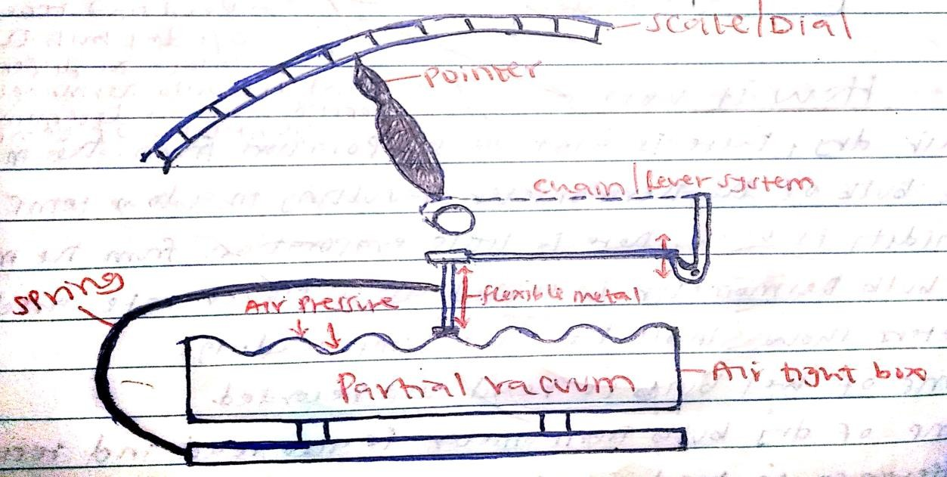

- When air pressure increases, air tight box contracts. The movement is transmitted by lever system to a pointer on a dial/scale which shows increase in the pressure on a scale.
- When air pressure falls, air tight box expands. This movement is conveyed to the pointer by lever system showing the fall in pressure on a scale.
- The readings are taken in kg/cm2

HUMIDITY
- Humidity is the amount of water vapour in the atmosphere of a place.
- It is measured by hygrometer.
- The actual amount of water vapour that a given volume of air holds at a specific temperature is called Absolute humidity. It is expressed in gm/m3
- The ratio of the actual amount of water vapour in the air to the maximum amount of water vapour air can hold (saturated air) at the same temperature is called Relative humidity. i.e.
Relative Humidity =

Absolute Humidity

Maximumamoutnof watertheair canhold at thesametemperature
×100%

- Saturated air is the maximum amount of water vapour air can hold at a specific temperature.
- The temperature at which air becomes saturated is called dew point.

Examples
- Saturated air contain 19.0g/cm3 of moisture but at the same temperature it contains 13.3g/cm3. Calculate the relative humidity.
Relative Humidity =

Absolute Humidity

Maximumamoutnof watertheair canhold at thesametemperature

= 13.3g/cm3 X 100%
19.0g/cm3
= 70%
×100%

- If the air at 20˚c contains 8.26g/m3 and given that air can hold a maximum of 17.17g/m3 at 20˚c. Calculate relive humidity.
Relative Humidity =

Absolute Humidity

Maximumamoutnof watertheair canhold at thesametemperature
×100%

= 8.26g/m3 X 100%
17.17g/m3
= 48%
Factors influencing humidity –kcse 2009

Temperature.
- High temperature leads to high humidity because air is heated, it expands increasing in volume creating more space to hold more water vapour.
- Low temperature leads to low humidity because air is cooled, it contracts decreasing in volume creating less space to hold more water vapour.

Air pressure.
- High atmospheric pressure compresses air, warming it increasing its capacity to hold moisture hence high humidity.
- Low atmospheric pressure allows air to expand and cool thus reducing its capacity to hold moisture hence low humidity.

Altitude.
- Low altitude areas have high temperature and high atmospheric pressure which allows air to hold more moisture hence high humidity.
- High altitude areas have low temperature and low atmospheric pressure hence reducing the air’s capacity to hold moisture leading to low humidity.

Distance from large water bodies/seas.
- Places near large waterbodies e.g. Kisumu and Mombasa experience high temperature leading to high evaporation rates increasing amount of water vapour in the atmosphere hence high humidity.
- Places far away from waterbodies e.g. middle of desert have little water vapour in the atmosphere hence low humidity.

Latitude.
- Areas at the equator experiences high temperatures hence high humidity while areas at the poles experiences low temperatures hence low humidity.

Seasons.
- The amount of moisture in the air is higher in the summer (warm season) than in winter (cold season) and during the day than at night.

Natural vegetation/forests.
- The amount of moisture in the air is higher in forested areas due high evapotranspiration rates leading to more water vapour in the atmosphere hence high humidity unlike in areas with little/no vegetation cover.

Measurement of Humidity
- Humidity is measured by hygrometer/ a wet and dry bulb thermometer/ Psychrometer –kcse 2022

Dry bulb thermometer
  - It has no muslin.
  - It measure air temperature.


Wet bulb thermometer
  - Its bulb is wrapped in a muslin which is dipped into water container.
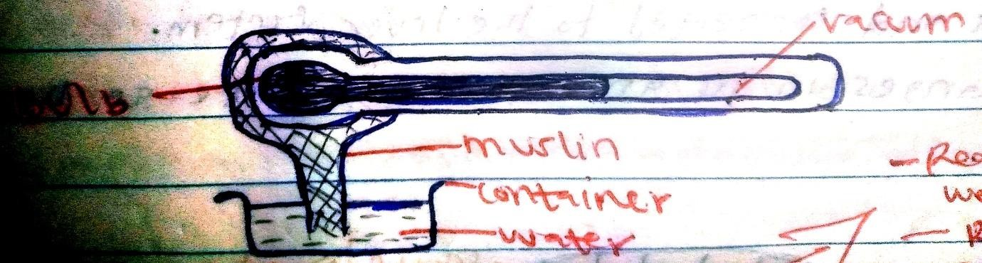
How humidity is measured –kcse 2009
  - Read and record temperature of wet bulb thermometer.
  - Read and record temperature of dry bulb thermometer.
  - Calculate the difference in temperature of wet and dry bulb thermometers.
  - Use conversion scale to determine humidity/interpretation of temperature difference.

Interpretation of hygrometer readings.
- If the atmosphere is saturated, there is no evaporation and so the atmosphere reading on both thermometers are the same. Relative Humidity is 100%.
- When the difference is small, it means that relative humidity is very high.
- When the difference is large, it means that relative humidity is very low.

Winds
- Wind is a moving air over the earth’s surface.

Types of winds.
  - Planetary/Prevailing winds.
- Winds blowing in a place frequently and consistently and which influence the world weather.
- They follow a regular path.
- In Northern hemisphere;
  - North East trade winds
  - The westerlies
  - The polar easterlies
  - North west trade winds
- In Southern hemisphere;
  - The south east trade winds
  - The westerlies
  - The polar easterlies
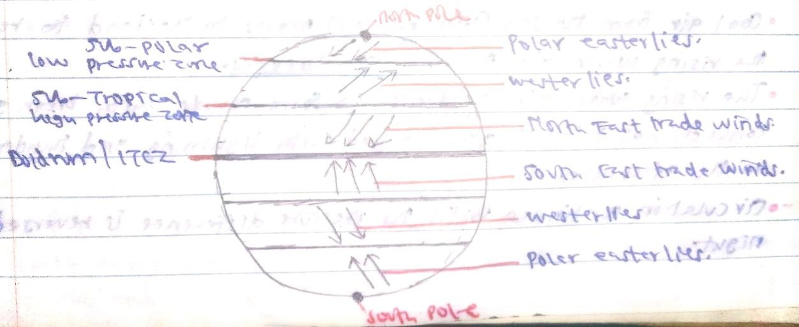
  - The south west trade wind

Monsoon wind
- They are seasonal winds.
- They show a reversal in the direction of flow according to season.
- They are best developed in the Indian sub-continent, china, Japan and south east asia.

Examples of monsoon winds.
- North east monsoon wind.
- North west monsoon wind
- South east monsoon wind
- South west monsoon wind

Local winds
- Winds blowing within a local small area for a short period of time.

Examples of local winds
- Land and sea breezes
- Anabatic and katabatic winds
- The harmattan winds
- The leveche, Sirocco, Chili and Khamsin
- Berg winds
- Fohn winds

- Sea breeze –kcse 2016
  - This is a mass of cool air blowing from the sea to the land during the day
  - During the day, the land heats faster than the sea.
  - The warmer air over the land rises.
  - The cool air from the sea blows towards the land to replace the rising air.
  - The cool air from the sea is called sea breeze.
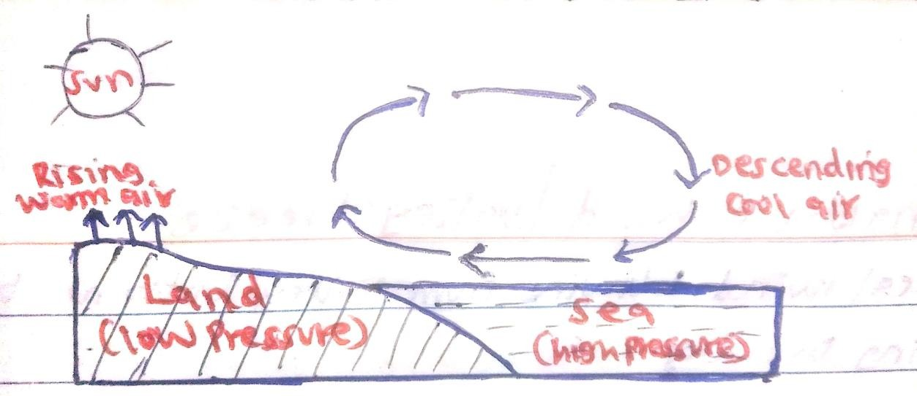

Ways in which sea breezes influence the adjacent land –kcse 2011
    - It lowers temperatures of adjacent areas.
    - It may increase rainfall.
    - It may increase relative humidity.
    - It moderates diurnal range of temperature.
    - It may lead to convectional rainfall.

- Land breeze –kcse 2023
  - This is a mass of cool air blowing from the land to the sea at night –kcse 2011
  - During the night, the land cools faster than the sea since the land looses heat more rapidly.
  - High pressure develops over the land.
  - Warm air above the sea begins to rise causing low pressure.
  - Cool/ cold air over the land flows towards the sea to replace the warm rising air.
  - This movement of cool air from the land to the sea during the night is called land breeze.
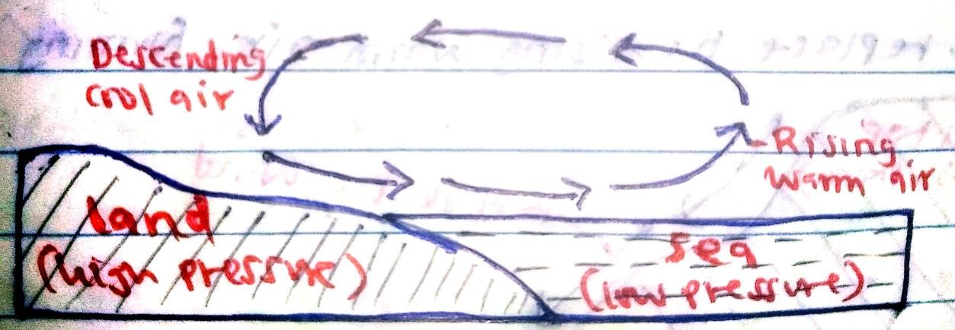

Anabatic winds
  - These are cold local winds that blow from the valley bottoms to the hill tops.
  - They occur in areas of temperature inversion (condition where the temperatures on higher parts of a slope are warmer than the lower parts)
  - During the day, the hill tops/mountain slopes receive more solar radiation compared to the valley bottoms.
  - The hill tops warm up leading to lower pressure whereas the valley bottoms remain cold with high pressure.
  - Air at the upper slopes is heated more than air over the valleys causing the air over the slope to rise by convection.
  - The cools air from the valleys flow uphill to replace the rising warm air as anabatic winds.

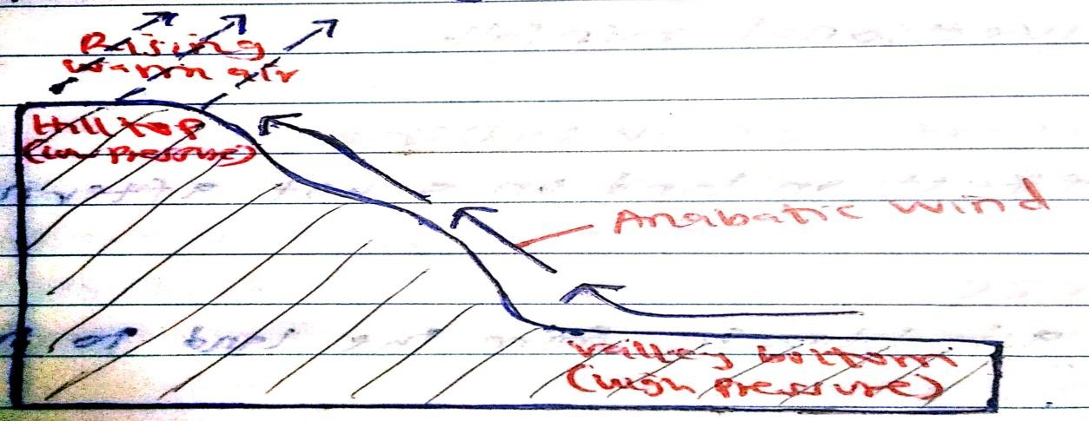

Katabatic winds
  - These are cold local winds that blow from hill tops to valley bottoms/downhill.
  - At night, the air over the hill tops and mountain slopes is cooled faster compared to the air at the valley bottoms.
  - The air at the hill tops become denser and with higher pressure while at the valley bottoms the air becomes warm/light and with lower pressure.
  - Warm air at the valet bottoms rises while cool winds blows from the hill tops to replace the rising warm air at the valley bottoms as katabatic winds.
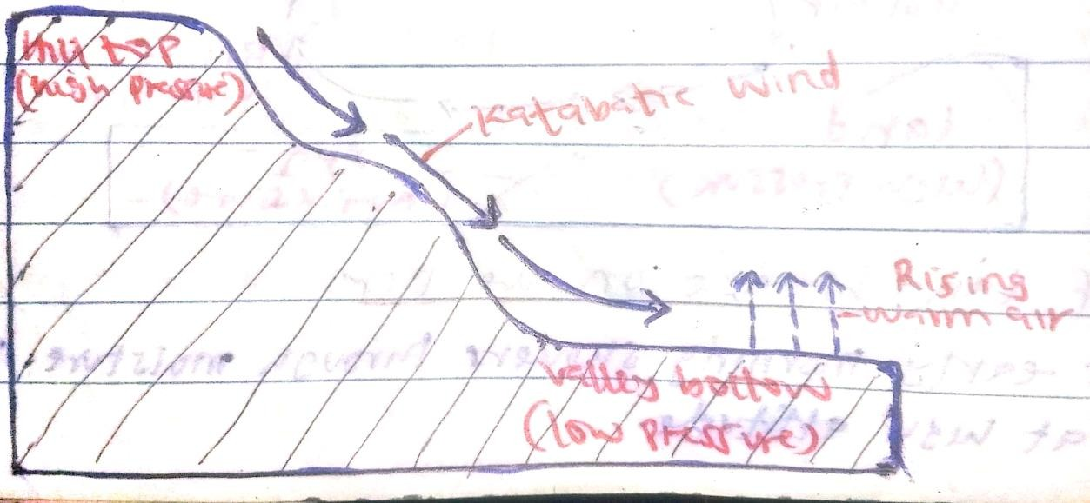

Factors influencing wind flow (wind direction and speed)
- Pressure gradient.
  - Air flows from a region of high pressure to a region of low pressure.
  - Steep pressure gradient (usually determined by the distance between two regions of different pressure) results in strong winds.

Coriolis Effect.
  - The Coriolis Effect is a force which acts upon any moving body or a parcel of air in an independently rotating system such as the Earth.
  - Winds blowing closer to the poles will be deflected more than winds at the same speed closer to the equator.

Centrifugal force.
  - When air streams move along a curved isobar in anticyclones, there is a centrifugal force acting outwards from the centre of the curvature.
  - Thus, in the northern hemisphere, air will tend to move clockwise in anticyclones and anticlockwise in cyclones.

Effect of friction.
  - Topographical obstacles create friction on moving air causing it to lose strength and even change direction.

Measurement of Wind
  - Wind Speed
  - This is measured using an anemometer in km/hr or in knots (nautical miles/hour)
  - It has three to four metal cups fixed to a metal arm and rotating freely due to the effect of blowing wind on a vertical shaft.
  - The number of times it rotates every minute gives the wind speed. The number of rotations is recorded by a small counter at the base of the shaft.

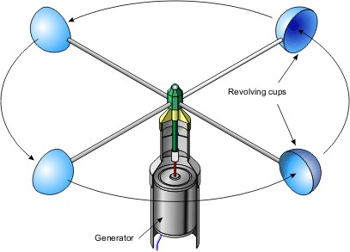
-
  - Wind Direction
  - This is measured using a wind vane that shows the four cardinal points of the compass; North, South, East and West.
  - It pivots on a vertical shaft. When the wind blows the arm swings until the pointer faces the wind.

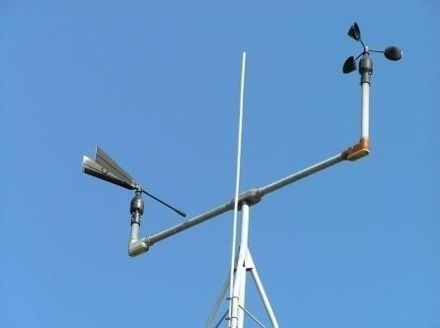

Sunshine
- This refers to the direct rays of sunlight reaching the surface of the earth.
- Sunshine duration and intensity depends on factors such as latitude, aspect, cloud cover and revolution of the earth.
- Lines drawn on the map showing places having the same sunshine intensity are known as Isohels.

Measurement of Sunshine
- The duration of sunshine for the day is measured using the Campbell stokes sunshine recorder.
- It is a glass sphere which focuses the sun’s rays on a sensitized paper mounted on a metal frame.
- Since the rays are focused on the sensitized paper, they burn a line as the sun moves across the sky.
- There are calibrations in hours on the margin of the paper. Continuous sunshine will produce continuous burn whereas intermittent sunshine produces unburnt parts on the paper.
- The length of all the burnt sections is added so as to obtain the total hours of sunshine for the day.
- The sensitized paper is changed every day.

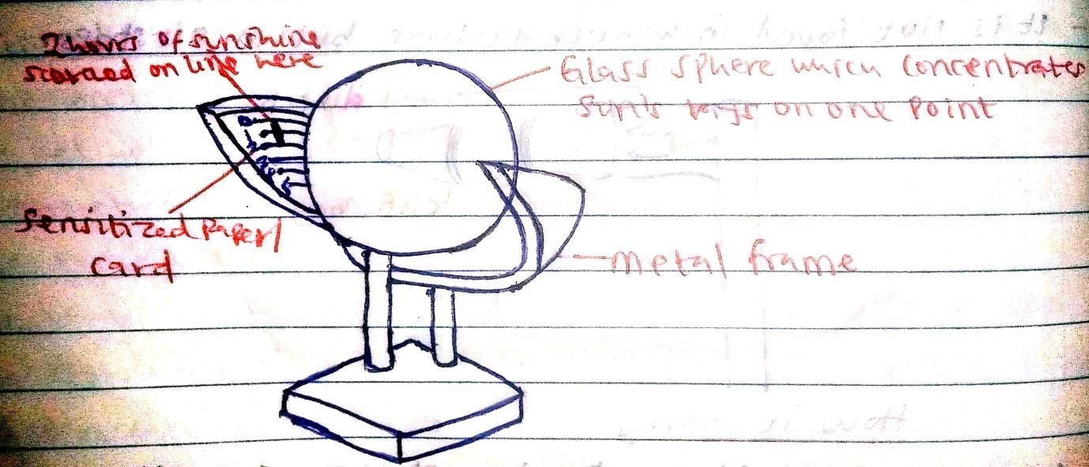

A Weather Station
- A weather station is a place set aside for the observation, measuring and recording of weather elements like temperature and rainfall.
- Weather stations are found at meteorological centres, agricultural institutions, schools, colleges, army barracks and airports.
- The study of weather is called meteorology and people who study weather are called meteorologists.

Instruments for measuring weather elements –kcse 2004
  - Thermometers for temperature
  - Rain gauge for rainfall
  - Hygrometer for humidity
  - Barometer for air pressure
  - Wind vane for wind direction
  - Anemometer for wind speed
  - Windsock for wind strength
  - Campbell stokes sunshine recorder for sunshine duration/intensity

Conditions necessary for Siting a Weather Station –kcse 2011
- The area should be away from buildings/trees/tall objects.
- The ground should be gently sloping/free from floods.
- The area should be open to the surrounding landscape/have a wide view.
- The area should be secured to keep off intruders like animals and thieves.
- The area should be accessible so that recording can be done easily.
A Stevenson Screen –kcse 2012
- This is a white wooden box mounted on four metallic legs 1meter above the ground in which meteorological instruments are kept at a weather station.

Instruments found in a Stevenson Screen
  - Maximum thermometer
  - Minimum thermometer
  - Six’s thermometer
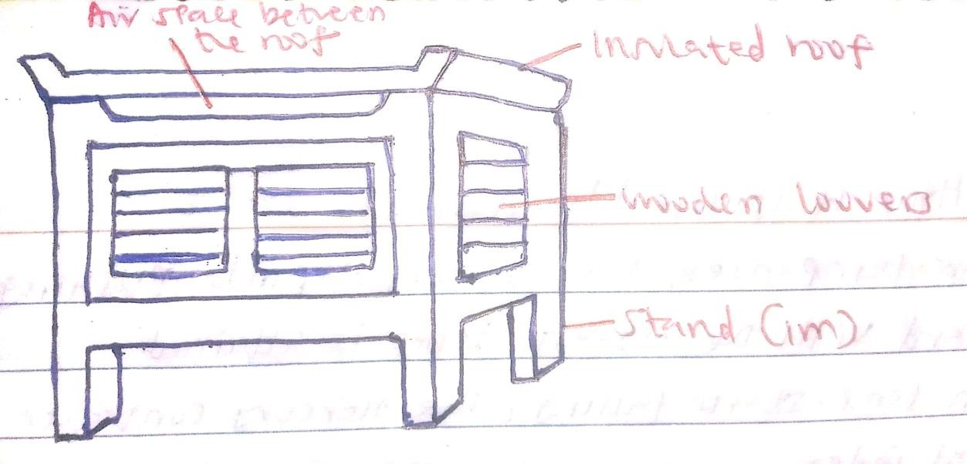
  - Hygrometer

Qualifications which make Stevenson screen suitable for its work.-kcse 2014
  - Its sides are made of wooden louvers to allow the free circulation of air –kcse 2005
  - It has double roof/insulated roof to prevent direct heating from the sun/to prevent rain to fall on instruments.
  - It is painted white to reflect excess rays of the sun –kcse 2005
  - It is raised above the ground (1.2m) to prevent contact with terrestrial radiation.
  - It is mounted on four metallic legs to prevent termites from destroying the wood.
  - It is made of wood so as not to absorb heat from the sun.
  - It has air space between the roofs/ it is well ventilated to allow easier flow of air inside it.

The Atmosphere –kcse 2018
- Atmosphere is a thin layer of gases and vapour surrounding the earth and held by the earth’s gravitational pull.

Composition of the atmosphere -kcse 2008
  - Gases
  - Smoke particles
  - Dust particles
  - Water vapour

  - Salt particles
  - Pollen grains
  - Ozone

Structure of the Atmosphere.
- Atmosphere consists of four main zones namely;
    - Troposphere
    - Stratosphere
    - Mesosphere
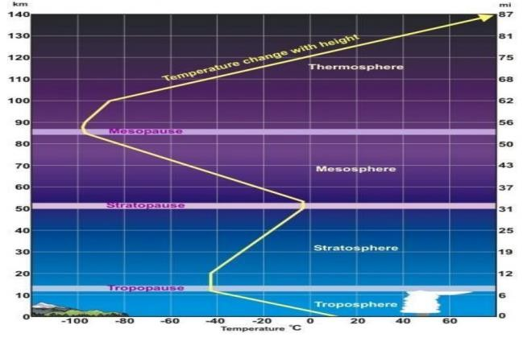
    - Thermosphere
- The troposphere –kcse 2016
- It is the lowest layer of the atmosphere.
- It extends to a height of 8km at the poles and 13km around the equator.
- It contains most of the weather making consituents.
- Temperatures decreases with an increase in height (it experiences a normal/positive lapse rate).
- It supports life.
- Pressure falls with an increase in height.
- The speed of wind increases with an increase in height.

- It contains most of the atmospheric water vapour.
- It is unstable layer because it contains water vapour, cloud, dust and other pollutants.
- Rainfall is got from it.
- Effect of gravity decreases with increase in height.
- The transitional zone between the troposphere and stratosphere is known as the

tropopause.
- The Stratosphere –kcse 2015
- It extends from the tropopause.
- It extends 30km above the tropopause.
- It contains most of the atmospheric ozone and is therefore also known as the ozonosphere.
- It contains little dust and water vapour therefore lacking clouds.
- It has ozone layer which absorbs the ultra violet radiations that would otherwise be harmful to life.
- Temperature increases with increase in height (negative lapse rate).
- Winds are light in the lower parts but increase with height.
- Pressure falls with increase in height.
- The transitional zone between the stratosphere and mesosphere is known as the

stratopause.
- The Mesosphere
  - It extends from the stratopause to about 80km.
  - Temperatures decrease with increase in height i.e. has a positive lapse rate.
  - It has no water vapour, cloud and dust to absorb the incoming radiations
  - It experiences the lowest temperatures (about – 90⁰C)
  - It experiences strongest winds (about 300kmh⁻¹)
  - The transitional zone between the mesosphere and thermosphere is known as the

mesopause.
- The Thermosphere
  - It lies above the mesopause.
  - It extends 90-120km above the earth’s surface.
  - It is also known as the ionosphere because gases found here have been ionized by the gamma and x-rays of the sun.

  - It contains electrons and ions that influence radio waves.
  - Temperature increases with an increase in height(negative lapse rate).
  - The pressure is very low.
  - High radiation is present.
  - Has no definite top but merges gradually into the outermost part of the atmosphere called Exosphere.
  - Exosphere consists of rare gases like hydrogen and helium.
  - Beyond the atmosphere there is outer space.
  - Outer space is the universe beyond the atmosphere in which other planets and stars exist.

Isothermal layer
- It is a layer in the atmosphere within which temperature remains constant despite the increasing altitude.
- It is a layer experiencing zero lapse rate i.e. there is no change in temperature with an increase in height.

Examples of isothermal layers.
  - Tropopause
  - Stratopause
  - Mesopause
NOTE: Lapse rate is the change of temperature in relation with increasing/decreasing height/altitude.
: Temperature inversion is a condition in the atmosphere where the upper layer of air is warmer than the lower layer.
Weather forecasting –kcse 2017
- It is the prediction of the state/conditions of the atmosphere of a given place within a specified time/period.

Methods of weather forecasting
- Ancient methods.
  - In ancient times it was believed that weather was governed by gods. Weather forecasting in the 17th century was based on astrological, local, traditional and religious theories.
  - Some of the traditional weather forecasts showed careful observation expressed in form of poems and jingles that were passed on from generation to generation.

Weather lore.
  - This refers to a body of traditional facts and beliefs relating to weather like –kcse 2022
    - Observing movement of animals and migration of birds.
    - Observing changes in plants/ shedding of leaves.
    - Observing heavenly bodies/ appearance of the moon.
    - Observing changes in the wind patterns.
    - Observing changes in temperature/ intensity of solar radiation.
    - Observing cloud/ colour of the sky.
    - Appearance of rainbow.

Modern methods.
  - They are more reliable and accurate.
  - They use advanced and modern equipment e.g. electronic computer, satellites, rockets, radar aircrafts, balloons, airships and submarines.
  - World Meteorological Organization has set up a conventional system of weather recording and interpretation for international use.
  - In Kenya, weather forecasting is based on records from meteorological stations and remote sensing centre.
  - Dagoretti is the headquarters of meteorological stations in East and Southern Africa.
Significance of Weather Forecasting –kcse 2019
- It enables farmers to plan their farming activities.
- It helps in guiding tourist activities.
- It enables military personnel to plan their military activities.
- It enables people to choose their suitable clothing.
- It guides people on sporting activities.
- It guides people on fishing activities.
- It helps to determine the times for air/sea travels.
- It helps in planning for weather related disasters.

Factors hindering weather forecasting.
- Inadequate data.
- Inaccurate/unreliable data brought about by faulty equipment.
- Intervening factors like slope of the land, nature of the vegetation, soil moisture conditions and winds lead to variation in temperature at different areas adjacent to each other.

- Inadequate personnel in developing countries
- Vagaries of nature like storms and earthquakes.

Reasons why recording of data at a school weather station may be inaccurate –kcse 2000
- Use of defective weather instruments which are mainly improvised.
- Occurrence of extreme weather conditions e.g. El Niño.
- Human error in setting up and reading the values from the instruments.
- Interference/ tampering of instruments by students.
- Natural calamities.
- Poor siting of the weather station

Factors influencing weather
- Altitude
  - Temperature decreases with increase in altitude in the troposphere i.e. highland experience cooler temperatures/while lowland areas experience higher temperature.
  - Atmospheric pressure decreases with increase in altitude due to weight of air layers above.
  - Highland areas on their windward sides under the influence of rising moisturized winds receive more rainfall compared to their leeward sides.

Continentality
  - Also referred to as nearness to large water bodies
  - Large water bodies such as lakes, seas and oceans facilitate development of breezes through creation of pressure differences.
  - These breezes may:
    - Strengthen/reverse the direction of prevailing winds
    - Lower temperatures of the surrounding areas.
    - In coastal areas, ocean currents influence temperatures and precipitation of adjacent lands.
    - High/increased precipitation by supplying moisture through evaporation.

Aspect
  - This is the direction a slope faces with respect to the incoming solar radiation.
  - Sun facing slopes are warmer that the opposite slopes especially towards the poles.

Inter Tropical Convergence Zone (ITCZ)
  - It is a zone of low pressure lying within the tropics.
  - Since it a convergence zone of South east trade and north east trade winds.
  - It experiences high convectional rainfall.
  - It experiences high temperature.

Latitude
  - High latitude areas are cooler/experience lower temperature compared to low latitude/equatorial areas which are hotter/experience high temperatures.
- Cloud cover –kcse 2015
  - Cloud cover reduces the amount of solar radiation reaching the earth’s surface thus decreasing atmospheric temperature.
  - Absence of cloud cover leads to an increase in diurnal range of temperature.
  - The type of clouds determine the type/amount of rainfall.
  - The amount of cloud determines the intensity of sunshine received on the earth’s surface.
- Local winds –kcse 2015
- Warm winds blowing over an area bring the warming effect thereby raising the temperature of the place.
- Cold winds blowing over an area bring the cooling effect hence lowering the temperature of the place.
- Moist winds passing over a region drop moisture as precipitation/increase humidity.
- Dry winds passing over a region bring drying effect/aridity/lower humidity.

“END OF TOPIC THREE”

TOPIC FOUR: STATISTICAL METHODS
Definition of Terms
- Statistics refers to the exact numerical facts and figures collected systematically and arranged for a particular purpose.
- Statistical data refers to the information collected in numerical form.
- Statistical methods are techniques of collecting, recording, analysing, presenting and interpreting statistical data in order to draw a valid conclusion from it.

Significance of statistics in Geography.
- Prediction of future trends of weather and climate.
- Prediction of natural disasters e.g. droughts and floods.
- Helps government in planning for provision of social amenities e.g. hospitals and schools.
- Helps to make comparison between components e.g. county with the highest number of people.
- Summarises geographical information which saves time and space.
- Illustrates the relationship between two or more varying quantities e.g. maize production and amount of rainfall.
- It shows changes through time e.g. population size.
- It shows accuracy of measurement e.g. exact population of an area.
- It enable geographers to minimize subjective or personal judgements and increase objectivity e.g. today’s temperature is 30⁰c and NOT the day is very hot.

Types of Statistical Data.
  - Primary Data.
- These are first hand or original information collected from the field.
- It is collected through different methods like Oral interview, direct observation, administering questionnaires, measuring, counting and taking photographs.

Secondary Data
- The information that has already been collected and documented and is available for reference e.g. textbooks, newspapers.

Nature/ classification of statistical data.
- Statistical data has different characteristics hence further classified into;

Discrete data.
- Information given in whole numbers e.g. 1000 people, 192km, 20⁰c

Continuous data.
- Information given in either decimals or fractions e.g. ½ km, 2.67%,

Individual data.
- The exact value of information is given for each item in a sample range e.g. Busia County has about 400, 000 people.

Grouped data.
- It is not- precise/ no exact figures are quoted but values ranges in groups e.g.
Age group | Boys | Girls
15-19 | 32 | 29
20-24 | 8 | 15

Sources of statistical data.
- Primary sources.
- These are people who have first-hand or original information.
- They include;
  - Direct observation in the field.
  - Interviewing resource persons.
  - Administering questionnaires.
  - Field/ laboratory experiments.
  - Taking measurements in the field.
  - Counting in the field.

Secondary/ Derived sources.
- These are materials in which information collected by others was stored.
- They include;
  - Textbooks.
  - Census reports.
  - Newspapers.
  - Maps.
  - Research articles.
  - Journals.
  - Magazines.

Factors to consider when selecting method of data collection.
- The cost of collecting data- The selected method should enable us to collect data cheaply.
- Time spent on collecting data- The selected method should enable us to collect data as quickly as possible.
- Accuracy of information- The selected method should give us accurate data.

Methods of Data collection –kcse 2021 pp1
  - Observing
  - Interviewing
  - Administering questionnaires
  - Sampling
  - Note making
  - Photographing/video recording/filming
  - Counting/Census taking
  - Reading secondary sources/content analysis
  - Taking measurements
  - Reading instruments.

Observing
- This method involves direct visual observation of the geographical phenomena.

Advantages of observations
- It provides reliable data.
- It saves time by collecting relevant data.
- It provides first-hand information.

Disadvantages of observations
- This method is subjective since it is based on personal observation.
- Very expensive due to travelling cost.
- It is affected by weather conditions.
- Visual impairment may limit the effectiveness of this method.
- It may not be possible to collect data on past activities.

Interviewing.
- It is a direct discussion between the researcher and the respondent when they meet face to face or indirect when they converse over the phone.
Advantages of interviewing.
- Reliable first-hand information is collected.
- The researcher is able to seek clarification for ambiguous responses.
- It provide an instant source of information.
- It can be used to extract information from illiterate people.
- Direct contact with the respondents enables the researcher to estimate the accuracy of the responses.
- The researcher is in a position to dispel any fears from the respondent and therefore ensures that truthful answers are given.

Disadvantages of interviewing –kcse 2012 pp2
- Susceptible to bias.
- Time consuming compared to other data methods.
- May be seen as intrusive to the respondent.
- Language barrier may arise.

Administering questionnaires.
- It uses questions to gather information.
- It consist of a list of questions related to the topic being researched on.

Types of questionnaires.
- Open- ended/ leading questions.
- Respondent is given a chance to express his/her views e.g.
  - What causes low farm produce in your area?
..............................................................................................................................
..............................................................................................................................
  - How do you transport farm produce to the market?
…………………………………………………………………………………
…………………………………………………………………………………..

Closed-ended/ Rigid/ Structured questions.
  - Respondent is given answers to choose from e.g.
    - Which food crop do you grow?
      - Maize □ beans □ cassava □ All

    - Do you sell your food crops?
      - Yes □ No

Factors to consider when preparing a questionnaire.
- Simplicity and clarity- Questions asked should be simple and clear.
- Number of questions- Questions asked should not be too many as this discourages respondents.
- Logical order of questions- Questions should start from simple to difficult ones.
- Relevance of questions- Questions should be strictly related to the topic under research.
- Nature of the questions- Questions that may annoy the respondent should be avoided
e.g. personal/privacy life of a person.
- Objectivity of the questions- Questions should be free of bias. Leading questions that help the respondent decide on the answers should be avoided.

Characteristics of a good questionnaire.
  - Short
  - Uses simple language
  - Clear questions
  - Systematically arranged from simple to difficult
  - Questions relate with the topic
  - Don’t touch on respondent’s privacy

Advantages 75
- The researcher is able to seek clarification of unclear response by asking supplementary questions.
- The researcher is able to win the respondents’ trust and dispel any fears that the respondents might have.
- Direct contact with respondents provides the researcher with an opportunity to gauge the accuracy of the answers given.
- A lot of information can be collected.
- Comparisons can be made easy because similar questions are used for all the respondents.
- They are useful sources of first-hand information.
- Rigid questionnaires when posted to the respondents reduce fieldwork expenses.

Disadvantages
- Travelling expenses inflate research costs.
- A lot of time is also lost in movement.
- The questionnaire may not be effective where the respondent is illiterate or where there is a language barrier.
- Mailed questionnaires usually bring back insincere and inaccurate responses especially where opinion questions are involved.
- Questionnaires when mailed may never reach the respondent.

Taking measurements.
  - Data can be obtained in the field using measurements such as;
- Pacing like in land surveying.
- Estimations e.g. distances
- Counting e.g. traffic flow, population
- Using instruments like tape measure, thermometers, rain gauge

Advantages of Measurements
    - It is easy to measure and read information shown in the instruments.
    - Data obtained is accurate.
    - It is a quick way of collecting data.
    - It provides first-hand information.

Disadvantages of Measurements
    - Sometimes the data obtained may be inaccurate.
    - Errors may occur.

Secondary sources (Content Analysis).
  - This involves a researcher gathering secondary data by extracting/examining previous research work.
  - Secondary sources include:
- Journals
- Periodicals
- Census reports
- Textbooks
- Maps
✓

Advantages of using content analysis
- It is easy to collect data.
- Inexpensive.
- Gives access to old information.

Disadvantages of using content analysis –kcse 2006 pp1
- The available information could have been biased and thus emphasized prejudiced.
- The data could be outdated and in some cases irrelevant.
- In some cases the secondary data may have been inaccurately collected.
- The available data may appear in a format that is not appropriate.

Sampling.
  - A sample is small part of anything intended as a representative of the whole.
  - Sampling is the process by which a representative portion of the phenomena under research is selected for analysis.

Types of sampling techniques –kcse 2022 pp2

a.) Random sampling.
- This sampling technique is useful where the phenomena under research is not distributed in any particular order.
- For example, To select 5 students to go for a tour from a class:
  - Class members write their names on pieces of paper.
  - They are folded and put in a bucket.
  - The bucket is shaken well and five papers are taken out.

b.) Systematic sampling.
- This method is useful where the phenomena is large and evenly distributed. The objects for study are selected at regular intervals.
- For example, To get the average age of students in form one class, you use the class sitting arrangement and get the age of every 5th student, then get the average of data collected.

c.) Stratified sampling.
- This involves the selection of study samples on the basis of the groups or categories of the similar elements of the phenomena e.g. based on age, sex, tribe etc.
- For example, To select 6 students to go for a tour, you break the class into boys and girls, select 3 students from each group by either random or systematic sampling, combine units from each group to form the required sample.

Advantages of sampling
- It is less expensive.
- It saves time.
- It avoids bias.

Disadvantages of sampling
- A poorly selected sample can lead to misleading information.
- It is not suitable to an unevenly distributed population particularly the systematic sampling.
- It gives generalization of an area/ population which may be inaccurate.

Give four reasons why it would be necessary to sample part of a forest during a field study –kcse 2000/2001/2013/2014pp2
- To do a detailed study.
- To reduce cost of the study.
- To save on time.
- Area too large to cover as a whole in a day.
- Less tiring to study a small area.
- Some parts may not be accessible as there are no roads.
- Helps reduce bias.
- Helps focus on relevant areas for the study.
- Suitable as vegetation in a forest grows randomly.

Give two advantages of sampling the households for the study –kcse 2022pp2
- To save time
- To reduce bias
- To allow for detailed study
- To reduce costs

Experimentation.
  - This is an act of conducting a test or investigation to provide evidence for or against a theory.
  - In geography, experiments can be carried out to determine;
    - The chemical composition of rocks.
    - Rock density.
    - Moisture content in a soil sample.
    - The specific gravity of a substance.

Advantages of Experimentation.
- First hand data is obtained.
- It can lead to further discoveries.
- When properly conducted it gives accurate results.

Disadvantages of Experimentation.
- Time consuming.
- It may be expensive.
- Use of defective instruments may lead to inaccurate data.
- Improper handling of equipment and chemicals may lead to accidents.8

Counting.
  - This is taking census of the items as they occur in the field e.g. counting of people living in a certain place or traffic flow in or out of a certain area.

Advantages of counting
- Provides first-hand information.
- Obtains accurate data.
- It is quick method of obtaining data.

Disadvantages of counting.
- It may be difficult when the items to be counted are many and mobile e.g. vehicles.
- It may be confusing if not recorded immediately especially through tallying.

Methods of Recording Statistical Data –kcse 2019 pp1
  - This involves the recording of figures and facts collected in the field to ensure that all details are available for analysis.
  - They include;
    - Note taking.
    - Photographing.
    - Field sketching/drawing diagrams.
    - Filling in questionnaire
    - Tape recording.
    - Video recording/filming.
    - Labelling of samples.
✓

a.) Tabulation
  - This is recording of data by arranging facts of figures in form of table or list.

b.) Photographing
  - This is capturing of what is observed in the field and storing it inform of photographs.
This is done by use of a camera to record geographical information.

c.) Note Taking
  - This involves the making of short notes during an interview so that no information given is lost.

d.) Labelling of Samples
  - Once the samples are collected in the field they should be put in polythene bags and clearly labelled by naming them.

e.) Filling in the questionnaires
  - The data is recorded by filling in the information as instructed in the questionnaire.

f.) Mapping
  - This involves the drawing of a sketch map to show the distribution of various items in an area.

g.) Field Sketching
  - This involves the preparation of a simple sketch of what is observed in the field.

h.) Tape recording
  - This can be done when one is collecting data through an oral interview where one uses tape recording device to record conversation.

i.) Tallying
  - Used when the data is collected through counting. One counts and puts a vertical strike for every item counted, on the fifth count one puts a diagonal crossing the four strokes

Analysis of statistical data
  - Statistical data analysis means examining the recorded figures and facts in detail so as to explain the meaning and features of the data.

Methods of data analysis.
1.) Calculation of percentages.
  - The data collected may be converted into percentages to make it more meaningful.
Example
In the study of a farm, 20 hectares where devoted to tea and the total acreage is 100 hectares. Find the percentage under tea.
Solution 20
100 𝑥 100 = 20 %

2.) Measures of central tendencies.
  - Central tendency is the outstanding general characteristics of the data. The main measure of central tendency are:
    - The mean
    - The median
    - The mode

The mean
  - The mean also known as arithmetic mean is obtained by dividing the sum of the number of all the values with the number of observations made.

Example
The population densities for five sub- locations are found to be 10,11,14,20 and 20 persons per 𝑘𝑚2 then the arithmetic mean (average) is:
(10 + 11 + 14 + 20 + 20)
5
= 15 𝑝𝑒𝑟𝑠𝑜𝑛𝑠

The median
  - This is the middle value in given set of data arranged in a rank. To obtain the median, all the values are arranged in an ascending or descending order and then the middle value is determined.
Example
Find the median 5, 9, 10, 30, 12, 20, and 17 Solution
5, 9, 10, 12,17,20,30
12 is the median
Note:
When the set is an even number we simply add the two middle numbers and divide by two to get the median.

The Mode
  - This is the most frequent recurring value in a set of data. Example
Find the mode 4, 5, 7, 9, 5, 2, 8, 4, 9, 5, 1 and 5 Solution
The mode is 5 because it appears the most i.e. 4 times

3.) Measure of dispersion.
  - Measure of dispersion show how the data provided is spread out.
  - The main measure of dispersion is the range. The higher the range, the more dispersed the data is and the lower the range, the less dispersed it is.
  - The range is obtained from subtracting the lowest value from the highest value.
Example
The data below shows height of girls in cm. Calculate the range.
456, 390, 380, 520, 495, 450, 350

Range= Highest value – Lowest value
= 520 – 350
= 170 cm

Statistical Presentation of Data.
  - This is the method of putting collected, recorded and analysed data in a form that brings out meaning to other people.
  - The type of method of data presentation depend on:
- The type of data being presented.
- The information being put across.

Method of Data presentation.
  - These are one or two dimensional drawings that show the relationship between two types of data.
  - When one variable changes, it causes a change in another variable.
  - The first one is called an independent variable while the second one is called dependent variables.
  - In drawing a graph the independent variable is put on the x – axis while the dependent variable is put on y – axis.

Types of graphs.
    - Simple line graph
    - Simple bar graph
    - Combined bar and line graph/ polygraph

Simple line graph
  - This is one dimensional diagram that shows the relationship between two variables.
  - It is a useful method for presentation of continuous data such as temperatures.
  - A simple line graph may be either curved or straight with sharp angular turns.
  - Curved simple graphs are used to present continuous data like the mean monthly temperature, population growth rate and changes in air pressure.
  - Straight simple line graphs with sharp angular turns are used to represent data which may have some discontinuity.

Construction of a simple line graph.
The table below shows mean monthly temperature of Thika. Study it and draw a simple line graph.
Month | J | F | M | A | M | J | J | A | S | O | N | D
Temp ⁰c | 19 | 21 | 21 | 24 | 26 | 18 | 17 | 17 | 19 | 20 | 25 | 28
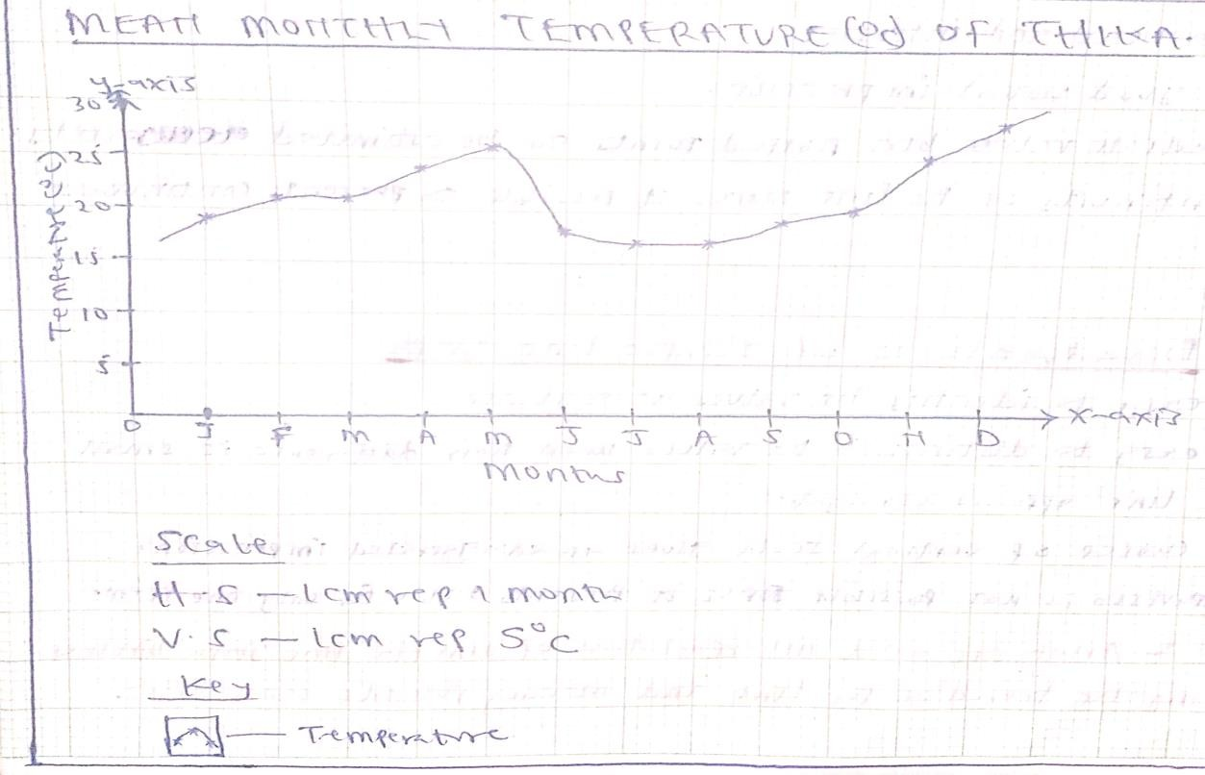

Analysis and interpretation of the drawn simple line graph.
Analysis and interpretation of simple line graph involves studying the trend of the line and making possible conclusions.
- The month of December recorded the highest temperature.
- The months of July and August recorded the lowest temperature.
- The annual temperature range is 11⁰c i.e. 28⁰c - 17⁰c = 11⁰c
- There was temperature increase between August and December.
- In July and August, temperature remained stable at 17⁰c followed by an increase in September.
- In February and March, temperature remained stable at 21⁰c followed by an increase in April.

Advantages of simple Line Graph
- It is easy to draw/construct.
- It is easy to read/ interpret.
- It gives a clear visual impression.
- It does not involves lengthy and tedious calculations.
- The trend of the relationship can easily be seen.
- Allow comparison.

Disadvantages of simple line Graphs
- It is not easy to identify the values at a glance.
- The causes of the illustrated relationship cannot be established from the graph.
- Comparison is not possible since it presents data for only one item.
- It ignores some details of change and may give a false impression on the continuity of some data.
- Represents a few variables/ items.

Assignment: The table below shows mean monthly temperature figures. Use the information to draw a simple line graph.
Month | J | F | M | A | M | J | J | A | S | O | N | D
Temp  ⁰c | 21 | 21 | 20 | 20 | 22 | 23 | 23 | 24 | 22 | 20 | 19 | 18

Simple Bar Graph
  - Also called columnar graph/ a bar chart/ histogram.
  - This is a two dimensional diagram which shows the relationship between two variables.
  - This graph is composed of single separate vertical or horizontal bars with each bar presenting a given value.
  - The width of the bars should be the same and conveniently chosen. (Usually 1 cm wide).
  - The length of the bar is equal to the value being presented.
  - The space between two adjacent bars should be constants.

Construction of simple bar graphs.
The table below shows annual rainfall distribution of Busia town.
Month | J | F | M | A | M | J | J | A | S | O | N | D
Rainfall  in mm | 50 | 50 | 300 | 250 | 160 | 40 | 30 | 30 | 20 | 70 | 100 | 160
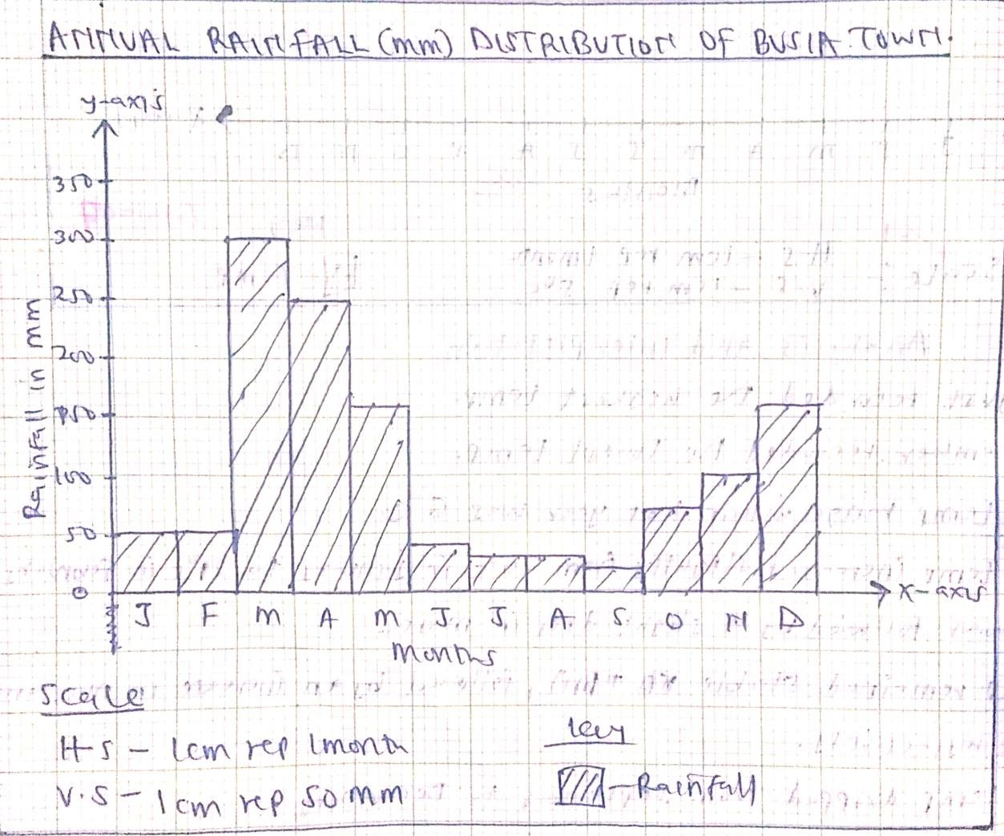

Analysis and interpretation of the drawn simple bar graph.
- Busia town received rainfall throughout the year.
- The annual rainfall total is 1260mm.
- The average amount of rainfall is 105mm.
- The month of March received the highest rainfall.
- The month of September received the lowest rainfall.
- Rainfall increased between September and December.
- Rainfall decreased between March and July.

Advantages of Simple Bar graph.
- It allow ease in comparison.
- It give clear visual impression.
- It is easy to read/interpret.
- It is easy to draw/construct.

Disadvantages of Simple Bar graph.
- It is not easy to identify values at a glance.
- Difficult to choose a suitable scale when the value for each variable differ by a great magnitude.
- It does not show relationship between the same types of data such as temperature or rainfall amounts of more than one place.
- The causes of variation in the variables cannot be established from the graph.
- Represents a few variables/ items.

Assignment: The table below shows monthly rainfall amounts for Eldoret. Draw a simple bar graph.

Month | J | F | M | A | M | J | J | A | S | O | N | D
Rainfall  in mm | 20 | 30 | 50 | 150 | 130 | 100 | 170 | 190 | 80 | 50 | 50 | 40

Combined line and Bar graphs/ Polygraph.
  - This graph is a combination of the line and bar graphs.
  - It is mainly used to show the relationship between two types of data especially temperature and rainfall.

Construction of combined line and bar graph
The table below shows mean annual temperature (⁰c) and rainfall (mm) for Kakamega.
Month | J | F | M | A | M | J | J | A | S | O | N | D
Temp  ⁰c | 19 | 21 | 21 | 24 | 26 | 18 | 17 | 17 | 19 | 20 | 25 | 28
Rainfall  in mm | 50 | 50 | 300 | 250 | 160 | 40 | 30 | 30 | 20 | 70 | 100 | 160
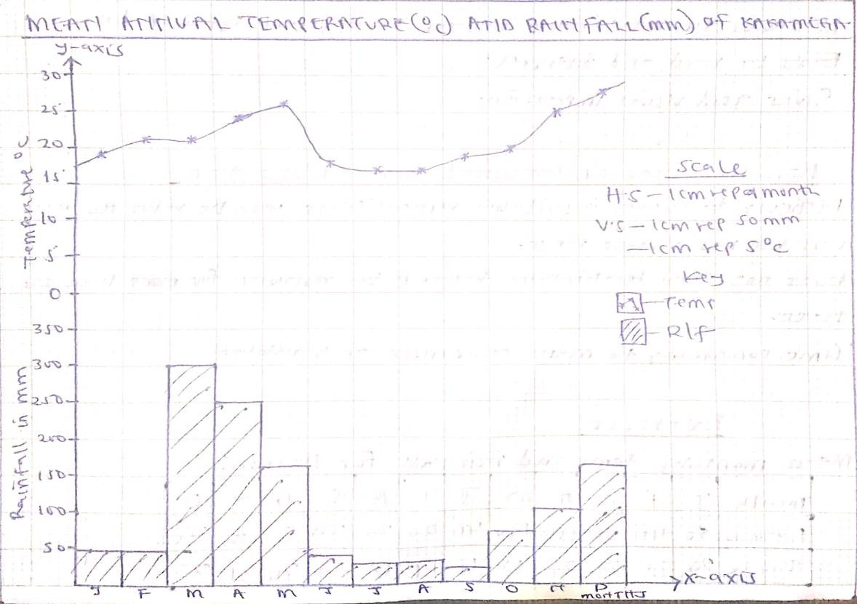

Analysis and interpretation of combined line and bar graph drawn.
- Kakamega receives rainfall throughout the year.
- There is double maxima of rainfall/ two rainy seasons.
- The month of March received the highest rainfall.
- The month of September received the lowest rainfall.
- The annual rainfall total is 1260mm/ Kakamega receives high rainfall total.
- Kakamega experienced moderate to high temperatures/ 21.25⁰c throughout the year.
- The area has a temperature range of 11⁰c.
- The month of December experienced high temperatures.
- The months of July and August experienced low temperatures.

Advantages of combined Line and Bar Graph
- It is easy to draw/construct.
- It is easy to read/interpret.
- It gives a clear visual impression.
- Allow comparison.
- It shows the relationship between two different types of data such as the relationship between temperature and rainfall.

Disadvantages of combined line and Bar Graph
- It is time consuming while drawing/constructing.
- Represent a few variables/ items.
- It is not easy to read values at a glance.
- It does not show relationships between the same types of Data.
- It is difficult to choose a suitable scale when the value for each variable differ by a great magnitude.
- The cause of variation in the variables cannot be established from the graph.

Assignment: The table below shows mean monthly temperature and rainfall for Nairobi. Draw a combined line and bar graph.
Month | J | F | M | A | M | J | J | A | S | O | N | D
Rainfall  in mm | 50 | 40 | 80 | 150 | 130 | 40 | 20 | 30 | 30 | 50 | 90 | 70
Temp  ⁰c | 20 | 21 | 20 | 20 | 19 | 18 | 17 | 18 | 19 | 20 | 21 | 20

Wind rose
  - This is a statistical chart that is used to show diagrammatically the average frequency and direction of the wind at a given place.
  - The central part is either a circle or an octagon with each side representing the eight cardinal points of the compass.
  - The length of the column shows/represents the frequency of wind in the given direction.
  - At the centre of the circle or octagon, the number of calm days is written.
  - Calm wind is obtained by finding the difference between the total numbers of days wind blew in that month from the total number of days in that particular month.

Construction of a Wind Rose.

The table below shows the frequency of wind direction for July 2017. Use it to draw a simple wind rose.
Direction  of wind | N | NE | E | SE | S | SW | W | NW | Calm
Number  of days | 3 | 3 | 1 | 4 | 3 | 7 | 2 | 4 | 4

Solution.
Scale- 1cm represent 1 day.
Calm wind = 31 days – (3+3+1+4+3+7+2+4)
= 31 – 27
= 4 calm days
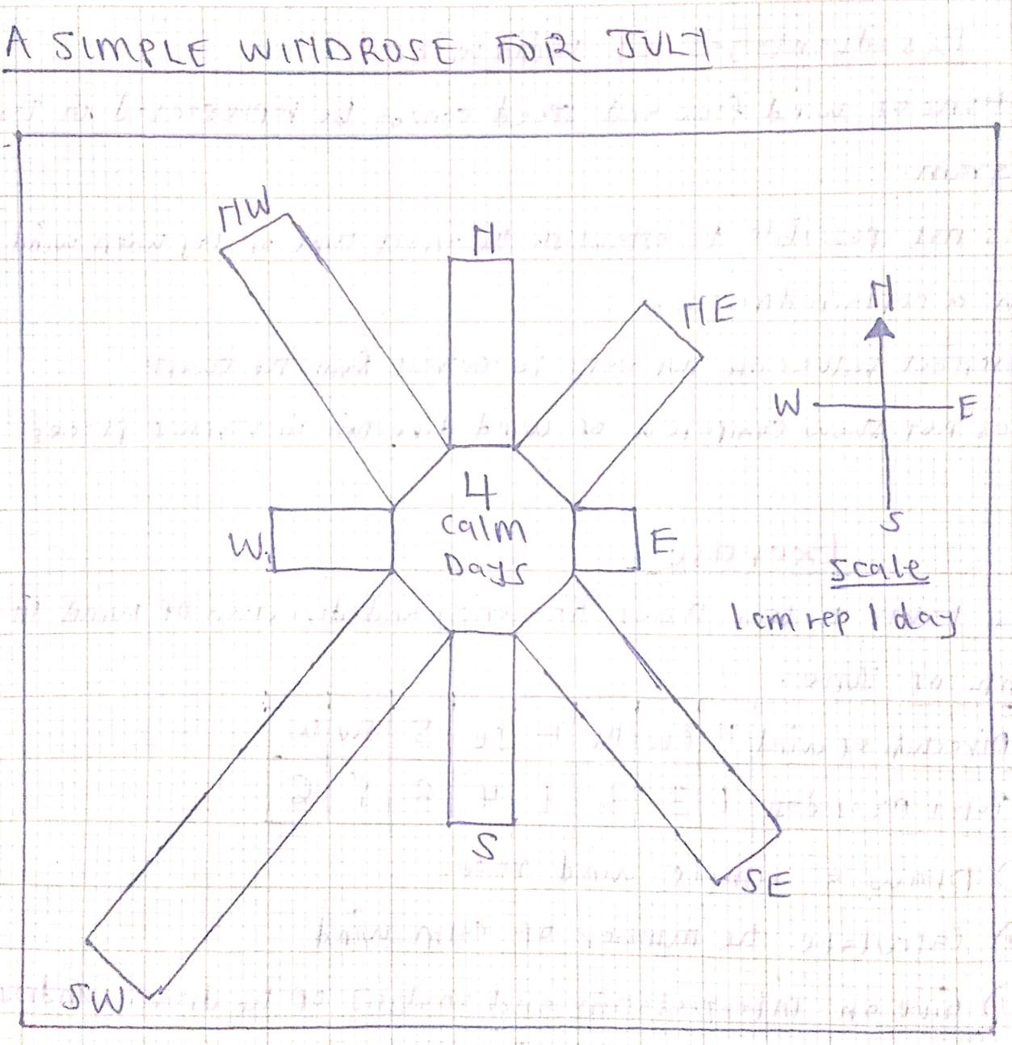

Analysis and interpretation of the drawn simple wind rose.
- Wind blew for many days from the SW direction.
- Wind blew for few days from the East direction.
- There were four days in July when the wind was stationary/ calm.
- Wind blew for same days from N, NE and S direction and also from SE and NW.

Advantages of a simple Wind Rose
- It is easy to construct.
- It gives a clear visual impression.
- It is easy to read/ interpret.
- Allow comparison.

Disadvantages of a simple wind Rose
- It does not show the speed of wind.
- Represent a few variables/ items.
- It does not show the comparison of wind direction.
- It is time consuming while constructing.
- It is difficult to read values at a glance.

Assignment: The table below shows frequency and direction of wind in the month of June 2023. Calculate the number of calm wind and then draw a simple wind rose.

Direction  of wind | N | NW | NE | E | SE | S | SW | W | Calm  wind
Total  number of days | 1 | 3 | 2 | 1 | 4 | 6 | 5 | 6

“END OF TOPIC FOUR”

TOPIC FIVE: MAPS AND MAPWORK
Definition of Terms
  - A picture is an image of an actual object represented either as drawing, painting or photograph.
  - A plan is a representation of an object, a feature or a place on a flat surface like a piece of paper.
  - A map is a representation of the whole or part of the earth surface on a flat surface like a piece of paper, a wall, clothes e.t.c.
  - Map work is the ability to read/ interpret/ analyse/ draw maps for better understanding of relief, drainage and various human activities on maps.

Types of maps.
    - Topographical map.
  - It is one which shows a selected number of physical and human features and their positions on the earth surface.
  - It is drawn by specially trained people called cartographers.
  - It is drawn from air or aerial photographs and ground surveys.
  - Topographical maps are used to answer question six of geography paper one (312/1).

Characteristics of topographical maps.

    - They are drawn to scale.
    - They are medium scale map sizes (1:50,000).
    - They have a map title and map name.
    - They have marginal information.
    - They represent a small area such as a village/location.
    - They depict physical features (relief, drainage, vegetation) and human activities (social and economic).

Atlas/ projected map.
  - It is a collection of many maps bound in one volume, resembling a book showing different physical features and human activities.

Characteristics of Atlas Maps.
    - They are used to represent a large area such as a country/continent/World in a small sheet of paper.
    - They are drawn on a very small scale.
    - They may represent specific or general information in an area.

Sketch/ outline map.
  - Refers to rough drawings showing specific information which the user requires to see
e.g. A sketch map of Africa showing distribution of Major Fold Mountains.

Characteristics of a good sketch map.
  - Be neat and clear.
  - Have a title.
  - Enclosed in a frame.
  - Have compass direction.
  - Have a key.

Uses of maps.
- They show direction and location of places and phenomena on the earth surface.
- They show human and economic activities like settlement patterns, land-use, communication network, mining areas, forestry and fishing.
- They indicate physical features like relief and drainage patterns.
- They show weather trends like rainfall distribution, temperature and climatic regions.
- They show political and administrative boundaries hence useful for land ownership.
- They are useful in military strategies to pin-point the enemy’s position.
- They are used to find distance between places.

Marginal information on a map.
  - These are information provided in the margin of a map.
  - They include;
    - The title
    - The scale
    - The compass direction
    - The key/ legend
    - Map sheet number and series
    - Date and edition
    - Grid systems
    - Publisher and copy right
    - Conversion table
    - Index to adjoining sheets

Name of the map/ sheet name.
  - It is found at the top middle part of the sheet written in bold letters e.g.Taita hills, Busia, Kisumu East.

The title/ sheet title.
- Usually printed on top left hand side of the map extract containing scale and country e.g. Kenya 1:50000 or East Africa 1:50000

Type of information contained on the sheet title;
  - Region where the map was developed.
  - The ratio scale.
-

The scale
  - It is usually shown on the map as a representative fraction e.g. 1:50,000 and a linear scale e.g.
0 1 2 3 4 5 km
⎯⎯⎯⎯⎯⎯⎯⎯⎯⎯⎯⎯⎯

The compass direction
  - It is given in the form of a diagram i.e.

Magnetic north True north

Grid north
*

Magnetic
variation Grid variation

  - Magnetic variation is the angular difference between magnetic north and true north e.g.
Busia map - 2⁰ 21’ Taita hills map - 0⁰ 30’

  - Magnetic declination is the rate at which the angle between the true north and magnetic north changes with time as indicated on the map centre.

QUIZ: Magnetic declination of Taita Hills map is 0⁰ 30’ as at 1991. What is the magnetic declination as at 1995?
Solution
Year difference = 1995 – 1991 = 4 years
1 year = 5’
4 years = 4 x 5’ = 20’
Magnetic declination as at 1995 = 0⁰ 30’ + 20’ = 0⁰ 50’

  - Grid variation is the angle between grid north and true north.

The key/ legend
  - It contains convectional signs and symbols used on maps to represent both natural and human-made features in a given area. Not all features in the key are found in the map.

Map sheet number/ map edition/ map series
  - They are mostly found in a small box on top right corner of the map provided.
  - Sheet number identifies the map sheet from the other sheets in the same group e.g.
115/1- Yimbo.
  - Map edition shows the year when the map was published/ printed e.g. 1971.
  - Map series shows the group of maps to which a particular map sheet belongs e.g.
Y73 (D.O.S 423)
Series Y73(D.O.S.423)
Sheet 115/1 Edition 1971

How to identify a map.
- Map series e.g. Y73(D.O.S 423)
- Map sheet e.g. 115/1
- Map edition e.g. 1971
- Map name e.g. YIMBO
-

Grid systems
  - The numbers for the grid eastings (vertical grid lines) and northings (horizontal grid lines) are shown at the edge of the map i.e. the inner margin.

Publisher and copy right
  - In Kenya, topographical map is drawn and published by either Directorate of overseas surveys (D.O.S) or the survey of Kenya.
  - Copyright symbolised by © is a law that protects the owners of published works.

Conversion table
  - It is a scale for converting height from metres to feet and vice versa.

Index to adjoining sheets
  - It is a box containing nine squares. The centre square represents the map sheet you are looking at.

Assignment.
Study the map provided and use it to answer the following questions.
- What is the name of the map provided?

- What is the title of the map provided?

- What type of map is provided?

- Write the series and sheet number of the provided map.

- State two types of scales used in the map.

- What is the magnetic declination of the provided map?

- Giving the sheet number, name an area bordering the provided map to the;
  - West
  - South East

- Using the key, name two roads found in the mapped area.

- Name two districts covered by the map.

MAP SCALES.
  - A scale is the ratio between the distance on the map and the distance on the actual ground.

Types of scales.
- Statement scale
  - It is expressed in words e.g. 1cm represent 1km

Linear scale
  - It is a line sub-divided into small equal units of either kilometres or metres e.g.
0 1 2 3 4 5 km
⎯⎯⎯⎯⎯⎯⎯⎯⎯⎯⎯⎯⎯

Representative fraction (RF) scale/ Ratio scale
  - It is a scale where distances on the map are expressed as a fraction of the actual distances on the ground e.g. 1
⎯⎯⎯⎯ or 1: 50, 000
50, 000

Conversion of scales
- Converting statement scale to RF scale.
e.g. Convert 1cm represent 2km into R.F
Solution 1km ⎯ 100,000cm
2km ⎯ 2km X 100,000cm
⎯⎯⎯⎯⎯⎯⎯⎯ = 200,000cm 1km
Therefore, RF = 1
⎯⎯⎯⎯ or 1: 200,00
200, 000

Converting RF scale to statement scale.
  - e.g. Given RF as 1
⎯⎯⎯⎯
50, 000
1km ⎯ 100,000cm
?? ⎯ 50,000cm 50,000cm
⎯⎯⎯⎯ X 1km = 0.5km or ½ km 100, 000cm
Therefore, statement scale = 1cm represent ½ km or 0.5km

Converting linear scale to RF scale.
e.g. Given 0 3 6 9 12 15 km
⎯⎯⎯⎯⎯⎯⎯⎯⎯⎯⎯⎯⎯
Here, 1cm represent 3km 1km ⎯ 100,000cm
3km ⎯ 3km X 100,000cm
⎯⎯⎯⎯⎯⎯⎯⎯ = 300,000cm 1km
Therefore, RF = 1
⎯⎯⎯⎯ or 1: 300,000
300, 000

Converting RF scale to linear scale.
  - e.g. Given 1
⎯⎯⎯⎯ or 1: 400,000
400, 000
1km ⎯ 100,000cm
?? ⎯ 400,000cm 400,000cm
⎯⎯⎯⎯ X 1km = 4km 100, 000cm
= 1cm represent 4km Therefore, linear scale =
0 4 8 12 16 20 km
⎯⎯⎯⎯⎯⎯⎯⎯⎯⎯⎯⎯⎯

Converting linear scale to statement scale.
e.g. 0 4 8 12 16 20 km
⎯⎯⎯⎯⎯⎯⎯⎯⎯⎯⎯⎯⎯
Here, 2cm represent 4km Therefore, 1cm represent 2km

Sizes of scales.
  - Small scale.
  - It is used on a map when showing a large area of land on a small size of paper.
  - It ranges from 1: 250,000 and above.

Medium scale.
  - It fall between small scale and large scale maps.
- It ranges from 1: 25,000 to 1: 250,000

Large scale.
  - It is used on a map when showing a small area of land on a given size of paper.
  - It ranges from 1: 25,000 and below.

Uses of scales.
    - Used to measure distances on maps.
    - Used to calculate areas on maps.
✓

Measuring of distances on maps.
- We use;
  - A pair of dividers.
  - A paper edge.
  - A piece of string

Calculation of areas on maps.
- Regular shapes.
- Triangle- ½ b h
- Rectangle- l x w
- Square- l x l
- Circle- πr²
- Trapezium – ½ (a+b)h
- Rhombus- b x h
- Parallelogram- b x h

- Irregular shapes



Complete squares = 12 Incomplete squares = 22
Area = complete squares + incomplete squares
2
= 12 + 22/2
= 12 + 11 = 23 square units

NOTE: The methods used in estimating areas of irregular shapes include;
- The use of rectangles and triangles.
- The use of strips.
- The use of grid squares (on 1:50,000 maps)

“END OF TOPIC FIVE”

TOPIC SIX: FIELD WORK
- Fieldwork is the scientific study of geography using the environment as a laboratory/source of information.
Types of fieldwork -kcse 2014

Field study/Field Teaching
-It involves individuals or a group of people who go out to the field with an aim of collecting information or data in order to achieve specific objectives.

Field excursion/Field trip/Field Tour/Field Visit.
-This involves individuals go for a sight-seeing or visit some areas for pleasure and relaxation.

Field research
-It is a problem-solving approach conducted by experts in their respective fields of specialization.
-The researcher identifies the problem, causes and their solutions.
Importance of fieldwork –kcse 2014 pp2/ 2017pp1/2022pp1/ 2023 pp1
- It enhances retention of information.
- It enables one to get first-hand information.
- It helps learners understand better concepts learnt in class.
- It enables one to acquire knowledge/ skills (problem solving skills/ critical thinking.
- It enables collection of samples for future reference.
- It breaks the monotony/ makes learning interesting.
- It makes learning real/meaningful.
  - It help learners apply knowledge learnt in class.

QUIZS: 2014- Give three advantages of studying floods through fieldwork.

: 2017- Give reasons why it is important to study soils through fieldwork.

: 2022- State advantages of studying landslides through fieldwork.

: 2023- Give three advantages of studying wind depositional features through fieldwork.

Procedure used in fieldwork
  - Identification of the topic of study.
  - Identification of the area of study.
  - Formulation of objectives.
  - Formulation of the hypotheses.
  - Preparation for the fieldwork.
  - Conducting the actual field study.
  - Follow up activities of the field study.

Identification of the topic of study/theme
- This is the title of the field study that is to be carried out. It is also the geographical problem investigated.
- A research topic should be short and researchable.
- Examples include:
  - A study of rocks
  - A study of weather station
  - A study of tea farming
  - A study on sugar factory

Identification of the area of study
- Choose the area of study carefully to ensure a success in the field study.
- Proper selection of the area of study helps the researcher to achieve his or her objectives.
- Examples include:
  - A study of rocks around the school.
  - A study of Dagoretti weather station
  - A study of tea farming in Nyeri.
  - A study of Mumias sugar factory.

    - Formulation of objectives -kcse 2020 pp1
- These refers to the aims or purpose of the field study.
- A good objective should be SMART i.e. Specific, Measurable, Achievable, Realistic and Time bound.
- Objectives should always begin with, “to find out, to identify, to investigate or to establish’’
  - For example, if the topic of study is “A study of Dagoretti weather station’’ the objectives maybe:
- To find out the elements of weather observed and measured in a weather station.
- To identify the factors considered while siting a weather station.
- To establish the instruments found in a weather station.
- To find out the importance of keeping instruments in a Stevenson screen.

Formulation of the hypotheses.
  - It is an anticipated idea, a guess or a suggestion about the problem to be researched.
  - It is a possible idea about a possible result to the problem in question.

Types of hypotheses –kcse 2014 pp2
      - Alternative or substantive hypothesis- It is positively stated e.g. All rocks are volcanic.
      - Null hypothesis- It is negatively stated e.g. Not all rocks are volcanic rocks.
      - Question form hypothesis.

    - Preparation for the fieldwork –kcse 2017pp1/2019pp2
- Seeking permission from relevant authorities.
- Conducting a pre-visit or reconnaissance.
- Reading from reference books.
- Conducting discussion in class.
- Consult geography teacher.
- Assembling necessary tools.
- Preparing a route map.
- Formulating objectives and hypothesis.
- Preparing a questionnaire.
- Drawing a work schedule.
- Dividing students into groups.

- Reasons for seeking permission from relevant authorities -kcse 2013/2019pp1/2022pp1
- It is an official requirement.
- For aadministration to arrange for transport, lunch, meals, upkeep and entry fee.
- For administration to provide essential tools for use.
- For the authorities to arrange for a tour guide to take them around.
- For the principal to alert other teachers on the disruption of the routine.
- To be allowed by the principal to be away from the school.
- To be permitted to enter the facility/area of study.

A pre-visit/reconnaissance.
  - This entails visiting the area of study in advance before the actual field study day.
Reasons for conducting a reconnaissance/Pre-visit -kcse 2023 pp1
- To seek permission from relevant authorities.
- To assess the suitability of the area of study.
- To assist preparing a working schedule.
- To help adjust objectives and hypothesis for the study.
- To estimate the cost of the study.
- To identify relevant equipment /tools for data collection.
- To identify suitable data collection methods.

- To help in drawing a route map.
- To identify any problems likely to be encountered.
- Tools/Items to be carried during fieldwork -kcse 2007/2017pp1
  - Notebook and pen for writing short notes.
  - Camera for taking photographs.
  - Geological map for tracing areas of related study.
  - Geological hammer for breaking rock samples.
  - Jembe/hoe for digging to get soil samples -kcse 2019
  - Magnifying lens for viewing specimen.
  - Polythene bags for carrying rock samples -kcse 2019
  - Route map for showing/locating the area of study.
  - Spades for scooping soil to expose rock samples.
  - Tape recorder for recording interviews/discussion.
  - Tape measure/rulers for measuring.
  - Pencils for drawing sketch maps.

- Reasons why route maps are required during fieldwork -kcse 2010/2013/2021pp1
  - To help identify the direction to be followed.
  - To help in preparing a working schedule.
  - To help in locating features for the study.
  - To help estimate distance to be covered.
  - To guide in estimating time for the field study.
  - To help to estimate the cost of the study.

- Why map of the area is needed during fieldwork -kcse 2009pp1
  - To show the extent/delimit the area of study.
  - To show the route to be followed during the study.
  - To show the location of features during the study.
  - To be able to estimate distances.
  - To show the general nature of the terrain.

Drawing a work schedule
- It is an organized order of events to be followed on the day of field study.
- It indicates specific time for each activity.
Time | Activity
7:30 am-7:59am | Assembling necessary equipment
8:00 am | Departure for the area of study

8:50 am | Arriving at the area of study and reporting to forest authorities
9:00 am-12:29 | Data collection
12:30 pm-1:59 pm | Re-grouping for lunch and taking lunch
2:00 pm-3:29pm | Continuing with data collection
3:30 pm  3.35 pm 4:25 pm | Reporting back to the forest authorities Departure from the area of study Report back to school

NOTE: According to M.O.E, 8:00am bus is allowed to leave the school and 6:00pm bus must be back in school.
Importance of a work schedule during fieldwork -kcse 2014 pp1/ 2020 pp1
i. It helps in carrying out the field activities systematically.
- It helps in estimating the total time required for the study.
- It ensures all areas of study are adequately covered.
- It helps in assessing progress of the study.
- It enables for proper use of available time.
- It confines one to the scope of the study.
- Advantages of dividing the class into groups -kcse 2006pp1/2022pp2
  - It facilitates more interactions among the group members.
  - It saves on time.
  - It enables field study to be carried out in an orderly way.
  - It encourages participation of all members of the class.
  - To collect wide variety of data, in case of a large area of study.
  - It enables students to study the entire area.

- Secondary sources of information you are likely to use before the actual fieldwork – kcse 2022pp2/ 2023 pp1 & 2
  - Geography notes
  - Internet/electronic media
  - Journals/magazines
  - Maps
  - Newspapers
  - Photographs/video tapes

  - Professionals/botanists/forest officers
  - Relevant text books

The Actual Field study.
- This refers to conducting the exercise in the field involving data collection and recording.
- The methods involved in the collection of data depends on the nature of the field as well as the type of data to be collected.

Methods of data collection during fieldwork –kcse 2011/ 2015/ 2018pp1/
2021pp1
  - Observing
  - Interviewing
  - Administering questionnaires
  - Sampling
  - Note making
  - Photographing/video recording/filming
  - Counting/Census taking
  - Reading secondary sources/content analysis
  - Taking measurements
  - Reading instruments/thermometers

Methods of recording during fieldwork data –kcse 2018pp1/2019pp1
    - Note taking.
    - Photographing.
    - Field sketching/drawing diagrams.
    - Filling in questionnaire
    - Tape recording.
    - Video recording/filming.
    - Labelling of samples.

Activities done during field study -kcse 2012/2017pp1 N/B: These are methods of data collection and recording. They include;
- Asking/answering questions/interviewing.
- Collecting samples
- Counting.
- Digging/breaking rocks
- Drawing sketches/transects
- Estimating heights
- Labelling samples
- Measuring distances
- Note taking/Note making
- Observing the rocks/features

- Taking photographs

    - Follow up activities of the field study -kcse 2010/2014pp1/2018pp1
- Follow up activities are the activities done after the fieldwork. They mainly involves analysis and presentation of data.
- They include;
- Asking/answering question.
- Assessing the information collected against the hypothesis.
- Consulting geography teachers.
- Data analysis/Data presentation.
- Discussion about findings/discussing the findings.
- Displaying of photographs taken/items collected.
- Drawing conclusions.
- Drawing diagrams
- Reading more on the topic.
- Report writing.
- Sketching the features.

Usefulness of information obtained from the field to the local community –kcse 2012/2015pp1
- It would be used to plan for precaution/safety.
- It would be used in the conservation of land/wildlife/soil/water.
- It would be used as a basis for further research.
- It would be used for planning agricultural activities.
- It would help in the rationalization of land use.
- It would be used for future reference.
- It would be used to determine economic uses of plants/herbal medicine.
- It would be used to identify new resources existing in their areas.
- It would help to identify alternative uses of the resources existing in their areas.
- It would help the local to identify new routes.

Problems likely to be encountered during fieldwork –kcse 2013/ 2017pp2/ 2018pp1
- Accidents /injuries may occur.
- Possible attack by wild animals like snake/Insects.
- Difficulty in breaking some features like rocks
- Difficulty in identifying some features/rocks
- Fatigue due to difficult terrain.

- Sudden/heavy rain making students to seek a shelter.
- Scorching sun making students to seek a shelter.
- Getting lost/loss of direction
- Inaccessibility of some areas/thick/thorny vegetation/rugged terrain
- Inadequate time for data collection
- Uncooperative/unwilling/absent respondents

How to identify different types of plants during fieldwork.
- Their appearance
- Their color
- Their leaf size/pattern/types
- Their age
- The texture of the leaves
- The system of leaves
- Their flowers
- Their root system
- By observing them

Types of data likely to be collected during a field work in a weather station –kcse 2011
- Diagrams/photographs on weather instruments
- Information on operations of weather measuring/recording instruments
- Information on weather forecasting
- Statistical data on previous weather records
- Types of weather recording/measuring instruments

“END OF TOPIC SIX”

TOPIC SEVEN: MINERALS AND ROCKS.

Definition of minerals –kcse 2022
- Mineral is an inorganic substance occurring naturally beneath/ at earth’s surface.

Conditions for a substance to be called a mineral are;
  - It must be inorganic in nature.
  - It must be crystalline solid.
  - It must occur naturally on the earth surface.
  - It must have definite chemical composition.
  - It must have physical properties.

Classes/Types of minerals.
- Metallic minerals
- Ferrous minerals- contains iron e.g. limonite, magnetite, siderite and haematite.
- Non-ferrous minerals- do not contain iron e.g. copper, Aluminium, gold, lead, zinc and tin.

Non-metallic minerals
  - Examples(kcse 2008)- Graphite, Diamond, Coal, Petroleum, Phosphate, Nitrate,
Potash

Fossil fuels/mineral fuels/energy minerals
- They are not classified as minerals because they are of organic origin e.g. petroleum, natural gas, coal and uranium.

Characteristics of Minerals
  - Tenacity
- This is the ability of a mineral to resist/to withstand tearing, crushing or breaking. Minerals differ in the ability to resist tearing or breaking hence they are brittle, ductile, elastic, malleable or flexible.

  - Lustre -kcse 2012
- Refers to the surface appearance of minerals as it reflects light. Minerals differ in their brightness depending on the nature of their reflective surfaces (smooth surfaces are shinny whereas rough surfaces are dull) e.g. iron is dull and opaque while mica is glassy and shiny.

  - Colour –kcse 2012
- Different minerals display different colours for example gold is yellow, Copper is brown and gypsum is white.

  - Hardness -kcse 2007
- The measure of degree of resistance of a mineral to disintegration. Different minerals have different degrees of hardness e.g. Diamond is hard while Talc is soft.

Shapes
- Some minerals aggregate into distinct crystal shapes, for example, a crystal of quartz is a six- sided prism.

Composition
- Some minerals are composed of one element such as gold, copper, diamond and silver while others such as bauxite and feldspar have two or more elements.

  - Specific gravity/density -kcse 2012
- This is the measure of the relative weight of a substance. Minerals have different specific gravity/densities e.g. gold/lead are heavy while silicate minerals are light.

Tastes and solubility
- Different minerals have different tastes and solubility. A soluble mineral has a feel of a lump of sugar on tongue while an insoluble mineral has a feel of glass.

  - Cleavage/fracture -kcse 2007
- This is the tendency of a mineral to break along a certain line of weakness. Minerals differ in the ability to break along the line of weakness.

Texture
- This is the fineness or coarseness of minerals. Minerals have different textures i.e. coarse or fine grained.

Streak
- This is the colour mineral leaves when it is rubbed against a hard surface. Minerals differ in streak.

Minerals differ in their ability to allow light to pass through them.
- Some minerals are opaque, some are transparent while others are translucent.

Definition of Rocks –kcse 2018
- A rock is a naturally occurring aggregates of mineral particles forming part of the earth’s crust.

Ways in which rocks can be classified.
- By mode of formation or origin.
- By appearance (physical and chemical characteristics)
- By age

Classification of Rocks According to the Mode of Formation or Origin
- There are three classes/types of rocks namely;-kcse 2017
  - Igneous rocks
  - Sedimentary rocks
  - Metamorphic rocks

IGNEOUS ROCKS
- Igneous rocks are aggregates of minerals formed the cooling and solidification of magma/lava.
- Magma is a hot molten rock material found in the earth’s interior.
- Lava is a hot molten rock material that has reached the earth’s surface.
- General characteristics --crystalline in structure
--glassy in appearance

Formation of Igneous Rocks
- Land forming processes like tectonic movement leads to the formation of lines of weaknesses within the crustal rocks.
- Heat and pressure beneath cause rocks to melt forming magma.
- Magma escape from the earth’s interior towards the earth’s surface through the lines of weaknesses within the crustal rocks.
- Magma may fail to reach the earth surface but cools slowly and solidifies in the earth’s interior forming intrusive/plutonic igneous rocks e.g. granite
- At times, magma cools near the earth surface at a medium rate and solidifies to form
hypabyssal igneous rocks e.g. Dolerite
- On reaching the earth surface, lava cools rapidly and solidifies to form extrusive igneous/volcanic rocks e.g. granite.

Types of Igneous Rocks -kcse 2020
- Intrusive igneous rocks- Further sub-divided into Plutonic igneous rocks

and Hypabyssal igneous rocks.
- Extrusive igneous rocks/Volcanic rocks

Plutonic Igneous Rocks
- Plutonic igneous rocks are aggregates of minerals formed from the slow cooling and solidification of magma in the earth’s interior.
- Examples of plutonic igneous rocks;- kcse 2018
  - Granite –kcse 2022
  - Diorite
  - Peridotite
  - Gabbro
  - Syenite
  - Diabase
  - Nephnine

Characteristics of plutonic igneous rocks;
  - Form from cooling and solidification of magma.
  - Form deep inside the crust/great depth.
  - Cools slowly
  - Form large crystals
  - They are coarse textured.

Hypabyssal Rocks/Intermediate igneous rocks.
- Hypabyssal igneous rocks are aggregates of minerals formed from the medium cooling and solidification of magma near the earth surface.
- Examples of hypabyssal igneous rocks;-kcse 2014
  - Dolerite
  - Porphyry
  - Diabase
  - Lamprophyre
  - Porphyrite
  - Granophyre

Characteristics of hypabyssal igneous rocks;
  - Form from the cooling and solidification of magma.
  - Form near the earth surface/shallow depth.
  - Cools at medium rate.
  - Form medium sized crystals.

Extrusive Igneous Rocks/Volcanic rocks.
- Extrusive igneous/volcanic rocks are aggregates of minerals formed from rapid cooling and solidification of lava on the earth surface.

Examples of Extrusive/volcanic igneous rocks;-kcse 2022
- Those formed as a result of lava flows;
  - Rhyolite
  - Andesite
  - Basalt
  - Obsidian
  - Scoria
  - Trachyte

Those formed as a result of ejection of volcanic materials;
  - Pumice
  - Tuff

Characteristics of extrusive/volcanic igneous rocks;
  - Form from cooling and solidification of lava.
  - Form on the earth surface.
  - Cools rapidly
  - Form small crystals
  - They are fine textured.

KCSE 2009: Differentiate between the processes of formation of plutonic and volcanic rocks (2mks)
- Plutonic rocks form from magma which cools slowly and solidifies within cracks and chambers in the earth’s crust while volcanic rocks form from the lava that cools fast and solidifies onto the surface of the earth.

SEDIMENTARY ROCKS
- Also called derived rocks.
- Sedimentary Rocks are aggregates of minerals formed from pre-existing igneous or metamorphic rocks through the process of weathering/ erosion.
- The sediments are deposited in layers / strata in water or on land and over a period of time they are consolidated into hard rock.

Characteristics of sedimentary rocks –kcse 2022
- They form horizontal layers/ are stratified.
- They have bedding planes.
- They have cleavage/joints.
- Some sedimentary rocks contain fossils.
- They are non-crystalline.
- They form from pre-existing/original rocks.
- Many are multi-coloured.

Classification/Types of sedimentary rocks
      - Mechanically formed sedimentary rocks
      - Organically formed sedimentary rocks
      - Chemically formed sedimentary rocks.

Mechanically formed sedimentary rocks
- They are also called Clastic rocks.
- These are aggregates of minerals formed when eroded rock materials are transported by agents of erosion and deposited in layers on land.

Formation of mechanically formed sedimentary rocks –kcse 2018
- Sediments used to form the rocks are derived from weathering of existing rocks.
- The weathered materials are transported by wind/water/moving ice.
- The weathered materials are deposited in layers on land or in sea.
- They are then compacted and cemented into mechanically formed sedimentary rocks
e.g. sandstone, mudstone, shale, claystone, breccia, grit e.t.c.

Types of mechanically formed sedimentary rocks.
- Arenaceous rocks e.g. sandstone and Grit
- Argillaceous rocks e.g. shale, mudstone (kcse 2022), claystone, siltstone, loess
- Rudaceous rocks e.g. breccia, conglomerate, boulder clay

Organically Formed Sedimentary Rocks
- These are aggregates of minerals formed from the remains of dead plants and animals.

Formation of organically formed sedimentary Rocks – kcse 2018
  - These rocks are formed from the remains of dead plants and animals/fossils.
  - These remains accumulate in the oceans/basins/land in layers.
  - The accumulated materials are compressed/compacted/cemented into organically formed sedimentary rocks e.g. limestone, chalk, ironstone, diatomite, coal

Types of organically formed sedimentary rocks
- Calcareous rocks e.g. limestone, chalk
- Ferruginous rocks e.g. ironstone
- Siliceous rocks e.g. Diatomite
- Carbonaceous rocks e.g. coal

Chemically Formed Sedimentary Rocks
- These are aggregates of minerals formed when rocks are precipitated or when solutions of salt are evaporated and particles accumulate in layers.

Formation of Chemically formed sedimentary rocks –kcse 2012
  - Some minerals of some pre-existing rocks are dissolved when it rains.
  - Dissolved minerals are transported into water bodies.
  - They are then precipitated/evaporated over a long period of time.
  - The evaporates/precipitates are then compacted to form chemically formed sedimentary rocks e.g. Trona, dolomite, gypsum, rock salt, chert and flint -kcse 2005

Types of chemically formed sedimentary Rocks
- Carbonates e.g. Travertine, Dolomite and Trona.
- Sulphates e.g. Gypsum
- Chlorides e.g. Rock salt
- Silicates e.g. chert and flint
- Iron stones e.g. limonite and haematite

METAMORPHIC ROCKS
- Definition-kcse 2015: A metamorphic rock is a rock formed when the original/igneous/sedimentary rock is subjected to chemically active fluids/pressure/intense heat which changes its form/structure/composition.

Factors determining the ease and degree of change of rocks during metamorphosis
- The resistance of the rock to crushing.
- The grain size of the rock being changed.
- The porosity of the rocks.
- The solubility of the constituents of the rocks.
- The chemical action of the minerals.
  - The stability of the minerals that are produced.

Causes of metamorphosis/change of rocks from the original state.
a.) Heat which causes the minerals to re –crystalize; such action is called thermal Metamorphism.
b.) Stress/pressure which causes alteration in the rock structure. This action is called cataclastic/dynamic/kinetic/regional metamorphism.
c.) The action of both heat and stress/pressure. This action is called Thermal-Dynamic metamorphism.

Metamorphic processes/Types of metamorphism
    - Dynamic / Kinetic/Regional metamorphism.-kcse 2017
- Original rock is subjected to intense pressure.
- Pressure is caused by compressional force when the crustal plates collide.
- The great pressure alters the mineral line up/composition in the rock.
- The rock changes their physical appearance and characteristics forming a new rock.
- Examples: Clay changes to slate.
: Granite changes to gneiss

    - Contact / Thermal metamorphism.-kcse 2017
- Rocks are subjected to intense heat.
- Heat may be due to rocks being buried at great depths/due to contact with magma.
- The hot magma melts the minerals of the original rock, they cool and solidify to form a totally different rock/recrystallize the rock grains.
- New minerals may also be added into the rock by the intruding magma.
- The new rocks change their physical appearance/chemical composition.
- Example: Igneous rocks changed to soapstone in Kisii.

Thermal – dynamic metamorphism.
- Original rocks are subjected to both intense pressure and heat.
- Pressure is caused by compressional force while heat is due to rocks being in contact with magma.

- Both heat and pressure may occur during mountain building processes.
- They modify the structure of the original rocks forming new rocks.
- Examples: coal changes to graphite

Changes that occur in rocks during metamorphism
  - New minerals are formed.
  - The rocks are hardened / become more resistant.
  - Some minerals recrystallize further.
  - The chemical composition of the rocks change.
  - Physical characteristics / appearance of the rock changes/ is altered.

Examples of rocks and their metamorphic equivalent.

Original rock | Metamorphic rock
Sandstone | Quartzite/slate –kcse 2009
Limestone | Marble –kcse 2009
Coal | Graphite
Clay/shale | Slate/schist –kcse 2009
Mudstone | Slate
Augite | Horn blende
Basalt | Granulite
Granite | Gneiss

KCSE 2017: Give three examples of metamorphic rocks (3mks)
    - Schist
    - Hornblende
    - Slate
    - Marble –kcse 2022
    - Quartzite
    - Gneiss
    - Graphite
    - Serpentinite

The Rock formation cycle.
- It is a series of changes that occur in the formation of three types of rocks.
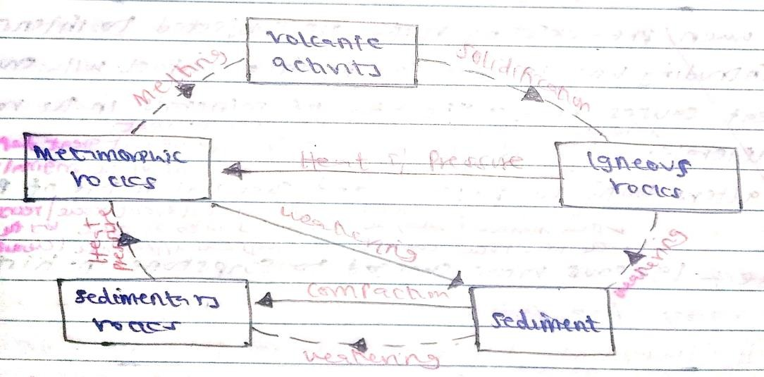

Characteristics of Rocks –kcse 2018
- Some rocks have joints.
- Rocks have varied degree of hardness.
- Rocks have cleavage.
- Rocks have varied texture.
- Rocks have different colours.
- Some rocks have lustre.
- Rocks have varied specific density.
- Rocks have different streak.
- Rocks have different minerals.

Distribution of major Types of Rocks in Kenya.
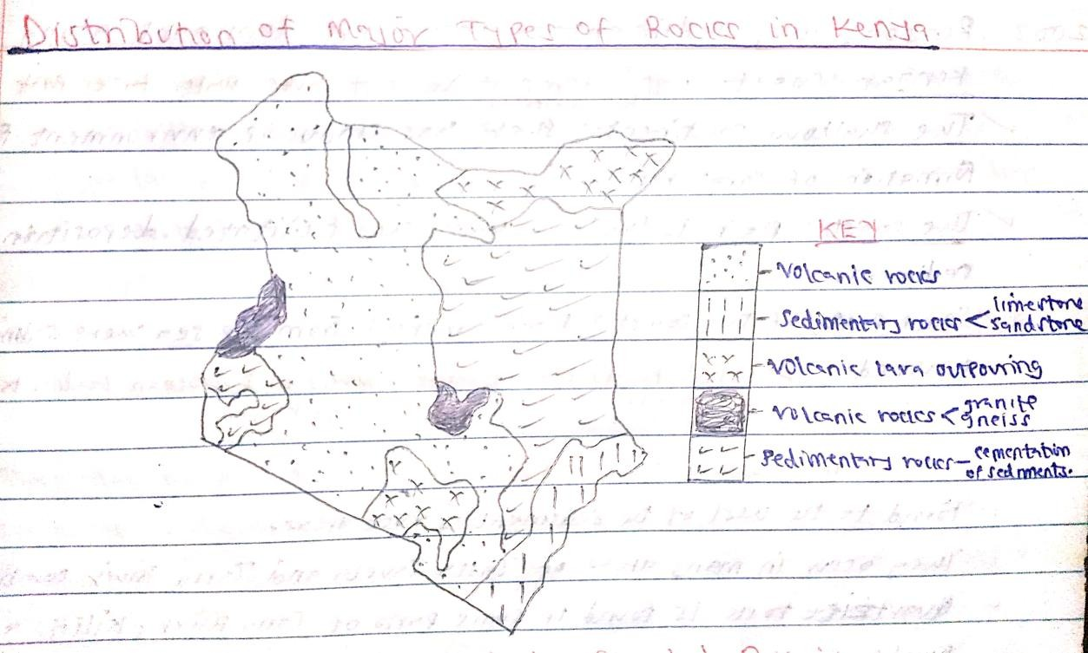

NOTE: Read on the Distribution of Rocks in the;
- Coastal Region
- Nyika plateau and dry lowlands
- Rift valley and its associated highlands
- Western Kenya

Why coral rocks are widespread at the coast -kcse 2007
- Salty water favours growth of coral polyps.
- Warm water for the growth of coral polyps.
- Clear water which is free from silt or mud favour coral polyps growth.
- Shallow water to which sunlight can penetrate for coral polyps growth.
- Well oxygenated water for coral polyps growth.

Reasons why sedimentary rocks are dominant along the Kenyan coast –kcse 2003
- High temperature at the coast causes water to evaporate leaving behind rock salts.
- The shallow continental shelf has conducive environment for the formation of coral rocks.
- The coastal plain is lowland which has facilitated deposition of sediments.
- Some parts of the coastal plain emerged from the sea where sedimentation occurred.
- Coral polyps die in large numbers in the ocean leading to the growth of coral reef which is a sedimentary rocks.

Uses of rocks –kcse 2020
- Some rock features like granitic tors are tourist attraction earning a country foreign exchange -kcse 2012
- Rocks weather down to form soils which support agriculture.
- Some rocks provide materials for building/construction.
- Some sedimentary rocks contain fossil fuels which are sources of energy for domestic/ industrial use -kcse 2012
- Some rocks are source of minerals.
- Some rocks act as storage for water which can be supplied for domestic/ industrial/ agricultural use -kcse 2012
- Some rocks provide raw materials for manufacturing industry e.g. Trona is processed to obtain soda ash used in glass-making industry.
- Some rocks like soapstone are used in carving.
- Some rocks are source of salt/food.
- Some rocks are used for scrubbing human bodies/sharpening tools.

QUIZ: Why is industrial diamond used in shaping hard stones and metals?
- Because it is the hardest mineral/It does not break easily.

“END OF TOPIC SEVEN”

TOPIC EIGHT: MINING

Definition of the term mining- kcse 2018
- Mining is the extraction of valuable minerals from the earth crust.

Factors influencing the occurrence of minerals- kcse 2018
- Vulcanicity (kcse 2016) - Vulcanicity leads to solidification of minerals in cracks and crevices. If minerals are found in small quantities, they are said to occur in veins and those in large quantities are in lodes. Minerals found in veins and lodes are copper, lead, zinc, tin and silver.

- Weathering exposes minerals near the earth surface. This makes some minerals to occur as weathering products e.g. (kcse 2023) nickel, iron, manganese, Bauxite/ ore of aluminium, Quartz and Olivine.

- Erosion loosens minerals and transports them eventually depositing them as alluvial deposits. Minerals due to alluvial deposition are gold and diamond.

- Sedimentation deposits, accumulates and concentrates minerals in specific areas making them occur in layers, beds and seams e.g. coal and iron.

- Metamorphism (kcse 2016) - Metamorphism leads to change into new mineral/formation of minerals e.g. diamond.

- Evaporation (kcse 2016) - Evaporation enhances crystallization leading to formation of salts and other minerals like soda ash and gypsum.

- Leaching results into concentration of minerals in the crust e.g. bauxite, nickel, iron and manganese.

Ways in which minerals occur - kcse 2002
- Some minerals may occur in beds and seams/layers.
- Some minerals may occur as weathered products.
- Some minerals may occur as alluvial deposits.
- Some minerals may occur as veins and lodes.
- Some minerals may occur as evaporates.
- Some minerals may occur in pools/wells in sedimentary rocks e.g. petroleum and natural gas.

Factors influencing exploitation of Minerals - kcse 2005
- The value of the minerals.
- Minerals that are of high value are often mined at a very high cost because of their high demand. Such minerals fetch high prices that lower the cost of extraction.
- Less valuable minerals cannot be mined if the cost of mining will be higher than the returns.

- The size of the mineral deposit.
- Large mineral reserves encourage mining than small mineral reserves which will be exhausted within a short period of time.

- The quality of Ore.
- Mineral ores (rock bearing minerals) with high mineral content are economical to mine.
- Mineral ores with low mineral content are uneconomical to mine except if they contain rare minerals like uranium.

- Method of mining.
- Minerals that occur at near the surface can be cheaply mined using open-cast mining method.
- Minerals that occur at greater depths in the earth’s crust are expensive to extract especially by deep shaft method.

- Level of technology - kcse 2013
- Advanced technology has improved mining operations thus leading to high quality/ large quantity mineral products.
- High level technology allows for effective exploitation of minerals leading to accurate location of minerals.
- Low level of technology limits exploitation/ low quantity mined.
- Advanced technology boost effectiveness in production hence reducing wastage.

- World market prices
- Fluctuation of world market prices affect the expected incomes by the exporting countries.
- When the prices are low, mining activities is shaken due to inadequate funds.

- Transport system - kcse 2013
- Efficient transport links allow mineral products to be moved from the mining site to the ports/ markets without delay.
- Minerals that are bulky require railway/ water/ cheap transport system to reduce the total cost of production.
- Mineral deposits in remote areas/ poorly developed transport system are less likely to be exploited.

- Capital
- Mining needs adequate capital to purchase modern equipment, to pay skilled personnel and develop means of transport.
- Inadequate capital hinders mineral exploitation.

- Political influence
- Political stability of a country allows mineral exploitation unlike wartime which stops mineral exploitation.
- Mineral deposits at the borders of two countries may not be exploited as dispute may arise concerning who mine it e.g. Iraq and Kuwait over Rumaila oil field.

- Labour
- Exploitation of some minerals require skilled and qualified workers and if they lack, mining is not done.

- Market
- High demand for certain minerals will encourage their exploitation.
- Low demand for minerals will hinder their exploitation.

Kcse 2013- Explain how mode of occurrence of mineral influence the exploitation of minerals.
- Minerals that occur in small quantities/ veins may limit exploitation since they are of low commercial value unless the mineral is of high value they will be exploited.
- Large mineral deposits are extracted as they are likely to be profitable/ can sustain the mining process over a long time.
- Minerals at or near the earth surface/ alluvial deposits are easier/ cheaper to extract hence need open cast mining method.
- Deep seated minerals are expensive to extract hence needs underground mining methods.

METHODS OF MINING
- The type of mining adopted depends on:
  - The mode of occurrence of minerals.
  - Relative ease of mineral exploitation.
  - The expense to be incurred.

The most common methods of mining are:
  - Open cast mining
  - Underground mining
  - Alluvial mining

- Open cast mining method. –kcse 2018
- Also called surface mining/ open- pit mining method.
- Method of extracting minerals which occur near the earth’s surface.
- Characteristics-
- It is cheap
- It requires simple machines
- Little capita input is needed

- There are two types of open cast mining method namely Stripping and Hill-slope boring.

- Stripping/ Quarrying –kcse 2018
- The mineral deposits lie within a few meters from the ground.
- The unwanted material on top layer/ overburden is removed.
- Soft mineral deposits are removed by drilling/ scooping.
- Hard minerals are removed by blasting with explosives.
- The mineral is then scooped by excavator.
- The mineral is loaded onto Lorries, transported for processing.
- Mineral extracted include coal, copper, iron ore and quarrying rocks like limestone.

Hill – Slope Boring
- If coal outcrops on hill slopes, boring instruments known as Augers may be employed to remove it.
- These augers are very large with a diameter of 1.5 metres and can reach as far as 105 metres below the ground.
- They drill out huge pieces of coal and bring them to the surface for transport by waiting trucks.

Negative effects of open cast mining on the environment –kcse 2002
- The land is left with gaping quarries which are ugly interfering with the natural beauty of the landscape.
- The heap of rock waste hinder any form of land use/ creates a landscape that is expensive to rehabilitate.
- The dust produced during the mining pollutes the atmosphere. It is a health hazard.
- It causes shortage of land hindering settlement/ leads to displacement of people/ hinders agriculture.
- Large scale blasting of rocks leads to instability of the basement rocks.
- Water collects in the hollows left creating ponds which becomes habitat for disease causing organisms.
- It interferes with the natural vegetation which is cleared before extraction of the mineral begins to take time to generate.
✓

Underground mining method.
- It involves extraction of minerals found in great depths below the earth’s surface.
- Characteristics-
- It is expensive
- It requires heavy capital investment
- It requires advanced technology/ complex equipment
•

Types of underground mining method.
a.) Drift or adit method b.) Shaft method
c.) Solution method d.) Drilling method

Drift or Adit Method
- It involves extraction of mineral deposits that occur in gently sloping veins or seams that are exposed on the side of a hill or valley.
- Horizontal or gently inclined tunnels (Adits) are dug from the hillside.
- Light railway line is constructed into the mine to bring out the mineral e.g. Copper mining in Kilembe, western Uganda.

Shaft method
- It involves extraction of mineral deposits found deep in the earth’s crust. –kcse 1998
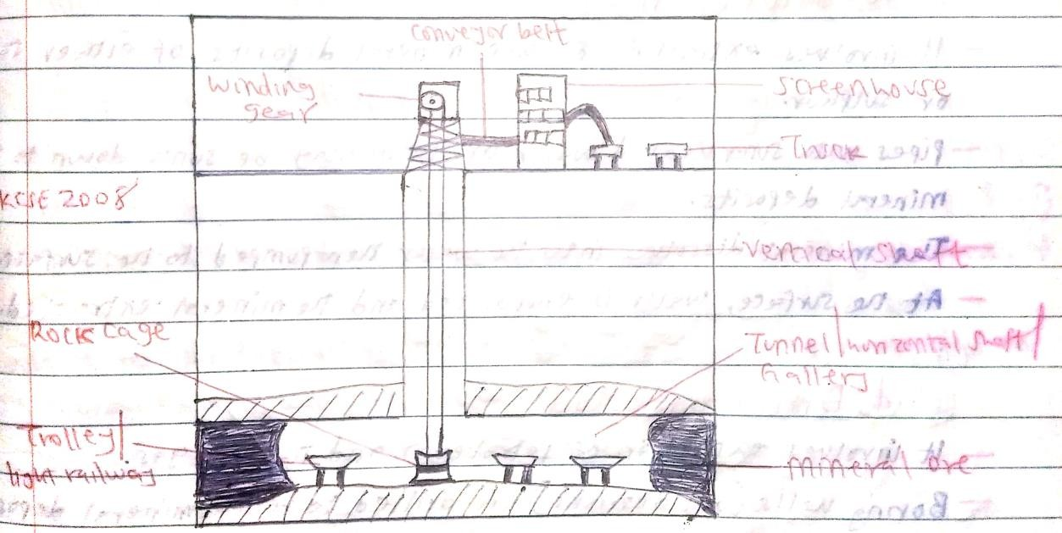

- Vertical shafts are sunk into the earth’s crust to reach the layer with the mineral.
- Horizontal tunnels are then dug following the veins of the mineral ores.
- Timber pit props/ steel concrete beams are erected to hold up the roof of the tunnel to prevent it from collapsing.
- The mineral bearing rock (ore) is blasted loose by explosives.
- The mineral deposit is transported in the tunnel on light railway to the bottom of the vertical shaft.
- It is then brought to the surface in a crane or a lift called a cage. The cage is also used in transporting miners and their equipment.
- At the surface, mineral deposit in the rock cage is offloaded onto the trucks and transported to the factory for processing.
- This method is used in South Africa to mine gold.

Problems associated with shaft mining method –kcse 2008
- Sometimes mines get flooded with sub-terrain water.
- There are occasional emission of poisonous gases in the mines.
- The dust produced causes respiratory diseases.
- Sometimes tunnel collapse causing deaths of the miners.

Solution Method
  - It involves extracting soluble mineral deposits of either salt or sulphur.
  - Pipes with super-heated water/steam may be sunk down to the mineral deposits.
  - The mineral dissolves into the water, which is then pumped to the surface.
  - At the surface, the water is evaporated and the mineral extracted.

Drilling Method
  - It is commonly used in the exploitation of petroleum and natural gas.
  - Boring wells (oil derricks) are drilled to reach mineral deposits.
  - Petroleum and natural gas is then brought to the surface either under its own pressure or by pumping.

Alluvial mining (placer mining)
  - It involves extraction of minerals occurring in alluvial deposits in the river beds e.g. gold, tin, diamond and platinum.

Types of Alluvial/ Placer mining methods
- Sluicing/ Panning
- Dredging
- Hydraulic mining
- Sub-marine mining

- Sluicing/ Panning –kcse 2016
- It involves scooping of the alluvial material from the river bed using a pan.
  - A mixture of water/ sand/ mud and mineral particles is scooped from the river bed using a pan.
  - Water is added if the mixture is thick/ if the water is excess it is decanted.
  - The material scooped is swirled in the pan. This separates the lighter material from the heavier particles which contain mineral particles.
  - The lighter material is removed/ poured out.
  - The heavier materials are sorted to display mineral particles which are collected from the pan.
  - Minerals obtained include (kcse 2016) - Gold, diamond, platinum and tin.

Effects of panning method on the environment –kcse 2016
  - It leads to water pollution hence unfit for human and animal use.
  - It leads to land dereliction interfering with the natural beauty of landscape.
  - It leads to destruction of vegetation as miners clears the land to access the area with minerals.
  - It leads to loss of biodiversity/ destroyed the ecosystem.

Dredging
- A dredger scoops water logged alluvium from the beds of the lake.
- The alluvium is passed over sloping channels with series of traps.
- Wastes are washed away and heavier materials are left at the bottom of the trap.
- This method is used in the extraction of soda ash at Lake Magadi.

Hydraulic mining
- It is used when alluvial deposits occur on a valley side or form thick terrace deposits.
- A powerful jet of water under high pressure is directed at the hill or terrace side.
- Gravel and mineral collect in the valley floor due to great pressure.
- Then gravel and mineral grains are recovered and washed out.

Sub-marine mining.
- It is used in extracting minerals in alluvial deposits lying deep down on the ocean floor.
- A sub-marine dredger goes down the ocean floor.
- It scoops mineral deposits and rises to the surface.
- The alluvium is passed over sloping channels with series of traps.
- Wastes are washed away and denser materials are left at the bottom of the trap.

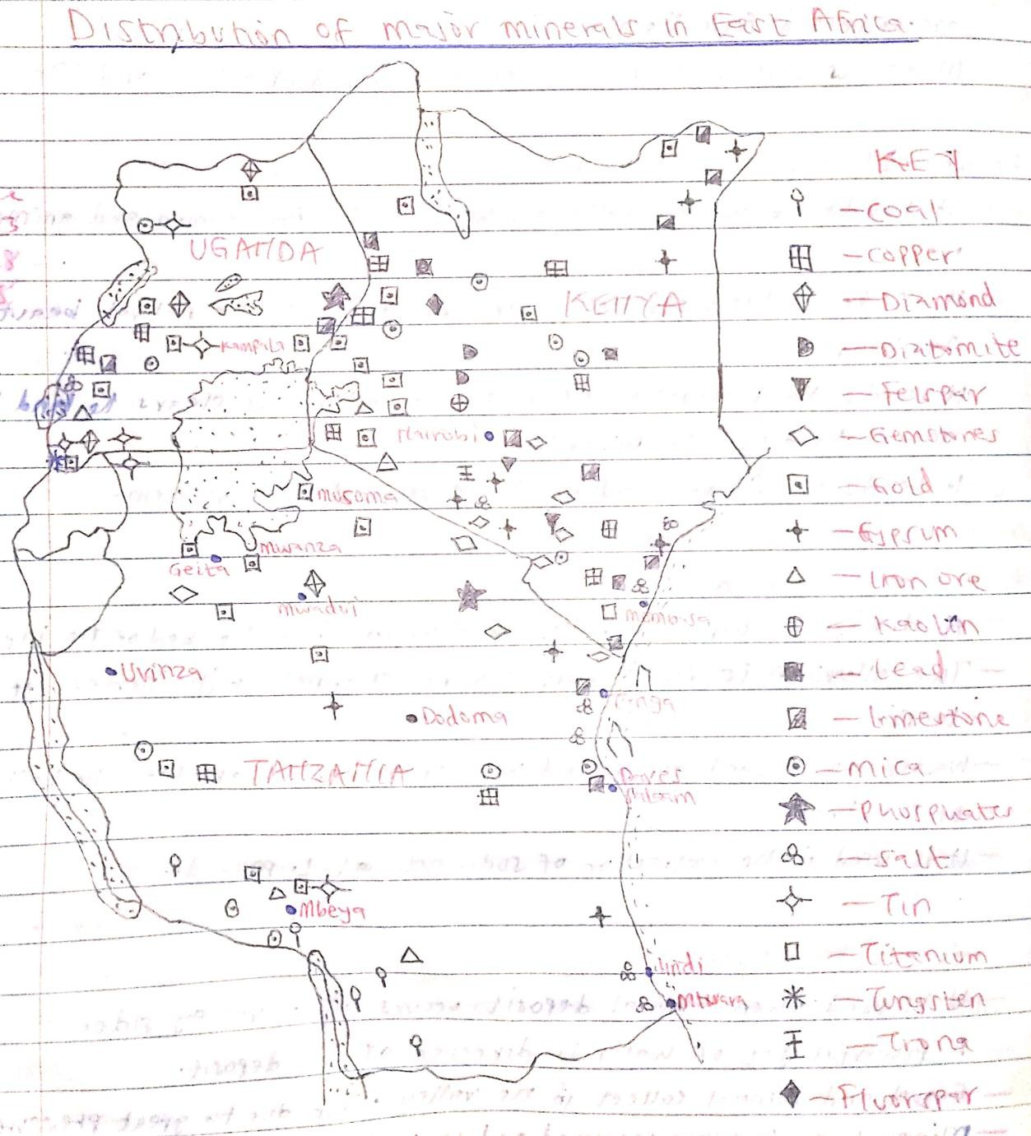

COUNTRY | MAIN MINERALS | AREA (S) MINED | MINING METHOD
UGANDA | Copper | kilembe | adit
 | Limestone | Hima & Tororo | open-cast
 | Phosphate | Tororo | open-cast
 | Salt | lake Katwe & Kasese | open-cast
 | Tin | Ankole & Kigezi
 | Gold | Kisoro
 | Iron ore | Kabale
 | Diamond | Upper Nile
 | Mica | Mubende & Kotido
TANZANIA | Diamond | Mwadui | open-cast
 | Gold | Musoma, Ngeita, Mwanza & Mbeya | open-cast/  shaft
 | Limestone | Tanga, Wazo hill & Mbeya | open-cast
 | Phosphate | Majingu hill | open-cast
 | Coal | Ruvuma, Ruruhu valley | open-cast
 | Salt | Vyinza, Bagamoyo & Kigoma | open-cast
 | Tin | Kyerwa
 | Mica | Morogoro
 | Iron ore | Chunga
KENYA | Soda ash | lake Magadi | Dredging
 | Fluorspar | Kerio valley/ Kimwarer | open-cast
 | Limestone | Athi River & Bamburi | open-cast
 | Diatomite | Kariandusi –kcse 2015 | open-cast/ adit
 | Salt | Ngomeni, Kilifi & Magadi –kcse 2015 | open-cast
 | Gold | Kakamega & Macalder (Migori county) | open-cast
 | Gemstones | Voi & Mwatate (Taita Taveta county) | panning
 | Copper | Macalder (Migori county) | open-cast
 | Natural carbon  iv oxide | Kereita & Esageri
 | Titanium | Kwale
 | Soapstone | Tabaka (Kisii)

Significance of minerals/ mining in Kenya –kcse 1998
- Mineral provide raw materials for industries e.g. soda ash is used in glass manufacturing industries –kcse 2018
- Minerals lead to development of transport and communication networks to make mining areas accessible.
- Mining creates employment opportunities for Kenyans improving their living standards.
- Mining leads to development of settlement / towns e.g. Magadi town which is centre for economic development.
- Minerals are exported to earn foreign exchange.
- Mining leads to development of social amenities e.g. hospitals and schools improving people’s living standards.
- Mining provides revenue to the government through taxation which helps to expand Kenya’s economy.

- Mining is a source of market for goods and services e.g. food outlets, shops, banking and insurance offered to people working in mines and related industries.
- Mining has enable Kenya to save her foreign exchange by reducing importation of minerals it exploits.

Kcse 2018- Explain three ways in which mining promotes industrialization in Kenya.
  - Some minerals provide essential raw materials for some manufacturing industries.
  - Minerals are exported to earn the country foreign exchange used for development of industries.
  - Mining stimulates development of roads/ railway which promotes industrial growth.
  - Mining attracts settlement/ development of towns which attract industrial development.
  - Mining has stimulated the growth of related industries that supply inputs/ services.
  - Mining creates employment raising the living standards of people creating demand for industrial products.

Problems facing the mining industry in Kenya.
- Inadequate capital for the exploitation of mineral has led to reliance on loans from the developed countries. Loans may not always be available, so exploitation may be delayed.
- Foreign companies manage most of the mining activities. They remit some export revenues to their countries, thus reducing the country’s export earnings. This has hampered the development of the mining industry.
- Remoteness and poor transport systems hinder exploitation of minerals in that areas with mineral deposits are inaccessible.153
- Insufficient skilled personnel in Kenya leading to dependency on expatriates for prospecting minerals and mining reducing profits accrued from mining.
- Kenya has small mineral deposits which are uneconomical to work on.
- Lack of sufficient power supply in localised areas which is necessary for mining activities.
- Land use conflicts which affect mining e.g. in Kwale between Tiomin (Canadian company) and the local people due to inadequate compensation.

Negative effects of mining on the environment –kcse 2008
- The dumping of rock waste has led to the loss of biodiversity/ destruction of natural vegetation.
- Dereliction of land due to dumping of waste materials destroys the natural beauty of the land.
- Pollution of the areas by noise/ blasts smoke and water pools are health hazards.
- Mining disrupts the water table which may lead to water shortage.
- Mining takes up land that would have been used for agriculture thus interfering with food production.
- Mining displaces human settlements thus disrupting people.
- Mining causes soil degradation/ facilitate soil erosion making land unsuitable for agriculture.
- Use of explosives during mining causes instability of basement rock leading to mass wasting.

Ways in which mining derelicts can be reclaimed –kcse 2005
  - Planting trees.
  - Creating a park to attract tourists.
  - Introducing aquaculture.
  - Landscaping for settlement or farming.
  - Refilling the holes.

EXPLOITATION OF MINERALS IN SELECTED COUNTRIES TRONA MINING ON LAKE MAGADI IN KENYA.
Location.
- Lake Magadi is 120km south west of Nairobi on the floor of the Great Rift Valley.

Occurrence.
- Trona is the raw mineral from which soda ash is manufactured.
- Trona occurs as a double salt of sodium carbonate and sodium bicarbonate.
- It forms a continuous thick crust of white grey crystals on the surface of Lake Magadi.

Mode of Formation
- Rain water dissolves soda salts in volcanic rocks.
- The solution percolates through the rock cracks and soils and gets beneath the basin.
- The accumulated solution is heated by the hot rocks beneath.
- Pressure builds up and the heated solution is pushed to the surface.
- It comes out of the ground inform of hot springs below or on the sides of the lake.
- Due to high temperature, water evaporates leaving behind crystals of trona on the surface of Lake Magadi.

Extraction and Processing
- A dredger scoops trona out of the lake bed.
- It crushes it into smaller pieces and separates it from rock debris.
- The material is mixed with a solution from the bed of the lake called liquor.
- The mixture is then pumped through a pipeline to the factory on the lake’s shore.
- The processing of Trona in Lake Magadi –kcse 2018
  - A mixture of Trona and liquor is pumped through a pipeline to the soda ash factory.
  - Trona is separated from water by being put on large sieve like trays.
  - The Trona is washed to remove mud and silt.
  - After drying, trona is heated/ roasted in big cylinders and it breaks into small particles of sodium carbonate/ soda ash.
  - Soda ash/ sodium carbonate is allowed to cool.
  - It is then ground, weighed and packed into paper bags ready for transportation to the market.

Uses of soda ash –kcse 2023
  - It is a raw material for making glass.
  - It is used in making detergents/soaps.
  - It is used in some chemical industries.
  - It is used in softening water/ water treatment.
  - It is used in de-sulphurizing steel.
  - It is used in paper making.
  - It is used in fixing dyes in textile industries.

  - Used in oil refining.
  - Used in making fertilizers, toothpaste, paints, pharmaceuticals
  - Waste air cleaning.

Marketing of soda ash.
- Soda ash is consumed locally in the related industries.
- Some of it is exported to Japan, India, Zimbabwe, Phillipines, China, Pakistan, Sri Lanka, Turkey, New Zealand, Argentina, South Africa, Congo, Ethiopia, Uganda and Tanzania.

Benefits of soda ash mining to the economy of Kenya –kcse 2012
- Kenya earns foreign exchange from the exportation of soda ash.
- Soda ash is locally used/ consumed saving Kenya’s foreign currency.
- It creates employment opportunities improving the living standards of Kenyans.
- It provides raw material for development of related industries like glass making industry.
- It has led to development of social amenities like schools and hospitals improving the living standards of Kenyans.
- It has led to the development of Magadi town which is centre for economic development.
- It has led to development of transport and communication networks that ease movement of goods.
- It earns revenue to the government through taxes.
- Soda ash is sold earning miners income.

Problems facing soda ash mining in Kenya
- Stiff competition from developed countries with large soda ash deposits e.g.
U.S.A and Israel.
- Low value of salt (sodium chloride) is insufficient to meet its production costs.
- High labour costs due to incentives given so that workers agree to work in hostile environment of Lake Magadi.
- Located in remote areas with poor transport and communication links.
- There is inadequate fresh water supply for use in the factory and domestic purposes.
- The area has no permanent inhabitants to provide reliable labour.

GOLD MINING IN THE REPUBLIC OF SOUTH AFRICA
- Gold is a shiny yellow mineral.
- It is found in a rock called banket that takes the form of beds of hard conglomerate.
- The gold ore is usually found in quartz veins, metamorphic rocks or in redistributed sediments.

Gold fields of South Africa.
- Witwatersrand (the Rand)
- Ogendaalrus
- Lydenburg
- Klerksdorp

Extraction and processing of Gold
- Vertical shafts are sunk underground from where horizontal tunnels are dug in the gold ores.
- Gold bearing rock (banket) is blasted using explosives.
- Gold ores are transported to the surface using rock cages and conveyor belts.
- The ore is transported to the factory for processing.
- At the factory, the ore is crushed into small chips and mixed with water.
- Cyanide is added to dissolve gold leaving behind wastes.
- Zinc dust is added causing gold to precipitate out leaving Uranium.
- Gold is melted out, cooled and packed ready for sale.

Uses of Gold
- Gold is used in the jewellery and ornament industries.
- It is used in dentistry.
- It is used in mintage (making coins to use as money).
- It is used in making medals.
- It is used by central bank as a form of security for national reserves.

Contribution of Gold to the Economy of South Africa –kcse 2008
- South Africa earns foreign exchange from the exportation of gold.
- It creates employment opportunities improving the living standards of people.
- Gold provides raw material for industries that make jewellery and other highly valued items thus promoting industrial expansion.
- Gold as a medium of exchange in the world is used in South Africa as a means of paying international debts.
- Gold mining has led to development of towns in the Rand and the Orange Free State creating a large demand for agricultural products.
- Mining of gold has led to the expansion of transport and communication networks which have created linkages between the mining towns and other parts of the country.
- Gold mining has led to the development of industrial mining skills that are useful in other sectors of the economy.

Problems Facing Gold Mining in South Africa.
- The costs involved in mining gold have increased greatly.
- Due to increasing demand to provide higher wages, married quarters and other social amenities this has led to additional cost in acquiring labour.
- A lot of water is needed for processing gold but the ever increasing population in the Rand also needs water, yet this area receives seasonal rainfall.
- The Rand mines are becoming deeper. This has led to pressure bursts underground and ground shatters as the ore is removed. This is due to the great pressure from the heavy weight of the rocks above.
- The gold grade being worked now is of poorer quality than that of some years back.
- Exhaustion of the minerals because gold is a non – renewable resources.

DIAMOND MINING IN THE REPUBLIC OF SOUTH AFRICA
- Diamond occur as scattered crystals in diamond rock bearing called Kimberlite/ blue ground.
- They occur in the form of pipes, dykes or volcanic plugs deep underground. A few diamonds are washed in the rivers and occur as alluvial deposits.

Diamond producing countries in Africa.
- South Africa
- Botswana
- Angola
- DRC
- Namibia

Diamond mining areas in South Africa.
- Orange Free State
- Transvaal
- Koffie
- Jagersfantein
- Kimberley
- Pretoria

Methods used in mining diamond.
- Deep-shaft mining
- Open-cast mining
- Alluvial or placer mining

Extraction and processing of diamond.
- Vertical shaft are sunk underground and then horizontal tunnel are dug to reach the diamond ore.
- The blasting of the diamond ore is done and then lifted to the surface using rock cage and conveyor belt.
- Diamond is also extracted using open-cast and alluvial/ placer mining methods.
- Diamond ore is then transported to the factory for processing.
- At the factory, diamond bearing rock (kimberlite) is crushed into small pieces.
- Crushed rock is mixed with water to remove impurities.
- The remaining rock and diamonds are passed over a rotating table covered with grease.
- Water is poured onto the ore, wet pieces of rocks are washed off as diamonds stick onto the greased table/ belt.
- The moving table/ belt is stopped to remove diamond.
- Diamond is washed to remove grease. This is done repeatedly.
- Diamonds are then sorted out and graded into gem diamonds and industrial type.

Uses of Diamond –kcse 2014
- For making cutting instruments.
- As abrasive for drilling purposes.
- For polishing metals.
- For making jewellery.

Contribution of Diamond to the Economy of South Africa
- It provides employment opportunities to thousands of people.
- It earns the country foreign exchange through exportation of diamond.
- It has led to the growth of urban centres like Pretoria and kimberly
- It has contributed to the development of transport and communication networks
e.g. Roads and Railways.
- It has led to development of related industries e.g. those processing diamonds to jewels.

Problems Facing Diamonds Mining in South Africa –kcse 2014
- Fluctuations of prices in the world market discouraging miners and prospective companies.
- Low mineral content in the ore making it processing elaborate and expensive.
- High cost of mining and processing of diamond hence reducing the profit margins and thus discouraging prospective miners/ companies.
- Competition of skilled labour with other sectors of the economy such as manufacturing.
- Continued mining has led to reduced diamond reserves s most mines are becoming depleted.
- Striking workers.
- Collapse of mines.
- Dustful condition.

PETROLEUM IN THE MIDDLE EAST
- Petroleum is the oil that comes from the earth’s crust in the crude form.
- Natural gas is the gas found with crude oil.

Conditions necessary for the formation of petroleum –kcse 2022
  - Presence of porous rocks in between two non-porous rocks.
  - Deposition of remains of flora and fauna over a long period of time.
  - Presence of non-porous rocks underneath the deposits of flora and fauna.
  - Deposition of the other layers of rocks/ non-porous over the remains of flora and fauna.
  - Compression of the remains of flora and fauna due to folding of the layers of rocks.
  - Presence of sedimentary rocks.
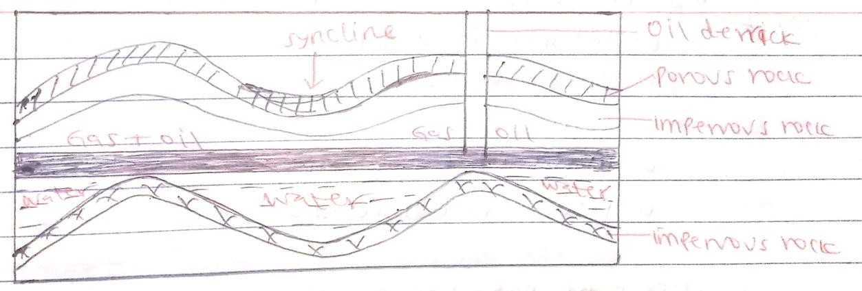

Method of extraction
- Oil mining is done using underground method/ drilling.
- An intensive study is done by geologists on the type of rock in which oil occur.
- The derrick drills the rock below to reach the oil reserve.
- The metal pipes are fixed as the drilling continues on the hole.
- When pipes are opened, the dissolved gas in the oil reservoir expands, sending out the mixture of oil and gas to the surface.
- The mixture is stored in the tanks built near the oil wells as crude oil which is transported to the factory for processing.

Processing.
- It is done by the fractionating tower/ column.
- Crude oil is heated before entering the tower.
- It is turned into vapour/ gas.
- As vapour rises through the tower, it gradually cools, condenses and collects on various trays and then allowed to overflow until it reaches an outlet.
- The heaviest oils condense first and settle below the light one.

By- product of a mineral
- It is the secondary product obtained during the processing of some minerals e.g. silver is a by-product of lead.
- By-products of crude oil/petroleum are –kcse 2022
- Bitumen/ Tar/ Asphalt
- Wax/ paraffin wax
- Sulphur
- Lubricants e.g. grease
- Petrochemicals/ Resin

Uses of petroleum
- Petroleum is used in making of:
- Paints
- Plastics
- Batteries
- Detergents
- Candle wax
- Asphalt
- Explosives
- Synthetic fibre
- Synthetic rubber
- Grease

Oil producing countries in the Middle East
- The major oil producers in the Middle East are:
- Saudi Arabia
- Iraq
- Iran
- Kuwait
- United Arab Emirates

- Other oil producers in the middle East are:
- Bahrain
- Qatar
- Oman
- Yemen
- Syria
- All the oil producing countries are members of OPEC

Contribution of oil to the economies of Middle East countries –kcse 2013
- The countries earn foreign exchange through exportation of oil.
- Petroleum is used as a raw material leading to the growth of petroleum related industries.
- The revenue/ royalties have enabled the Middle East countries’ investments overseas to increase immensely.
- Petroleum mining has led to creation of employment opportunities for local population improving their living standards.
- It leads to development of social amenities like electricity, schools and hospitals improving the living standards of people.
- It leads to development of transport and communication networks like roads that easens movement of goods.
- Income from petroleum mining has led to development/ growth of towns which are centre for economic development.

Problems facing oil industry in the Middle East.
- Insecurity e.g. wars between Iraq and Kuwait in 1990 disrupted oil industry.
- Shortage of labour due to small populations.
- Price fluctuations in the world market.
- Invasion by international companies which exploit oil reserves demanding high pay.

TOPICAL QUESTIONS.
- The diagram below shows the occurrence of petroleum in the earth’s crust.
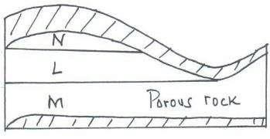
- Name the substances in the areas labelled L, M and N. L - Petroleum oil
M - Water N - Gas
- Give two by-products obtained when refining crude oil.
- Wax
- Bitumen / Tar/ asphalt
- Grease lubricants.
- Resin / petrol chemicals

- Sulphur

- Give three reasons why Kenya import crude oil.
  - It is cheaper than when already refined.
  - Refining of crude oil creates employment.
  - Kenya exports its refined petroleum products.
  - Waste products from refined oil e.g. bitumen is used for road surfacing.
  - Kenya gets by-products which are raw materials for other industries e.g. manufacture of plastics.

- Why is mining regarded as a robber industry?
  - Minerals are exhaustible and once exploited cannot replenish.

“THE END OF GEOGRAPHY FORM ONE WORK.”

BY MR. OGOTI ROBERT MAXWELL @ 0720780149/ 0736399175

TO GOD BE THE GLORY.

